Social Enterprise on a Symphonic Scale
No-one at Mount Pleasant Primary school is complaining about music cuts. Despite losing its peripatetic music teacher several years ago as part of Highland Council’s “restructuring”, the school has been left with a well-stocked music room, an enthusiastic and friendly staff and a visionary head teacher who has a real desire to keep music firmly on the curriculum for each and every pupil. This, combined with the practical philosophy of our new social enterprise, caithnessmusic.com, has recently been producing some extraordinary results in the far north of Scotland. Results which rival the successes of Sistema Scotland’s big-budget orchestral projects which are springing up in a few primary schools in deprived areas of the central belt. What makes the manifestation of our seventy-strong Mount Pleasant School Symphony Orchestra so extraordinary is that it has been created, as if by magic, out of pure desire, thin air and an eager and co-operative school community – ingredients which are surely in ready supply in any Scottish primary school.
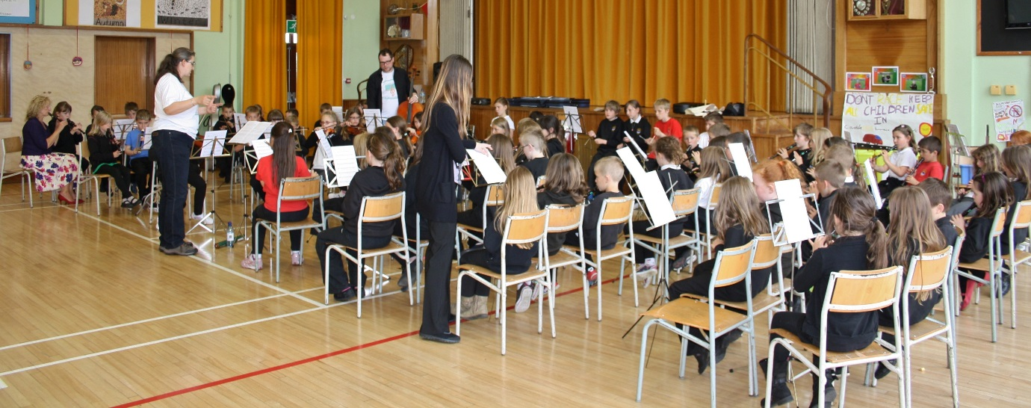
Mount Pleasant Primary School is, in so many ways, typical. A roll of 170 children in seven classes, set in a housing estate on the edge of a small town - we could be walking into just about any school in Scotland. The difference for us, as two professional musicians without any teacher training, is the warm welcome that we continue to get every time we cross the threshold of this particular school. Head teacher Suzanne Urquhart isn’t just pretending to be pleased to see us. She isn’t just being polite. She is genuinely delighted every time we come to visit her school. Her eagerness fuels our enthusiasm for the mission of our new musical social enterprise: “to promote health and well-being in Caithness through group music making.”
caithnessmusic.com is a musical organisation like no other. All of our work is based on four key principles: honesty, kindness, inclusivity and sharing. Co-founder Susie Dingle is a professional conductor with over 15 years of experience of working with youth orchestras, choirs and community music groups. Working alongside Susie as the other co-founder of caithnessmusic.com, I’m a professional orchestral bassoon player turned composer with a background in educating young musicians and working with adults with additional needs. I’ve written three pieces especially for our Mount Pleasant “Music Day” and am looking forward to hearing them played by this brand new symphony orchestra. Just for today, we’ve roped in friend and colleague Niall Laybourne. He is a part time strings instructor for Highland Council and this is usually his day off. All three of us agree that it was the inspirational adults in our lives, who were willing to share their enthusiasm and expertise freely with us when we were children, who enabled us to fulfil our musical potential. Now we’re all keen to give a little back in by sharing our orchestral experience with a new generation. We share a common vision to create an affordable “Sistema” of the north. The benefits of participating in orchestral playing are well documented, and our friends at Sistema Scotland have worked hard, both in terms of sharing musical skills and in terms of raising funds, to demonstrate this.
Without the benefit of any funding package or financial support, we have come together in an effort to afford these benefits to as many pupils in our local primary school as possible. We want to create a model for orchestral music making in Scottish primary schools which is affordable, realistic and easy to replicate within any school community.
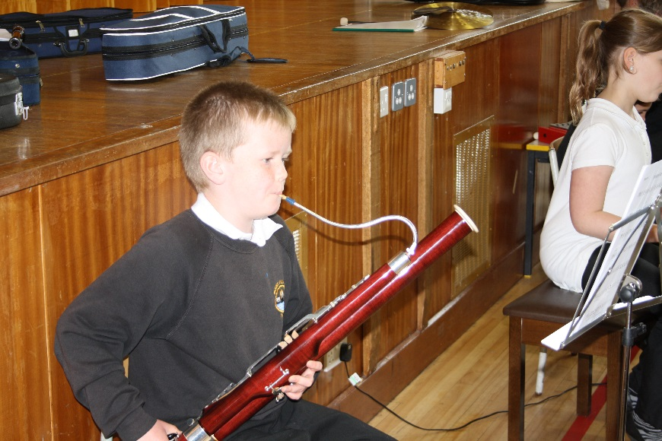
In preparation, we have assessed what symphony orchestra ingredients are already available within our school’s community. Our embryonic after school music club, now 10 months old, will form the core of our symphony orchestra. This small band of dedicated musicians, from p.4 – p.6, have been learning about the discipline and delights of orchestral music making at our music club every week and we feel confident that their commitment and discipline will be infectious. These, in our eyes, are real and useful musicians: four recorder players, a pianist, a mini-bassoon player, a flautist, two violinists and two dedicated percussionists, all of whom can already read the music AND watch the conductor! Part-time p.4 teacher Mrs Best has been working this term with her class and taught them four notes on the recorder. Susie and I have been working in class with p.3 and they can all play five notes, but read only three of them. Highland Council’s local string instructor is about to leave her post, but has been visiting the school every week and so we are blessed with one violinist who can use her fingers on the strings and another four who will be able to read and play the four-note open string parts. Mrs Best also runs an after school recorder group and this hopefully will provide us with an extra seven recorder players who can read and play a whole octave from D to D’.
We set a date for our “Music Day” confident that we potentially had a core of 50 young musicians with at least one note in common. We invited every child in p.3 and p.4, and issued an open invitation to anyone else in p.5 or p.6 who might want to join in. (We chose a day when p.7 were visiting the local high school, thinking this might be a “quiet day” in the school calendar to create a symphony orchestra!)
On our arrival at the school on “Music Day”, we find ourselves greeted by a smiling school secretary and a cheery head teacher. The friendly janitor helps us to lay out an ambitious 70 chairs and by 11am all of them are filled with eager young musicians. This includes several unexpected arrivals – a trumpeter, a guitarist, a chanter player and two new percussionists. True to our mission, we manage to include everyone who wants to join in. (But just for the record, a chanter really is tuned very much flatter than any recorder and so sadly can’t play along with the orchestra. Luckily our chanter player is more than willing to join in on percussion and her ability to read music makes her a truly effective contributor in that section!)
Our plan for the day is simple – one hour of rehearsal from 11.15 to 12.15, lunch, another short rehearsal from 1.30 to 2 and then a concert for the rest of the school at 2.15.

As Susie stands in front of a sea of 70 eager faces, the excitement is palpable. The real truth is that none of us have ever tried this before – expecting a symphony orchestra of eight to ten year olds to sight-read three new works in one day is extraordinary enough, but a completely inclusive orchestra where all the musicians come from just one small school? It is a first in Scotland and we all know it. Every atom of our beings is filled with anticipation. Will it work? What will it sound like? Can we even reach the end of the first piece together? Are we crazy?!
First things first: we explain how a symphony orchestra works. The need to listen carefully and quietly. The need to watch the conductor. We play some games using our one note in common: concert G. Starting together. Stopping together. Playing on every beat. Playing on just beat one. Playing on beat one and beat three. Half the orchestra on beat one and the other half on beat three… Fifteen minutes of our one-hour rehearsal have passed and I’m beginning to wonder if we’ve bitten off more than we can chew – we haven’t yet even tried to play any of the three pieces of music I have written for the day!
But luckily the orchestra is in safe hands with Susie. When she finally allows them to launch into “Fanfare for Fifty” (which really now must be re-named “Fanfare for Seventy”) the majority of musicians make it to rehearsal figure 1 together. She stops, and takes a moment to explain a bit of detail about rests, exactly what they look like and what they mean. We rehearse a section with musicians counting their rests out loud: “Toot, sh, sh, sh, sh, sh, sh, toot toot!”
For p.3, it’s a really steep learning curve but it does appear that some of them are beginning to understand what’s required. The rest of the musicians take to orchestral playing like ducks to water – sitting quietly, listening carefully, counting hard and playing well. This carries along the p.3 participants, some of whom have now worked out for themselves that, of their three notes G, A and B, two will fit in nicely on most occasions. And so while most are reading the music successfully, a few are enthusiastically “busking” (This is a technical term for intelligent improvisation, and is a phenomenon which occurs in every orchestra in the world when the demands of the composer exceed the capabilities of the musician. It is an invaluable skill in itself.)
With 20 minutes to lunch time, Susie calls the “New Year March” and we realise that a few of our youngest musicians need help even to be able to turn the page and read the title. But this tune is a little easier, and the orchestra has soon grasped the antiphonal feel of the piece. We make it to the end without injury and the young musicians are, collectively and individually, delighted with their achievement. Some are reluctant to leave the rehearsal room; “May I please come back early to do some extra practice during lunch?”
We head to the staff-room feeling tired but elated. The day has already been a success and we’re only half way through. As I pour a much needed coffee, I voice my only concern to Niall and Susie, “Let’s leave the third piece for next year, eh?” I know it’s a tough one – three beats to the bar rather than the familiar four, and with many more notes for the more experienced players. Susie smiles knowingly and nods without answer. We chat with p.7 teacher Mrs Firth over lunch. As a clarinet player she’s one of the few music readers on the staff of the school and voices how grateful she is to be able to read music. “It’s opened so many doors for me and I’ve made so many friends through making music.” We agree that musical literacy should be right up there with reading, writing and arithmetic as a basic life skill and vow to ensure a new era where everyone who leaves Mount Pleasant Primary School will be able to read music, even at a basic level. We know it’s not rocket science and we realise that we’ve already made a good start with p.3 and p.4. Our resolve strengthens to do whatever we can to help this friendly school community to fulfil their musical potential.
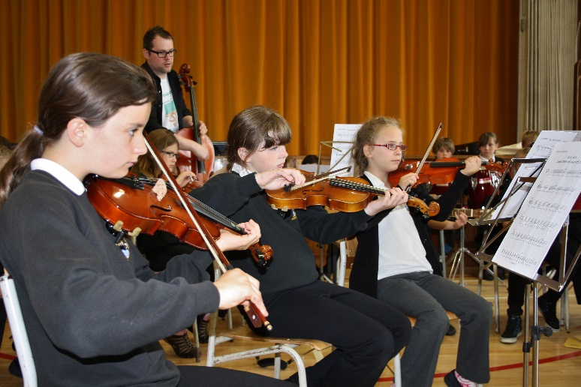
Refreshed by calories and caffeine, we return to the school hall to find that a large number of the children have come back early to do some private practice. We agree to “run” the third piece just so that we can say we’ve played it, and I pick up the camera to take some pictures, expecting it to fall apart within 16 bars. To my surprise and delight, the children read this piece easily all the way to the end. I make a composer’s mental note that the repetition and lack of rests in the beginners’ parts are a winning ingredients, as is the ritenuto and pause on the last note, allowing everyone to catch up and end together. It sounds grand, and I’m quietly very proud of the amazing phenomenon we’ve created today. No-one yesterday would have thought this was possible, and here we are today witnessing the birth of a real symphony orchestra. It looks like a symphony orchestra, it sounds like a symphony orchestra, and it is a unique and immeasurably valuable experience for the seventy small people who are concentrating, here and now, before my eyes.
I’m brought back to earth with a thud, as the remainder of the p.6 class arrives at the door of the hall, five minutes early for our “concert”.
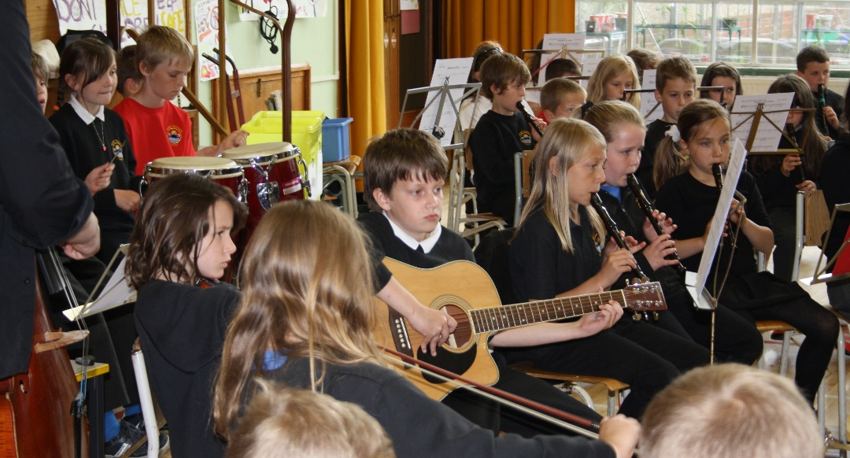
We take a break as the rest of the school arrives. Head teacher Suzanne has been busy in the office all day and has missed the rehearsals but is looking forward to hearing the concert. It is only in this moment that we all realise that there are more children in the orchestra than in the audience. Primaries one and two, and the remainder of p5 and p6, sit in awe, gazing up at the massive orchestra set out before them. One or two musicians voice their nerves, and I remind them that it’s actually excitement that they’re feeling, so there’s nothing to worry about. It is very exciting.
During the first piece, Suzanne disappears from the back of the hall, heading off to the office and I feel a pang of disappointment that she’s had to leave, assuming she’s been called away to attend to her duties. However, she reappears quickly with tissues in her hand and after our performance is over she explains to everyone why she had to leave: “Music should touch our hearts, and that’s what you’ve achieved this afternoon, children. As I looked at you all, concentrating so hard, playing so beautifully, listening so carefully and I heard the wonderful sounds you were all making, I was overcome with emotion and had to run away to get some tissues to dry my eyes! I’m so proud of you all and so proud of our school. Thank you for touching my heart and making me cry.”
Suzanne cannot read music herself and does not play a musical instrument. She has no idea what magic created the symphony orchestra in her school hall. The truth is that it was simply her desire to encourage only the best for her school community that has manifested one of the most inspiring and extraordinary orchestras the world has ever seen. We’d like to thank Suzanne for sharing her vision and that wonderful experience with us.
For more information about the Mount Pleasant School Symphony Orchestra, and free access to the orchestral scores and parts which you can use to make your own primary school orchestra, visit www.caithnessmusic.com

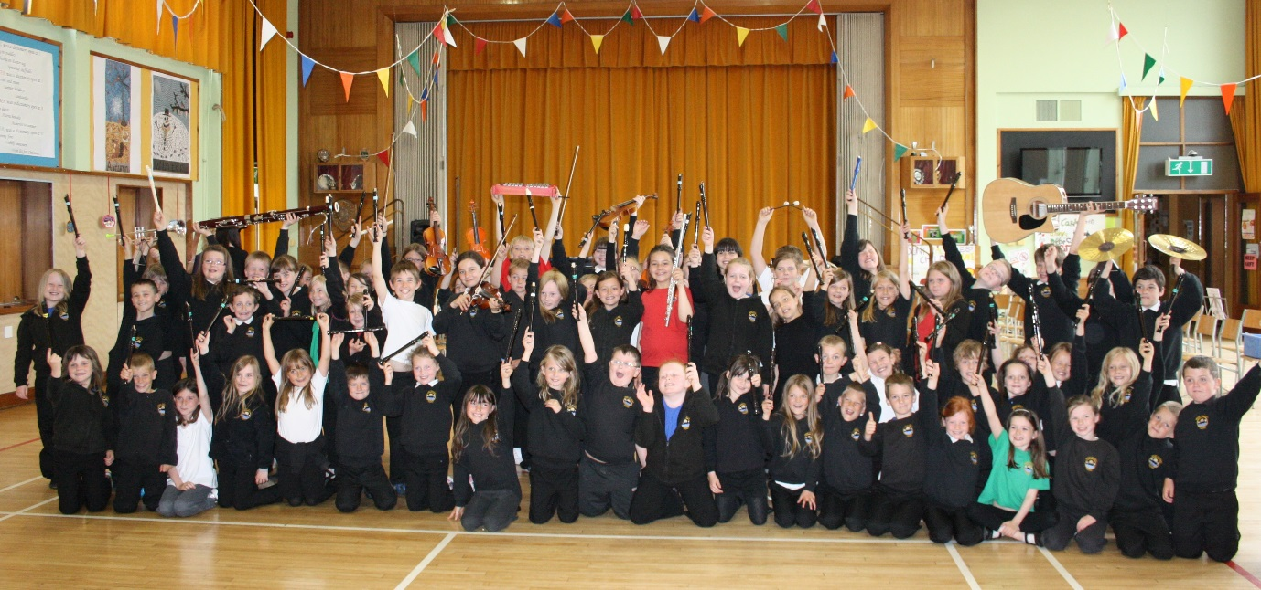

How to make your own primary school orchestra
- Think through your school community to find the “hidden” musicians. Can any of your staff members or regular visitors read music or play an instrument? Do you have any parents, uncles, aunts, or grandparents who are or have been orchestral musicians? Ask! You may be surprised at how many musicians are lurking in your community, sometimes doing other jobs. A keen amateur is just as valuable to you as a professional musician – enthusiasm and basic knowledge is all that’s required. Teenage musicians who play in a regional or high school orchestra might provide your young musicians with invaluable one-to-one assistance on the day.
- Get together with the people you have identified to discuss who might conduct your orchestra. Most orchestral musicians from the 20th century are able and willing to conduct – it takes a strong personality but make sure that you choose someone who is also patient and kind! Consider the talent that is already in your school. How many children already play an instrument? Do they get lessons? What notes can they play? Can you gather the resources to teach a whole class a few notes on the recorder to boost your numbers? We recommend A&C Black’s Recorder Magic Interactive cd rom for this purpose – it takes about 10 whole class lessons to acquire the skills and three notes required to be able to join in. Get your community musicians to help with this if your class teachers are not confident.
- Visit www.caithnessmusic.com and follow the links to our score exchange site, where you will be able to download scores and parts for free. If you need extra parts for other instruments (clarinet, trumpet, saxophone, double bass, etc) just get in touch with us and we will provide them, free of charge.
- Print off your parts, on card if possible.
- Find music stands! This may be the biggest challenge of all. Ask other schools if you can borrow their stands for the day. Advertise in your local press for the community to lend or donate music stands. For our orchestra of 70, we needed about 30 music stands. String players can share two to a stand, recorder players can share three to a stand.
- Set a date and make sure all of your teachers, pupils and helpers have it in their diaries. Remind parents just before the day to ensure that pupils remember to bring their instruments with them.
- Set up your orchestra and enjoy making music! Remember that the joy is in the making, so allow any wrong notes to flow over you and cherish and encourage the right notes. Keep discipline in a firm but friendly way. “Whenever we’re not playing in the orchestra, we’re listening…” Try to keep as many musicians involved as possible during the rehearsals by having some sections of the orchestra singing or clapping rhythms when they’re not required to play.
- Have a concert to celebrate your success, delight in the unique sound of your primary school orchestra, and post lots of pictures or even a video on your school website.

