Supplies List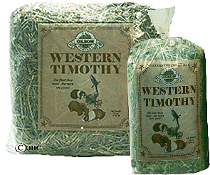

- Circle pen (can be made for around $20 or for a donation $50, we can make the pen for you) OR a store bought x-pen OR an approved habitat cage for indoor usage OR an XL wire dog crate (no wire bottoms) in either size of 28 x 42 or 30 x 46
- A new carpet remnant approximately 4’ x 4’ or 5’ x 5’ or a circular rug in either size if you are going to choose the x-pen option OR a bath mat to fit snuggly in the crate if you choose the dog crate option
- A pet carrying crate (small or medium)
- A LARGE or XLARGE litter box
- A large bag of GRASS HAY (Timothy, Orchard, Brome, Oat, Fescue, Bermuda) OR bale of grass hay (Orchard, Mixed Grass Hay) that can be purchased at most farm supply stores
- Two(2) heavy crock type or heavy dog bowls
- Plenty of toys for your bunny to play with (see toy list)
- Plain white vinegar for clean-ups
- Rabbit pellets: Oxbow Bunny Basics T or Kaytee (Oxbow T is the MOST recommended)
- Fresh veggies: 1 cup per 5 lbs. Weight per day
- 1 bag of pelleted pet bedding like Equine Select

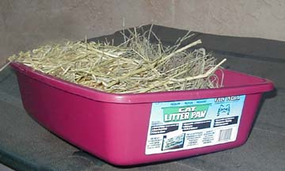
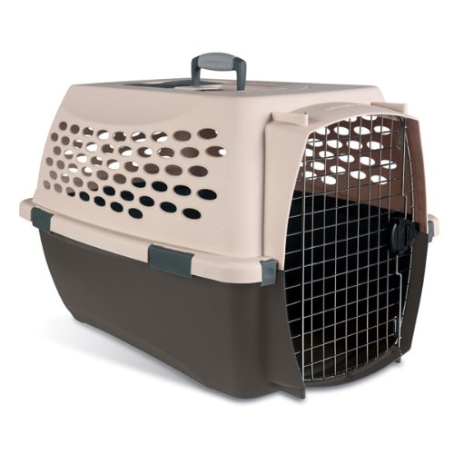

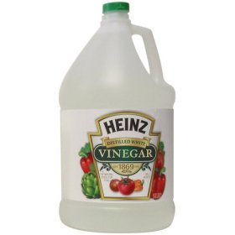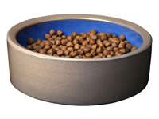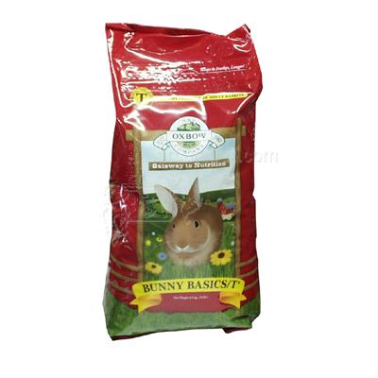

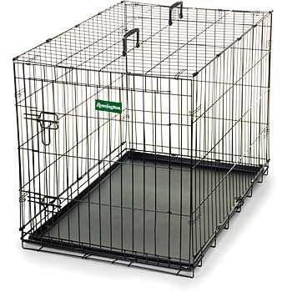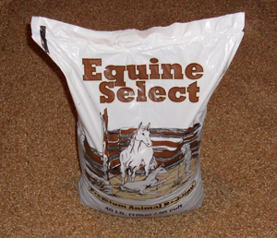

Example of X-Large dog crate either 28 x 42 or 30 x 46

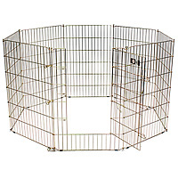
Example of store bought x-pen

