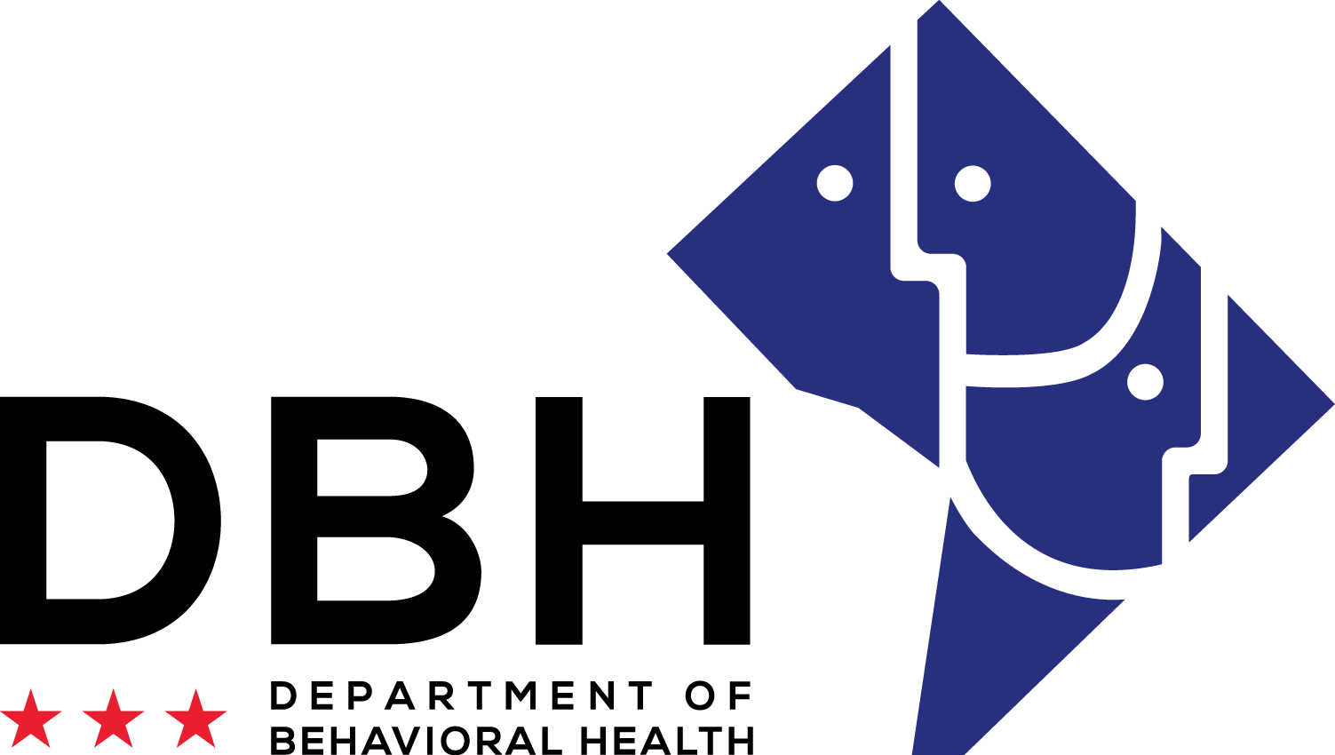

APPLICATION
2019 PEER SPECIALIST CERTIFICATION TRAINING

Name (please print clearly/or type):

Address:

_________________________________________________________________

Best Phone Number(s) to Contact You:

Email:

Class Schedule
Please submit no more than two class options. See full schedule for important dates.
□ Winter CPS Training: January 28 to February 28, 2019; Monday – Thursday 9:00 am- 12:30 pm
Application Deadline: January 4, 2019 at 12:00 pm

□ Evening CPS Training: April 22 to May 23, 2019; Monday - Thursday 5:30 pm- 8:45 pm
Application Deadline: March 29, 2019 at 12:00 pm

□ Summer CPS Training: June 24 to July 25, 2019; Monday - Thursday 9:00 am- 12:30 pm
Application Deadline: May 31, 2019 at 12:00pm

Requirements for Participation
Please submit proof of requirements 1 through 3 along with completed application.
- □ I am at least eighteen (18) years of age and able to work legally in the United States.
- □ I currently reside within the District of Columbia (D.C. resident).
- □ I have a high school diploma, GED (or equivalent) or degree from an accredited institution.

Ranking Factors

Please submit proof of requirements 1 through 2 along with completed application.

- Demonstrated successful completion of any training, workshop or class in mental health or co- occurring disorders. (e.g., BRIDGES, WRAP, MHFA, YMHFA, Recovery Coach, CAC).
Yes No
If yes, please submit proof of completion of training (e.g., letter, certificate, or diploma).

- Held a job(s) in the past or present as a Peer Specialist/Advocate.
Yes No
If yes, your resume should reflect this experience.

Application continues on next page.

DBH Application for
PEER SPECIALIST CERTIFICATION
My experience is with: (CHOOSE ALL THAT APPLY)
□ I am a current or former consumer of services within the Department of
Behavioral Health (DBH).
□ I am able to disclose that I am a person with a history of a mental health diagnosis and/or
substance use disorder and am able to role model my own self-recovery.
□ I am willing to create and follow a wellness recovery plan.
□ I understand this certification process may require submission to periodic drug testing.
□ I acknowledge that if I am accepted to the family or youth track, before the training starts I must submit to a criminal background check through the Department of Behavioral Health (DBH).

My primary lived experience is with: (CHOOSE ALL THAT APPLY)

Personal Recovery from Mental Illness or Substance Use Disorder Personal Recovery from Co-Occurring (Mental Illness & Addictive Disease)
□ Caregiver of a Child (ren) with an Emotional, Mental and/or Behavioral Disorder(s)

Personal Disclosure Statement: (Choose All That Apply)

YES, I agree to disclose my recovery history with mental illness and/or substance use disorder in keeping with policies and procedures of DBH.

Yes, I agree to disclose my history with dealing with my child (ren)’s (or the child (ren) in my care, emotional, mental and/or behavioral disorder(s) and recovery in keeping with the policies and procedures of DBH

NO, I do not want to disclose my history with mental illness and recovery at this time.

Statement of Accuracy: (Choose All That Apply)

I have been in recovery from a mental illness and/or substance use disorder for two years or longer.

I completed this application and the required attachments with assistance.

I completed this application and the required attachments on my own.

I hold a high school diploma, GED equivalent, or higher.
I can supply all documentation that has been requested for this application.
All information I have supplied is true and accurate to the best of my knowledge.

Application continues on next page.

APPLICATION ESSAYS

You must complete all essays for your application to be considered.

You may attach a separate sheet if needed. (150 words maximum for each question)
(Please print clearly or type) (Total of 45 points available)

- Why do you want to become a Certified Peer Specialist (CPS)? (5 Points)

- What makes you a good candidate to work with other consumers in the behavioral health field? (5 Points)

- What types of experiences have you had in advocating for consumers of behavioral health services? Please describe in detail, listing efforts in letter-writing, personal advocacy, public testimony, programs you began, the work you are doing now, etc... Be specific. (5 Points)

- Describe your current employment or volunteer situation. If neither applies, how do you spend your time? (5 Points)

Application continues on next page.

APPLICATION ESSAYS

You must complete all essays for your application to be considered.

You may attach a separate sheet if needed. (150 words maximum for each question)
(Please print clearly or type) (Total of 45 Points available)

- How do you define recovery? What do people who know you are in recovery say about you? (5 Points)

- How do you give back to your family and friends since you have been in recovery? (5 Points)

- Why do you think it is important for Certified Peer Specialist to share their story? (5 Points)

- What will be your most difficult challenge in attending this training? How will you deal with this challenge? (5 Points)

Application continues on next page.

APPLICATION ESSAYS
You must complete all essays for your application to be considered. You may attach a separate sheet if needed. (150 words maximum for each question)
(Please print clearly or type) (Total of 45 points available)

- Is there anything else you would like us to know in considering you for the Peer Specialist Certification Program? (5 Points)

Statement of Information:

I understand that DBH will provide an opportunity to apply for a transportation scholarship not to exceed $300.00, if available.

I understand that I must make all travel arrangements to and from the place of training and examination. I will receive directions to the training and exam site once I have been officially accepted.

I understand that the Peer Specialist Certification Training is not a job placement program.

Items to be submitted along with this completed application

Resume
- Diplomas, certificates or other proof of education/experience
- Two (2) recent, signed job/volunteer letter of reference with contact information.
- Proof of D.C. residency

Signature: Date: ________________________

Submit this application along with all supporting documentation via email (adrienne.lightfoot@dc.gov), regular postal mail or hand delivery to Consumer and Family Affairs Administration, DBH, 64 New York Avenue NE, 3rd Floor, Washington, DC 20002. Faxes will not be accepted. The contact person is Adrienne Lightfoot, OCFA, tel. # (202) 671-4089. Be sure to leave your name and phone number with your area code.

Application continues on next page.

Only fully completed applications with all supporting documentation will be considered. All applications must be delivered either by post,
e-mail (adrienne.lightfoot@dc.gov) or hand delivered no later than 12:00 pm ET on the appropriate date. (see full schedule for details)

Optional Questions – the answers do not increase or decrease your chances of being accepted

What ward do you live in? | 1 | 2 | 3 4 | 5 | 6
 | 7 | 8 | Homeless

What is your age? 18 – 24 25 – 34 35 – 50 51 – 64 65 & Older

What is your gender? Male Female
What is your race/ethnicity?

10 Tips to Completing a Peer Specialist Certification Application

Neatness
- Type or Clearly Print, Using Black or Blue Ink.
Fill in the blanks
- Answer all questions on the application.
Proofread
- Review application prior to submitting. Check for any spelling and grammar mistakes.
Accuracy
- Look over resume and ensure all information is updated. Make sure to list all accomplishments and certificates.
References
- Participants should have two recent signed references with contact information. Which should include one from your former employer/volunteer and a personal character letter.
Timeliness
- Submit application ahead of deadline. This helps participant’s avoid any last minute problem with deliver of submission.
Documentation
- Include all required supported documents inside the application.
Signature
- Don’t forget to sign application.
Application Process
- Applications will be reviewed and scored. Applications with a score of 30 or above will be granted an interview on a first come, first served basis. Participants are strongly encouraged to apply early to secure their seat in the class.
Interview
- Be on time for interview and dress professionally. Remember to be yourself & smile.

DO NOT continue unless you want to apply for
The Family and/or Youth Peer Specialist Certification
You must meet have the following requirements:

Family Peer Specialist Certification
□ I am a parent/caregiver who has cared for a child(ren) who has been diagnosed with an emotional, mental and/or behavioral disorder(s). (If you are not the biological parent or legal caregiver, you must be a significant non-paid caregiver).
□ I am able to disclose that I am a parent/caregiver of a child(ren) who is a current or former consumer of services within the Department of Behavioral Health (DBH).
□ I acknowledge that if I am accepted to the program, before the training starts I must submit to a criminal background check through the Department of Behavioral Health (DBH).

Youth Peer Specialist Certification
□ I am between the ages of 18-25
□ I am able to disclose that I am a young adult who has received mental or behavioral health services within the child serving system in the Department of Behavioral Health (DBH).
□ I acknowledge that if I am accepted to the program, before the training starts I must submit to a criminal background check through the Department of Behavioral Health (DBH).

* See last page for trainings we offer
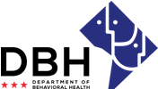

APPLICATION
FAMILY PEER SPECIALIST

CHOOSE ALL THAT APPLY
□ I am a parent/caregiver who has cared for a child(ren) who has been diagnosed with an emotional, mental and/or behavioral disorder(s). (If you are not the biological parent or legal caregiver, you must be a significant non-paid caregiver).
□ I am able to disclose that I am a parent/caregiver of a child(ren) who is a current or former consumer of services within the Department of Behavioral Health (DBH).
□ I acknowledge that if I am accepted to the program, before the training starts I must submit to a criminal background check through the Department of Behavioral Health (DBH).

APPLICATION ESSAYS

You must complete all essays for your application to be considered.

You may attach a separate sheet if needed. (150 words maximum for each question)
(Please print clearly or type) (Total of 10 points available)

- What strengths have you gained in caring for a child(ren) with emotional, mental and/or behavioral disorder(s) that you can share to help other parents and caregivers? (5 points)

- Describe how you overcame challenges when you were trying to get services for your child(ren) with emotional, mental and/or behavioral disorder(s). (5 points)

Signature: ___________________________________ Date: ____________________________

Only fully completed applications with all supporting documentation will be considered. All applications must be delivered either by post, e-mail (Adrienne.Lightfoot@dc.gov) or hand delivered no later than 12:00 pm ET on the appropriate date.
(see full schedule for details).

APPLICATION
YOUTH PEER SPECIALIST

CHOOSE ALL THAT APPLY
□ I am able to disclose that I am a young adult who has received mental or behavioral health services within the child serving system in the Department of Behavioral Health (DBH).
□ I acknowledge that if I am accepted to the program, before the training starts I must submit to a criminal background check through the Department of Behavioral Health (DBH).

APPLICATION ESSAYS

You must complete all essays for your application to be considered.

You may attach a separate sheet if needed. (150 words maximum for each question)

(Please print clearly or type) (Total of 10 points available)

- What strengths have you gained from navigating the various system of care for youth and young adults with emotional, mental and/or behavioral disorder(s) that you can share to help other youth? (5 points)

- Describe how you overcame challenges when you were seeking services for yourself and or supporting other youth in various system of care with emotional, mental and/or behavioral disorder(s). (5 points)

Signature: Date: _______________________

Only fully completed applications with all supporting documentation will be considered. All applications must be delivered either by post, e-mail (Adrienne.Lightfoot@dc.gov) or hand delivered no later than 12:00 pm ET on the appropriate date. (see full schedule for details).

Trainings We Offer:

Recovery Coach

Forensic Peer Specialist

Continuing Education

Mental Health First Aid

Narcan and CPR Training

Mindfulness for Emotional Wellness

QPR (Question, Persuade and Refer) Suicide Prevention Gatekeeper Program

