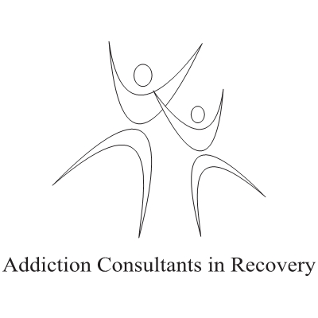

Objective Workplace Writing ©Learning Outcomes.

At the end of this training your staff will:

#1. Understand the core concepts of defensible documentation.
#2. Learn terms, phrases and language to avoid when writing at work.
#3. Recognize how to defensibly correct mistakes when writing.
#4. Appreciate how facts are more effective than personal opinion when documenting incidents.
#5. Understand how to properly document statements from others.
#6. Understand how to properly document profanity.
#7. Know how to correctly document decisions.
#8. Learn to properly document incidents.
#9. Understand how to objectively refer to themselves in workplace writing.
#10. Recognize how to properly describe actions.
#11. Learn how to defensibly continue writing.
#12. Discover how to properly add forgotten information to a workplace document.
#13. Understand how to use de- identification to protect confidentiality.
#14. Have a resource to call for further help or information.
Time for delivery: 2- 2.5 Hours, including Q & A.

To book your Objective Workplace Writing Training or for a quote contact:

Julian Toy H.S.C. R.S.S.W. Substance Abuse Professional
Pager: 1-888-718-5651
Web: www.myaddictionexperts.com
E-Mail: juliantoy@myaddictionexperts.com

© 2014 Julian Toy

