Social Media Kit
Parenting in the time of COVID-19

To help parents interact constructively with their children during this time of confinement, these tips for parents cover planning one-on-one time, staying positive, creating a daily routine, avoiding bad behaviour, managing stress, and talking about COVID-19. Use them to your and your kids’ advantage, and have fun in doing so.

Website with resources: bit.ly/COVID19parenting
Tag: @WHO @UNICEF @USAID @CDCgov @ParentingLH @GPtoEndViolence @accelerate_hub
Hashtag: #COVID19PARENTING #COVID19 #Coronavirus

Visual | Message for Twitter/Facebook/Instagram
 | Stressed by the school shutdown? Let’s use this time to build relationships and reach goals. Toilet training? Making something together? Now’s a time to try…  Useful resources: bit.ly/COVID19parenting  #COVID19PARENTING @WHO @UNICEF @USAID @CDCgov @ParentingLH @GPtoEndViolence #COVID19 #Coronavirus @accelerate_hub
 | Home with the kids? Try 20 minutes a day where they choose what you do together. You can give them some ideas. No phone or TV so you can focus on them. One-on-one time will help them feel safe and loved. Have fun!  Useful resources: bit.ly/COVID19parenting  #COVID19PARENTING @WHO @UNICEF @USAID @CDCgov @ParentingLH @GPtoEndViolence #COVID19 #Coronavirus @accelerate_hub
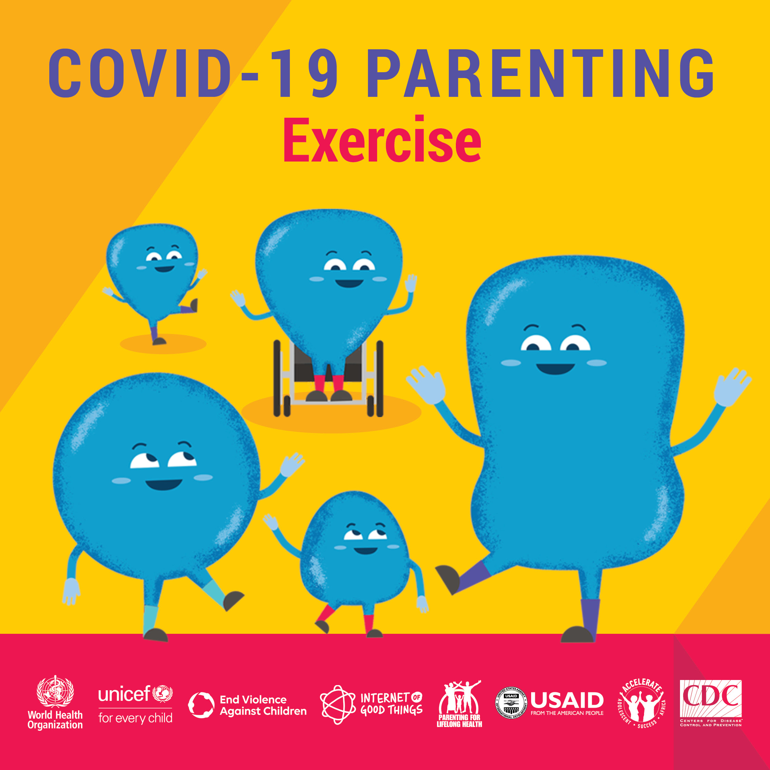 | Exercise helps kids (and adults) to de-stress when we’re stuck at home. Let your child choose the music and have a 10-minute dance! You might even impress them with your moves…  Useful resources: bit.ly/COVID19parenting  #COVID19PARENTING @WHO @UNICEF @USAID @CDCgov @ParentingLH @GPtoEndViolence #COVID19 #Coronavirus @accelerate_hub
 | Praise is powerful. Try praising your child or teenager for something they have done well. Do it in a genuine way. They may not show it, but you’ll see them doing that good thing again. It will also reassure them that you notice and care.  Useful resources: bit.ly/COVID19parenting  #COVID19PARENTING @WHO @UNICEF @USAID @CDCgov @ParentingLH @GPtoEndViolence #COVID19 #Coronavirus @accelerate_hub
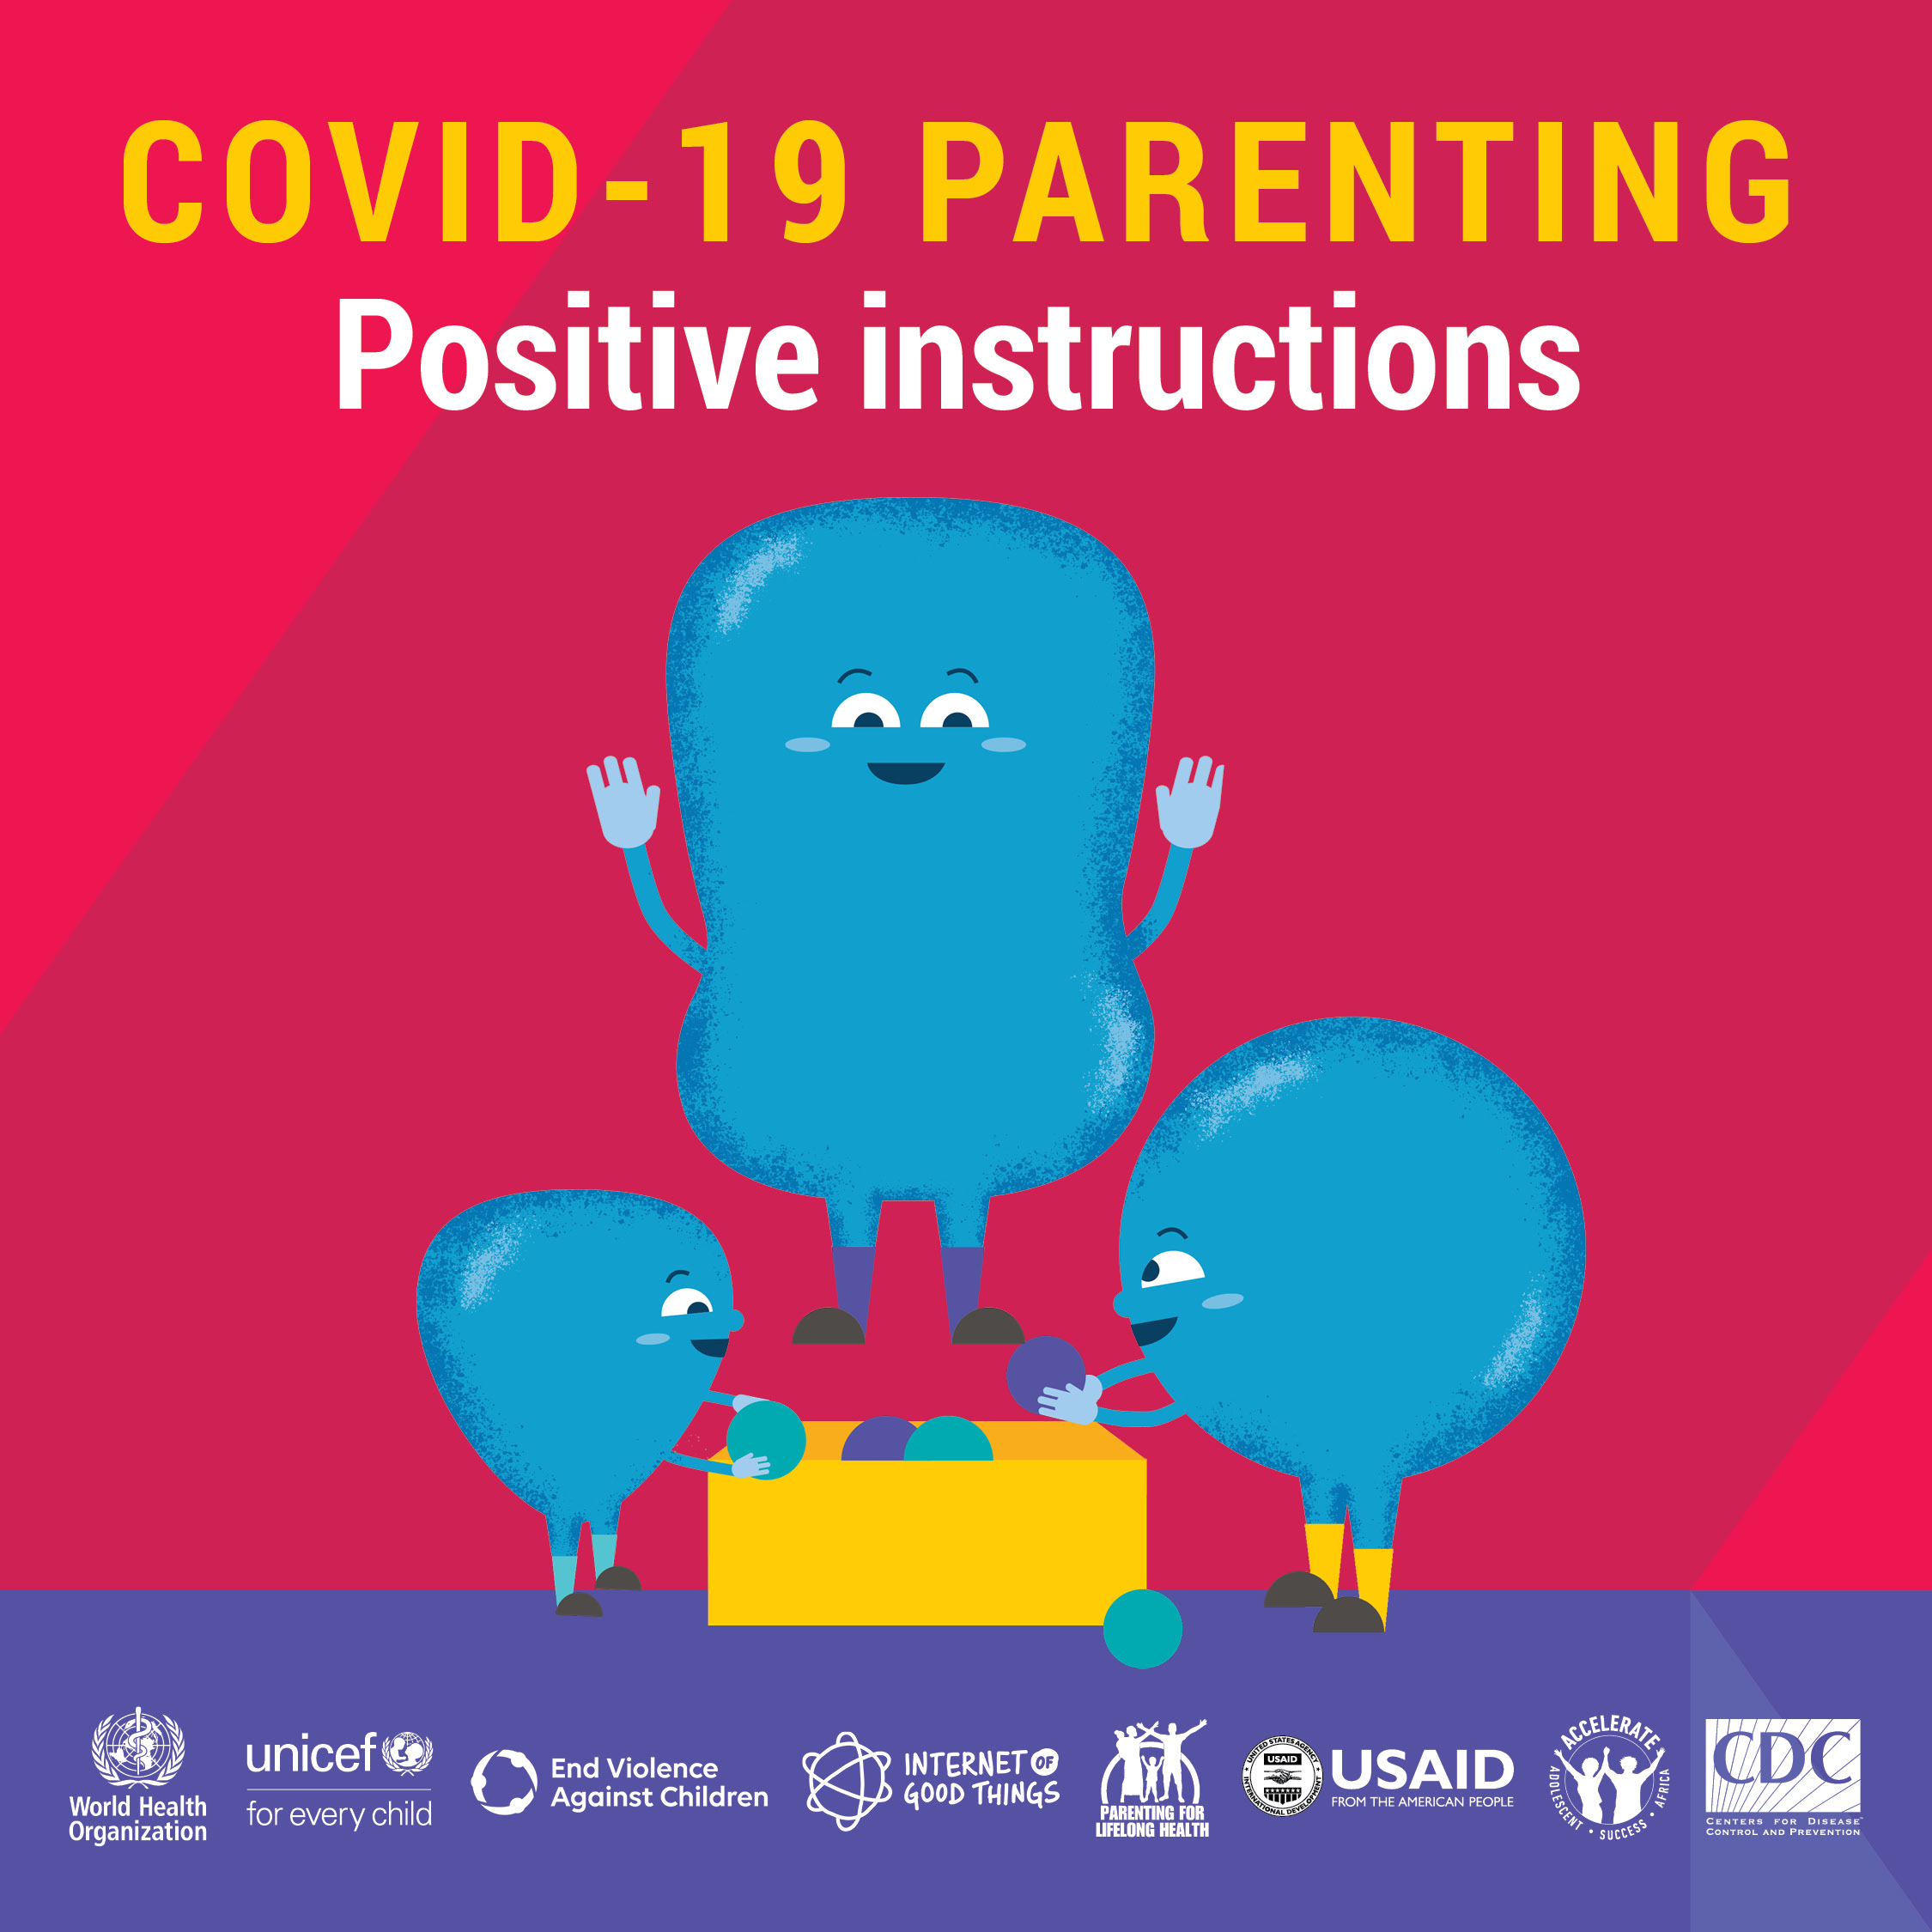 | Clear, positive instructions get us the behaviour that we want. Swap ‘don’t make a mess’ for ‘please put away your pens’. Give them something they can do – ‘you can’t write on the wall but you can write on your hand’. And praise them when they do it. Won’t work 100% but it’s a good start!  Useful resources: bit.ly/COVID19parenting  #COVID19PARENTING @WHO @UNICEF @USAID @CDCgov @ParentingLH @GPtoEndViolence #COVID19 #Coronavirus @accelerate_hub
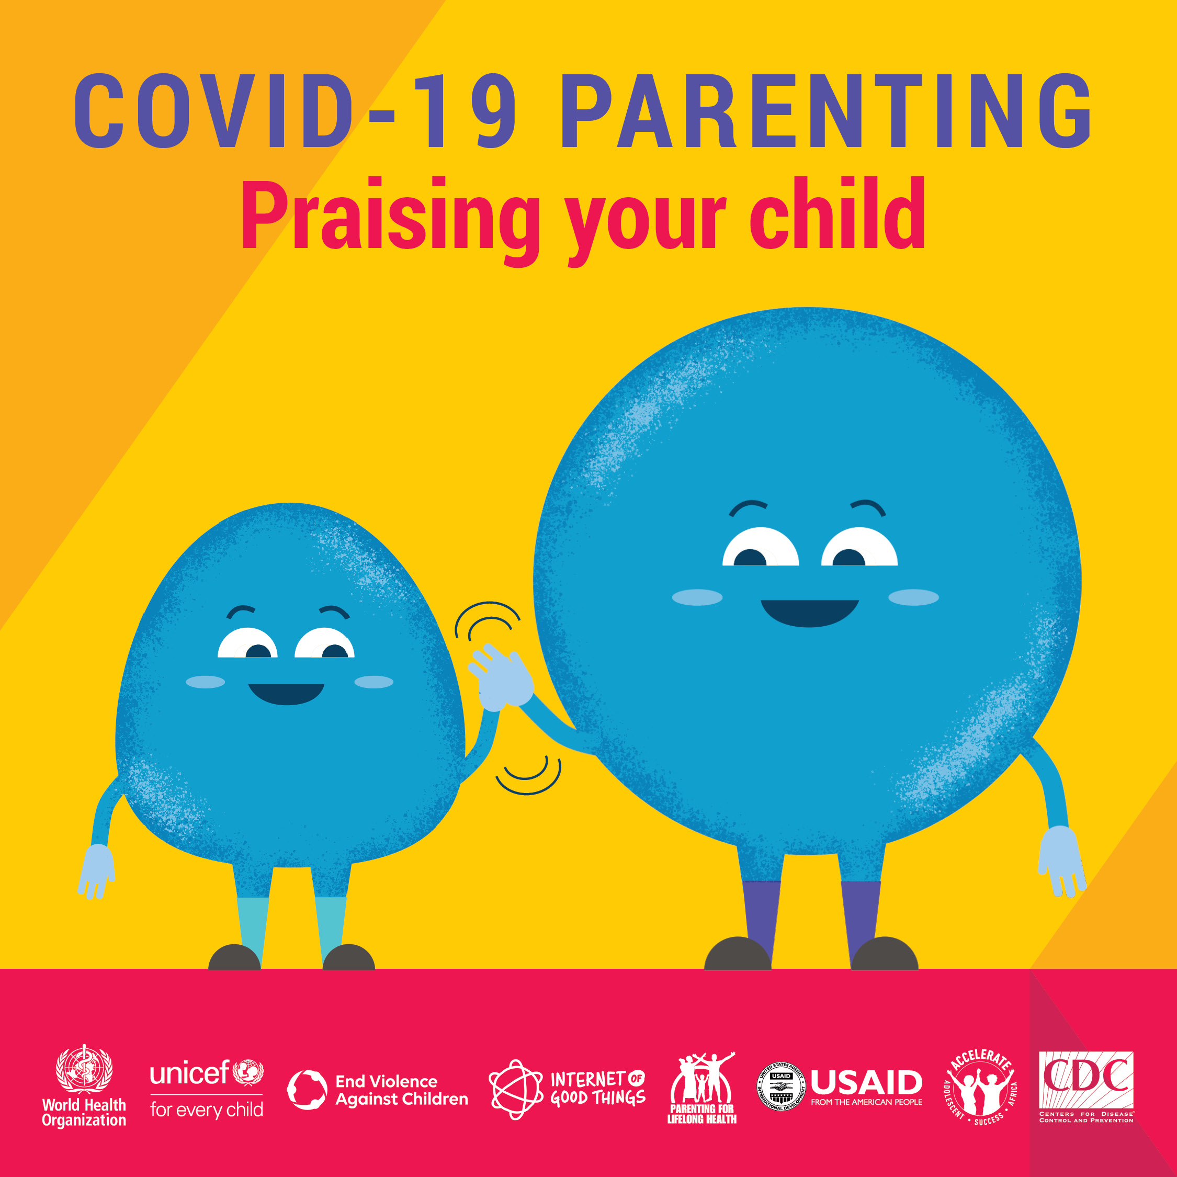 | PRAISE is a powerful tool. Notice good behaviour and PRAISE IT! Kids playing together without fighting? Being quiet when you are on the phone? Surprise them by praising them for their good behaviour and they’ll do it more! It’s effective parenting.  Useful resources: bit.ly/COVID19parenting  #COVID19PARENTING @WHO @UNICEF @USAID @CDCgov @ParentingLH @GPtoEndViolence #COVID19 #Coronavirus @accelerate_hub
 | Kids at home driving you crazy? Feeling like you are going to scream? Give yourself a 1-minute pause. Breathe in and out five times. Then respond. Millions of parents say this helps – a lot!  Useful resources: bit.ly/COVID19parenting  #COVID19PARENTING @WHO @UNICEF @USAID @CDCgov @ParentingLH @GPtoEndViolence #COVID19 #Coronavirus @accelerate_hub
 | You deserve praise. Looking after kids 24-7 during COVID-19 isn’t easy. Remind yourself of what you did well today. Think about the good moments. You are a star.  Useful resources: bit.ly/COVID19parenting  #COVID19PARENTING @WHO @UNICEF @USAID @CDCgov @ParentingLH @GPtoEndViolence #COVID19 #Coronavirus @accelerate_hub
 | Crowded house? Stressed out? Share your feelings. Take a break. Do something for yourself. Take care of yourself so you can take care of your children. You can do it!  Useful resources: bit.ly/COVID19parenting  #COVID19PARENTING @WHO @UNICEF @USAID @CDCgov @ParentingLH @GPtoEndViolence #COVID19 #Coronavirus @accelerate_hub
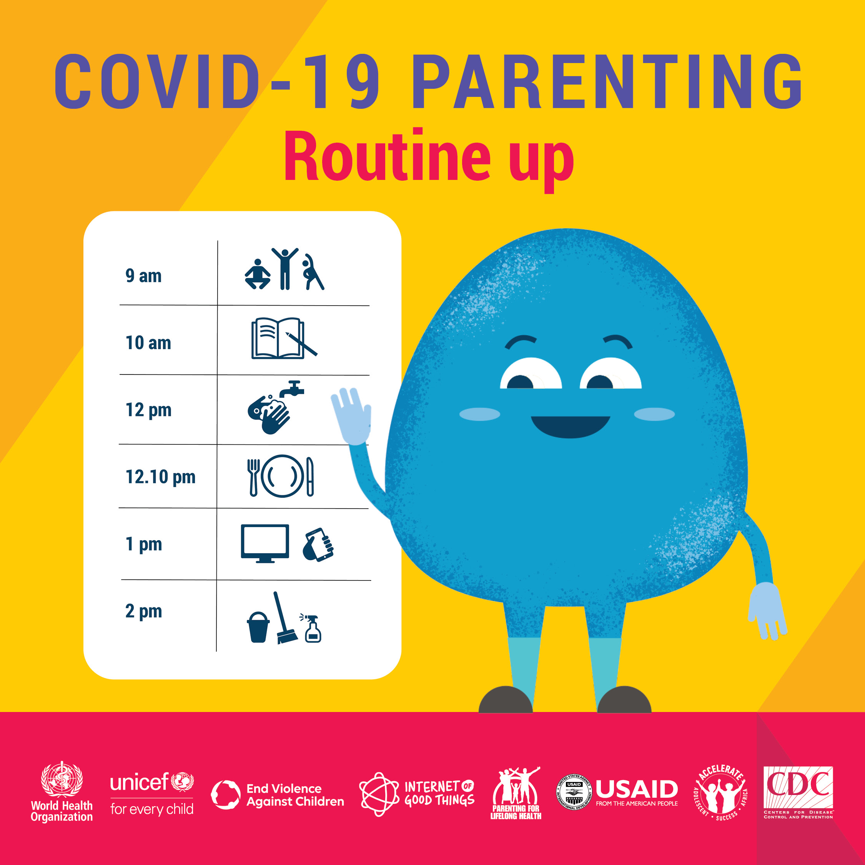 | Routine up! A structured day helps kids feel secure and makes it easier to manage them. Try making a timetable, with schoolwork, games, free time, exercise, and handwashing. Take charge of your days.  Useful resources: bit.ly/COVID19parenting  #COVID19PARENTING @WHO @UNICEF @USAID @CDCgov @ParentingLH @GPtoEndViolence #COVID19 #Coronavirus @accelerate_hub

