How to create a Ballet Bun
Hair: For dance exams, shows and festivals, students will sometimes wear their hair in a neat and tidy classical bun or pinned up so hair does not obscure the neckline or get in the students' eyes. The ballet bun keeps hair from flying in a dancer's face; it also creates a clean, elegant line for the dancer. Follow these steps to make the perfect bun:
Materials List
– Hairspray or hair gel
– Kirby grips (Thicker type with plastic tips.)
– Bobby pins
– Elastic band (same colour as hair)
– Comb & brush (Fine tooth comb preferable)
– Hair / bun net (Fine net with elastic edges. Should be same colour as hair.)
1. To start the process, wet your hands and the hair with water. This will give you better control over the hair. Gather the hair and pull it back. Apply hair gel if you need more control over the hair. | 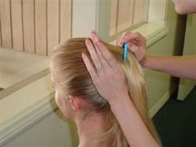
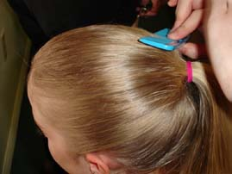 | 2. Use a hair brush to smooth out rough or uneven areas. Form a pony tail by brushing the hair up from the jaw line to the top part of the back of the head. This will form a high bun. The placement of the pony tail determines the placement of the bun. Mid and low buns are sometimes used and are good for short hair. Very short hair can use hair clips to fasten the hair down without a bun.
3. Use an elastic hair band to secure the pony tail. A tidy pony tail with hair drawn snugly back is the key to making a good ballet bun. | 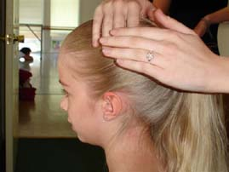
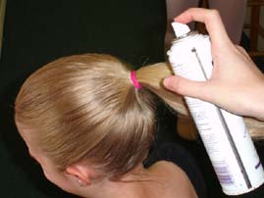 | 4. Apply more water, hairspray or gel to keep the hair neat, and twist the pony tail.
5. Coil the pony tail into a tight circle. | 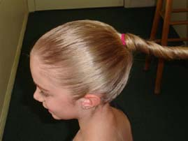
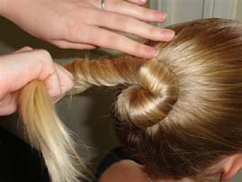 | 6. Use hair pins all around the coil to secure it to the rest of the hair. Slide each pin through the outer part of the coil, then into the base of the bun.
7. Wrap a fine hair net around the bun. Keep twisting and wrapping so that the hair net tightly secures the bun. Add a few more pins. | 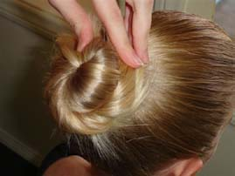
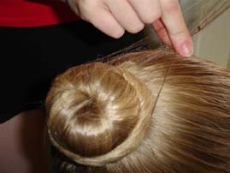 | 8. With long thick hair, you may end up with a bun that will protrude too much. A flatter bun is preferable. To flatten, remove all pins; the hair net will hold the bun. Then flatten the bun and re-pin all around the bun.
9. For extra hold, when the bun and hair are all secure, use hairspray. | 