February 2019 Valentine’s Day Edition

February is a very special month! School vacations, Presidents Day, some very special birthdays (Tom Brown, Kevin Furlong and Kara Waldron) and of course,Valentines Day. Valentines Day reminds us of the people and things we love and appreciate: for the Mary Jo Brown Foundation that means our supporters! Our Valentine’s Day Herobox shipment was really special thanks to the donations and kindness of the following:

Lauren and Michael Snedaker, Ed Gately and Amy Marino who collected lots of snacks and supplies for us to include in our shipment.
Haverhill MA Girl Scout Adria Gregoire (and her mom Danielle) for donating boxes of “Thanks A Lot” Girl Scout cookies. The perfect cookie to show appreciation!
AND a special thank you to the children in Ms. Berna’s 3 class of 3 year-old students at the Moody Preschool in Haverhill for providing artwork and thank you messages to our troops.

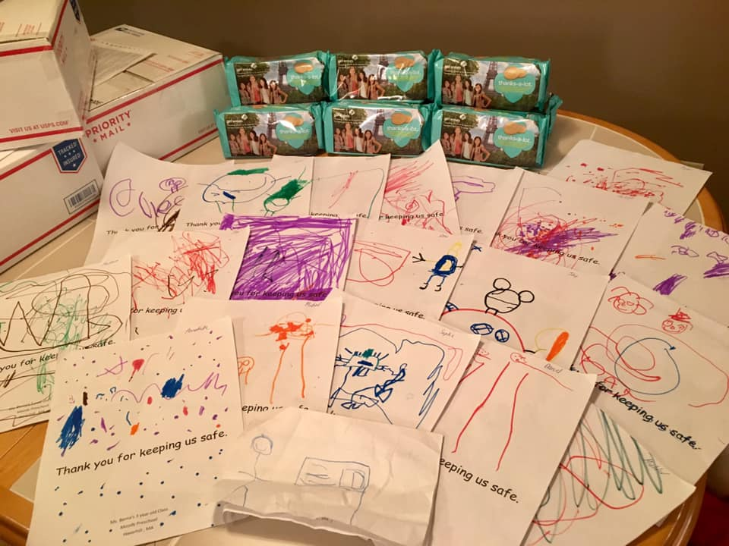

We also love seeing our 2018 Kindness Campaign Honorees being recognized by others!!
Our 2018 Grand Prize Winner Hannah Finn (One Wish Project) was honored in January at a pregame ceremony by the Boston Celtics as part of their “Heroes Among Us” program https://twitter.com/celtics/status/1086660759789162496
Hannah was also interviewed by Erika Tarantal of WCVB Channel 5 on February 7th in a Five for Good segment: https://www.wcvb.com/article/5-for-good-andover-high-school-student-bakes-birthday-cakes-for-kids-in-shelters/26236038?fbclid=IwAR2AjGxxPSb-ve--mnoaUjQUb7Nf_PbwzA-5beXOG3Hw08EqKVlCEHVwL7Q
We are also very proud of 2018 Kindness Campaign Honoree Meredith Casey (The Mighty Meredith Project) who was once again featured on the February 1st WCVB 5 for Good for ANOTHER visit to Floating Hospital for Children at Tufts Medical Center...delivering 1000 gifts and gift cards for pediatric patients. To quote Maria Stephanous "that's not 5 for good...that's 5 for GREAT!" Indeed it is. Meredith you ARE mighty!
https://www.wcvb.com/…/5-for-good-mighty-meredith-…/26115346

SPRING IS COMING AND SO ARE TWO IMPORTANT DATES!

Wine Tasting Fundraiser May 19th 1pm to 3pm Total Wines Everett, MA
$25 per person Note: Space is limited to the first 40 people who respond

Join us for our 2nd annual spring wine tasting! This year we have chosen “Tour de France”! Travel with us through the most famous French appellations. We will be tasting Grand Cru Champagne before sampling two stunning and food-friendly whites from the Loire Valley and Provence—followed by FIVE elegant reds! Light snacks will be served—and we will be giving out some lovely door prizes from William Sonoma and KEEP collective jewelry. We love spending time with our supporters and the luau never seems to be long enough to visit. So please consider joining us for a more laid-back and social event.

Method of payment: check, payable to "Mary Jo Brown Foundation" and mailed to Christina Brown 34 Concord Street, Wilmington, MA 01887. Spot is guaranteed with payment. She will also take payment via Venmo for anyone that has it and wishes to use it.

Textile Drive and Collection
Once again we are partnering with the Epilepsy Foundation of New England. We will collect clothing, linens, household textiles, shoes, etc. in 13 gallon kitchen-size trash bags. Last day to donate those items from your spring cleaning to our 4th Annual Spring Textile Drive is also May 19th. You need not wait until May if your items are good to go! Whenever your bags are ready for drop off or pick up please contact Christina at: christina@maryjobrown.org. If you are attending the Wine Tasting you might consider bringing your donations that day to hand off to us.

That about wraps it up for now. We hope to see you at Total Wines on May 19th! Remember: attendance is limited to 40 people (including our board members) and we will not be collecting on the day of the event. Seats will be secured only with payment.

Stay happy—stay healthy—keep smiling—and, as always:

May All Your Dreams Come True!

