“We’ve singing and dancing for hours at least…”

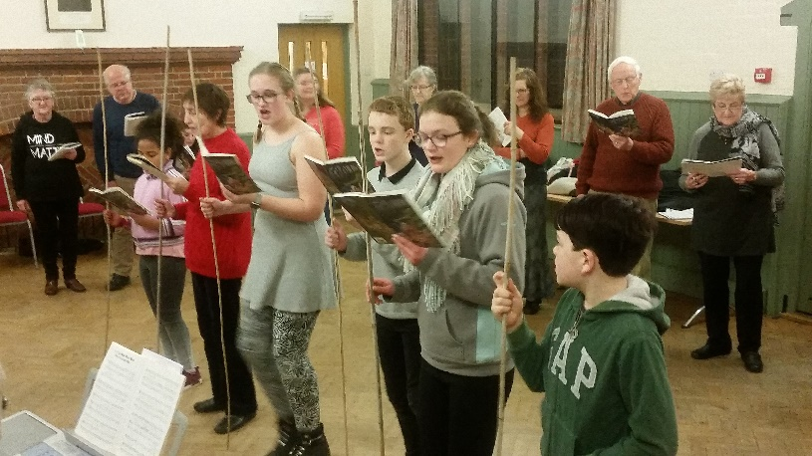
There’s a lot to enjoy about Peter Skellern’s “Trolls”, the final production of our 50th season. The story is an adventure of good versus evil and love conquering all, the Players are out in force, and the songs are absolutely fantastic. Rehearsals are now well underway, and the show is definitely starting to take shape!

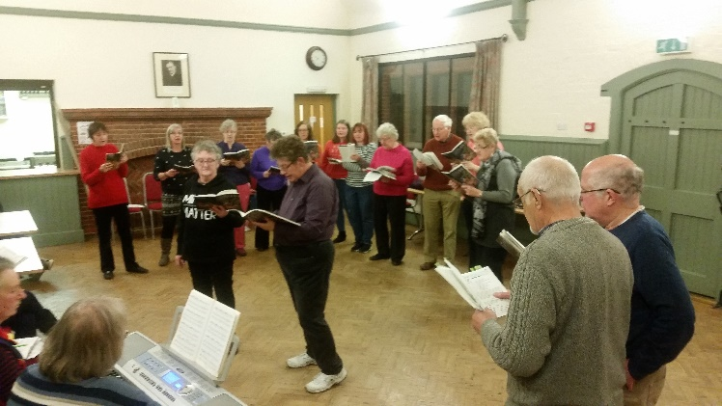
From the lively opening number to the softer ballads, the songs are simple but have a lot of character, helping to bring the world the Trolls inhabit to life. To help cement the songs as the true star of the show, we have been joined by the fantastic Pam the pianist. There is something about the music being played live that helps capture the mood of the moment in a way that a backing track can’t. The pianist and singers can work from each other, slowing a piece if needed, giving it a bit more bounce at times, and responding to what’s happening on stage. Slightly slow cue line? No problem. Applause coming mid-song? No problem. Singer forgotten the words? Well, that’s still a bit of a problem to be honest…

The music being played live adds to the challenges for Phil our fabulous sound man. He spends hours sitting at the back of the hall in the dark, flawlessly making sounds happen at the right moment. And as I don’t understand how he makes it all happen, it’s over to him to explain what he does…

“Hi I'm Phil the sound man
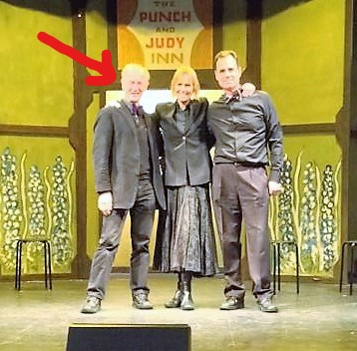
I joined the players a few years ago, after having moved to Winslow, gone along to a couple of shows, and been very impressed with how good the company was. Having spent my working life as a TV cameraman I was very familiar with all that went into rehearsing something to produce the best possible results at the performance.

It was obvious at that time the facilities available were excellent, with the exception of the sound which was practically non-existent. I made a comment to a friend who was a member of the society, who said “I'm sure we could use a sound man, why don't you join us”... the rest is history as they say. With little previous sound experience but a good understanding of what is possible I have set about bringing the Players capabilities up to scratch. I am fortunate in that many of my former colleagues were sound men so I have no problem with getting advice. Each production brings a different set of challenges, some have many sound effects. Not just the obvious ones, of say a car driving up before someone arrives on stage, but more lengthy atmospheric sounds, of say birdsong to suggest a summer day.

I have also been able to bring the capability to project video as part of our recent productions of “Oh What a lovely War” and “Don't you know there's a War on”. On both occasions, projections were used to inform or remind the audience of just what the war experience was like.

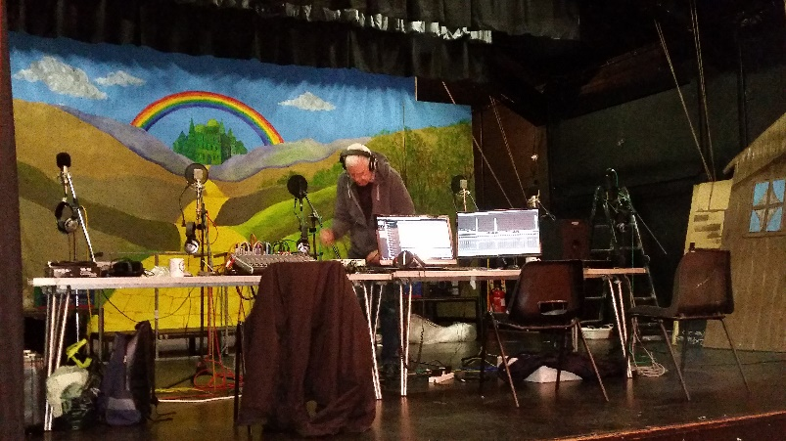
Typically I go along to rehearsals until I have a good idea of what is needed, and then disappear for a while to find the sounds that suit. Sometimes there is nothing available and I end up assembling the sound effect from suitable noises or homemade recordings. Rats were needed for one production, which resulted in the cast taking it in turns to make suitable noises. I then return and start playing them, partly to help the actors get used to them, but also to see if it is suitable and of the correct length.

The final part of the jigsaw is to assemble them in the correct order on a laptop, or often two, ready to play in on the day. Frequently two computers are needed at the same time if the effects overlap each other. These effects are usually tied very tightly to the action and require plenty of concentration to cue them at the correct time, so diligent following of the script is needed. It's all too easy to let the mind wander and miss a cue. It may not be noticed, or in the worst case might leave the actors standing wondering quite how to continue without the cue in to something they have been used to.

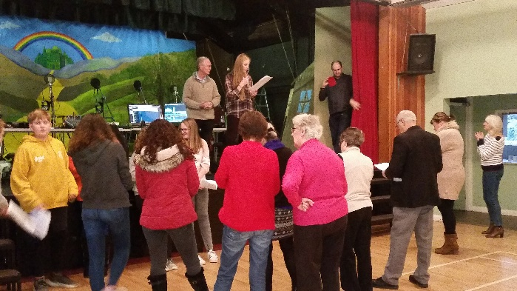
The recent pantomime had a great many songs from large chorus numbers to duets and solo items. It is very difficult to get good sound from the stage particularly when the singers are moving around or dancing, so these days I often pre-record, particularly the chorus numbers. This is done as a multi-track recording, when every singer is recorded individually and then mixed together afterwards. This will only work with a pre-recorded backing track, as each group of eight singers needs exactly the same backing to sing along to. Everyone on stage still sings live, but the overall sound is better for the audience. Solos for the panto were recorded as a backup in case of loss of voice on the day; handy to have as it means the audience don’t miss out on a performance, even when winter bugs are doing the rounds! The downside for me is that it is a very time consuming job, but worth it.

The forthcoming production, Trolls, was written by Peter Skellern, who was an excellent pianist. We are making a special effort for this production and I have the assistance of some of my former colleagues who will make a video, and a former sound man who will mix the sound for it. The sound will all be captured live with piano accompaniment. I will continue as usual to mix the sound for the audience in the hall.”

