S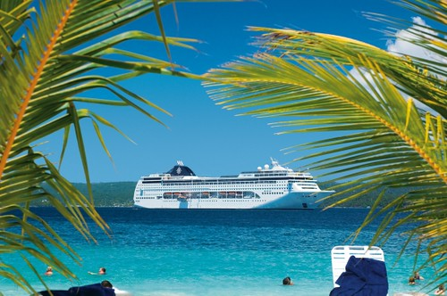

**“NO FREEZIN, JUST BREEZIN”**

**WITH**

**DAVRON TOURS**

**ON THE ROYAL CARIBBEAN’S**

**ANTHEM OF THE SEAS**

Departing from Cape Liberty, New Jersey

January 5, 2020 for 11 nights at sea, returning January 16,2020

Ports of Call: Cape Liberty, New Jersey, San Juan, Puerto Rico, Phillipsburg, Saint Martin, Saint Johns, Antigua, Castries, Saint Lucia, Saint Kitts and Nevus

Fares PP From(based on double occupacy)

Inside Ocean View Balcony Suite

**$1,128** **$1230** **$1460** $2879

It is now after final payment date and ayment must be made in full at the time of booking

***For more information and to book call Davron Tours 973-900-2245***