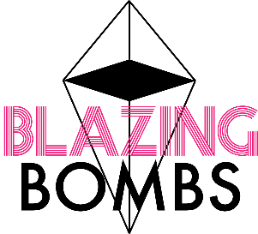
Custom Order Form
Submit this form to: blazingbombs@outlook.com
Please be aware that all custom orders must be submitted no later than 2-3 weeks before expected/desired pick-up time. If your custom order is cold processed soap, this form must be submitted minimum 4 weeks in advance as this product requires a 2-3 week (minimum) curing time prior to packaging.
Name:_________________________________________________
Date Submitted:_________________________________________
Date of your Event:_______________________________________
Requested Date for Order Pick Up:___________________________
Circle the following product:
Mini Bath Bombs (1.5oz) | Medium Bath Bombs (5oz) | Large Bath Bombs (7oz) | Gender Reveal Bomb
Glycerin Soap (2.5oz) | Cold Processed Soap (2.5oz) | Quote Soap (5oz) | (Only required to fill out the above information of this form)

Quantity: _____________
Refer to pamphlet and/or website for the above product specifications before completing the following chart below:
Design # | (One) Design Option | (One) Fragrance | Colour #1 | Colour #2 | Colour #3  (Applies to Glycerin Soap Only)
1
2
3
4
5
6
7
8
9
10

Example: Mini Bath Bombs – Quantity 40 (40x $1.60 each) Limitations (on site or pamphlet) “1-2 Fragrances & 1-2 Designs”
Design # | (One) Design Option | (One) Fragrance | Colour #1 | Colour #2 | Colour #3  (Applies to Glycerin Soap Only)
1 | Marbled | Bubblegum | Orange | White
2 | Solid | Cotton Candy | Blue

Custom Sticker (Your message):____________________________________________________________________
Theme Colours of your Event: _____________________________________________________________________
Celebration Type of your Event (ex. Baby Shower):_____________________________________________________

Custom Order Form

Font (Optional for you to choose)- use site: www.1001fonts.com and select your top 3. Write the name of the font below:
- _______________________________
- _______________________________
- _______________________________

Ribbon Colour Request: ______________________________________
Special Request*
(Please note special requests may result in an additional fee. Blazing Bombs will have this reflected on the completed invoice and inform you if your special request will affect the standard price of your order).

________________________________________________________________________________________________________________________________________________________________________________________________________________________________________________________________________________________________________________________

(Only if chosen)
Quote Soap Message: ___________________________________________________________________________

(Only if chosen)
Gender Reveal Colour: Pink or Blue

Thank you for supporting a local business and choosing a one of a kind party favor for your special occasion!

