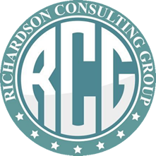
CAPABILITY STATEMENT

Out team delivers effective programs designed to maximize overall performance. These programs will help employees become rejuvenated and healthier becoming more productive and efficient. Programs will increase the morale and bring unity to the workplace.. These programs are designed for individuals and groups of all sizes..

=====================================================================

- Nutrition awareness
- Health awareness
- Financial Literacy
- Life Coaching
- Natural and Healthy Food preparation
- Reflexology and Acupuncture healing
- Organization Fundraising Program

NAICS CODES:
42 - Wholesale Trade 42,45 Retail Trade 54 - Professional Services
61 - Educational Services 62 -Healthcare 82 - Other Services

Business Classification: Small, Minority, Disadvantaged, Veteran Owned.

