“And sing and be jolly and merry and bright…”

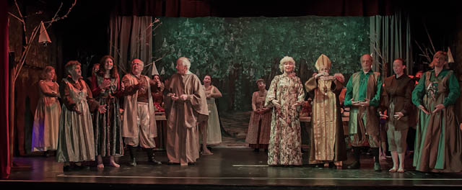Trolls rehearsals are going well as May draws closer. The fabulous army are being put through their paces as they assemble and go off to fight the bad guy. The villagers are fantastic, and the wonderful array of facial expressions on display during “Woodland Creatures” makes it a real shame that none of them will be visible from the audience. Song words are still a slight challenge, and the next job is putting the action and the songs together so that they become seamless before we get on stage. This is the point at which the technical team really start to get busy. Having had the views of Phil on sound, now it’s Owen, our lighting man.
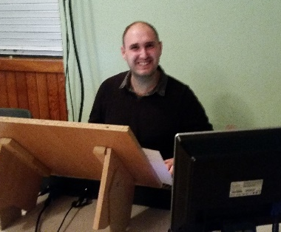
“When I first became involved with the Players, and experienced the warm welcome and the friendliness of everyone in the society, I just thought that this would be something that I’d love to do and get involved in. I am quite shy but being part of Players has boosted my confidence and now I like to think that you can’t stop me talking. I have made so many close friends since I started. I get a very sad feeling when each production is over but then the rehearsals start for the next one and the excited feeling comes back every time.

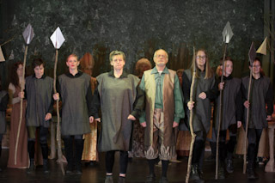
My favourite part about being involved in the Players is the huge fun and laughter we have at rehearsals and the performances. Also every time we meet up it feels like being part of one huge family which I love. They are a fab bunch of people. I am relatively new but I have learned so much. Since joining, I think the most interesting thing that I have done is actually being in a production of Aladdin. People who know me knows I can’t act plus I don't like being on stage that much hence why I really enjoy doing lighting where people can see your work instead. It was a good experience but I don't think I would do it again in a hurry.

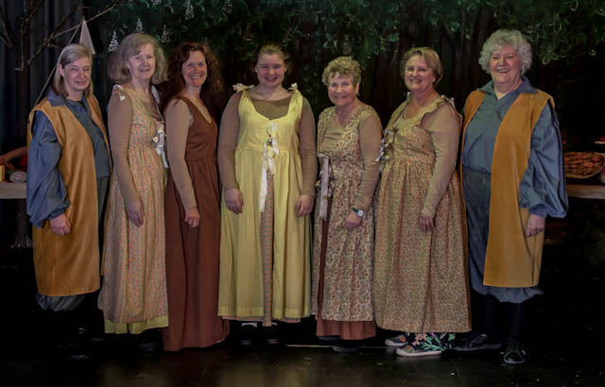
During performances, the buzz is huge! But I also quite nervous as getting things in the right place at the right time is very important and you don't want to miss or be late for cues. Sometimes I don’t have enough hands, especially when changing lighting banks and faders at the same time. But despite its challenges it doesn't put me off. I love it as sound and lighting go together; we support each other as well as having a laugh.

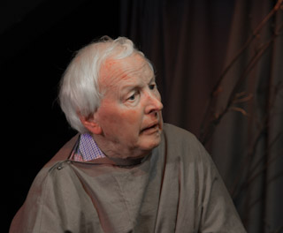
My biggest job between now and May is to re-adjust the lights and beams and to check all the programming and timings are set up property and work in time with the script. This also involves the sound as in most productions we work together. When I heard we were doing Trolls I was so excited as I love the musical. The music is awesome and the script is fab. We have got an excellent cast and the rehearsals are making everyone laugh - I can’t wait till the performances in May.

All in all I absolutely love being a part of this fab group and I look forward to many more years with them.”

Photographer and copyright-holder for cast photos; Brian Hubbard.

