November 2019 – Toddlers

Monday | Tuesday | Wednesday | Thursday | Friday
1

Bounce House
4  Letter Craft | 5  Number Craft | 6  Pizza Art | 7  Jello Sensory | 8  Decorate Cookies
11  Wear Yellow Day | 12  Sorting Activity | 13  My Christmas List | 14  Bubble Day | 15  Color Santa a Picture
18  Letter Craft | 19  Math Activity | 20  Wear Brown Day | 21  Thanksgiving Songs and Finger Plays | 22  Chalk Art
25  Shape Craft | 26  Turkey Sticker Sort | 27  Turkey Craft | 28 | 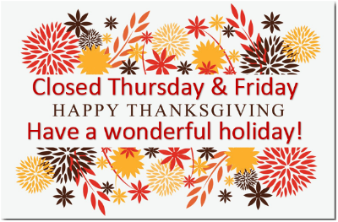  29

Focuses: Themes:
Letters: Jj, Kk, Ll Cooking and Baking
Number: 6 & 7 My Christmas List
Color: Yellow & Brown Letter to Santa Shape: Triangle What I’m Thankful For
Thanksgiving

