Nutrition Plus, Inc.
Emily Roark Patti Brenn Susan Morrell
(620) 221-2777 (620) 218-1811 (785) 230-7441
roark2@cox.net pattibrenn@cox.net smorrell12@gmail.com
www.nutritionplusinc.com
August is:
National Catfish Month
National Goat Cheese Month
National Panini Month
National Peach Month
National Sandwich Month

New phone numbers
Patti – (620) 218-1811
Susan – (785) 230-7441
These are dedicated Nutrition Plus lines for you to call or text on! Please update in your contacts.
Important dates:
August 28th – Checks/direct deposits go out

Training Updates
ASAP - Topeka Area & Winfield Area Workshops

We are considering turning these into Zoom meetings. We still have Infant Feeding training information and materials you need, so this is taking some thought on how to distribute it to each individual first. Thanks for your patience. The online options for the KSDE classes remain an option to do at your leisure.

https://learning.ksde.org/course/index.php?categoryid=32
or
https://theicn.docebosaas.com/learn

Please speak to Emily before taking a class through another site or agency. These two sources have approved trainings for the food program. Other training sites may not be approved by KSDE, and won’t count toward your 2 required hours.
August 2020

2021 Calendars are on their way!!!

They’re ordered, payed for, and have been shipped to Emily’s office! Aren’t they cute?!? We will hopefully start distributing in September. Fingers crossed!

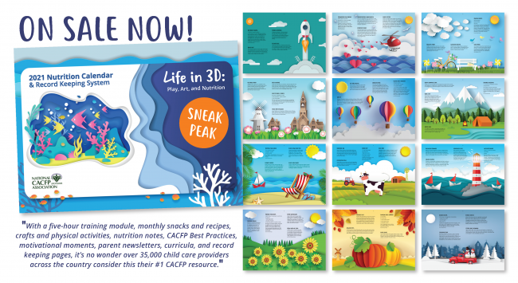

New forms and tools

We have 3 ring binders, recipes, cheat sheets (for whole grains and yogurts), product formulation statements, Infant Feeding Guides, Crediting Foods Guides, as well as the yearly forms, all to get to you. We are planning on camping out somewhere and letting providers come pick theirs up. For those unable to get out and get them, we will drop-off since the packs are too large to mail. Stay tuned for days and times to pick-up of your new goodies!
Social Distancing Games

Bust a rhyme!
How to play: Ideal for more than five players, start by having all participants stand in a circle 6 feet apart. Next, choose a leader to say a word (like "cat"), then have the child to their right say a word that rhymes with it. Continue around the circle until it gets back to the leader! The next person is the leader and the game continues. If someone gets a word wrong, can't think of something or says something not in the dictionary (hey, it happens!) then all participants do five squats.

Show me your moves!
How to play: Players line up at the start. Stand 6 feet away from each other.
Players listen to the leader. The leader will demonstrate designated moves.
The leader will call out a movement (walk, hop, shimmy, etc.), and players will do that movement to the finish line, then back to the starting line. Players must pay attention! The leader can change up the movement as you’re moving.
If a player misses a movement, he or she will do five jumping jacks or 5 seconds of silly dancing!

Memory making!
How to play: Players line up standing 6 feet apart from one another.
Players will be doing a lot of moving, but they must stay in their spot.
The leader says, "I have been on a many different adventures recently, (mountain climbing, jungle adventures, swimming in the ocean…) but I forgot my camera on every one! I need you to help me recreate some of my favorite moments so I can have some photos. I am going to describe some of my memories, and I need you to try and recreate them in 30 seconds using only your body and your imagination,"
The player who demonstrates moves closest to the leader's memory wins! All other players will do five jumping jacks.
Baked Eggplant Sticks
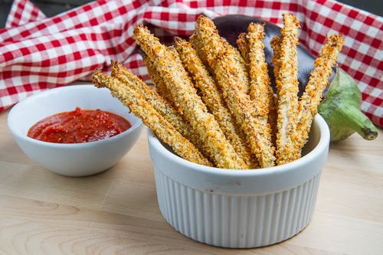

Ingredients:

- 10 ounce Eggplant
- 1/2 cup Italian seasoned breadcrumbs
- 2 tablespoons Parmesan cheese, grated
- 2 large egg whites, whipped

Directions:

- Cut off the eggplant ends and cut in half lengthwise.
- Cut 1/4 inch slices and then from those, cut 1/4 inch sticks.
- Mix breadcrumbs and cheese in a bowl.
- In another, whip the egg whites.
- Dip the eggplant sticks into the egg whites and then roll in the breadcrumb mixture.
- Lay on large baking sheet lined with parchment paper and bake in 450 degree oven for 10 minutes.
- Turn over and bake another 5 minutes.
Makes 32 sticks. Six sticks equal 1/2 cup baked eggplant. Snack Crediting: 5 Servings for ages 3-5

I love these so hopefully some of you will too! They are a neat way to get the kiddos to try something new and maybe get them excited about new foods!

Stay strong. We’ll get through this together.
As always, we are proud of what you are doing for our children. Thank you. Emily, Patti & Susan

