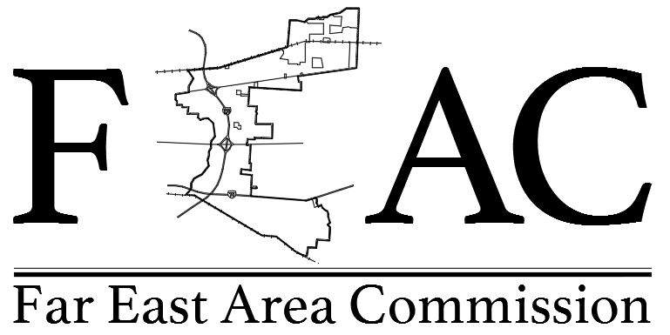

Meeting Minutes Tuesday, November 6, 2018

- Call to Order by Commissioner Chair Chamberlain at 6:45 pm
- Pledge of Allegiance
- Introduction of Commissioners: All Commissioners were in attendance except for Vice Chair Abner, Commissioner Hutsko, and Commissioner Watson.
- Approval of Minutes moved at recommendation of Chair Chamberlain for next meeting

2. Zoning & Variance Agenda:
a. BZA 18-111 Lindsey Collision Ctr- 5782 Chantry Drive Rooftop Screening Variance; Aesthetics Full Service Center. Motion approved unanimously.
b. Mt. Carmel – Pete Williams presented Zoning # BZA-GC-18-041 Motion approved unanimously.
c. 7077 Americana Parkway – Richard Sicker presented on setback variance Commissioner Eddy abstained. Motion approved.

- Tom Slack from ODOT Far East Freeway Project presented follow-up to take place on updates prior to spring of 2019
- No Secretary Update
- Zoning Update: Commissioner Marshall advised of demolition permit for Landscape Garden 2055 Brice Road.

Commission Business: Finance Update, Approval of 09/04/2018 meeting minutes to be given at 12/04/2018 meeting due to time constraints.

- No Community Update from Lynne LaCour as she was not present. Officer Poole presented new alarm rates for city.
- Commissioner Eddy requested Parliamentarian role be considered at next meeting as topic of discussion.
- Adjournment: Chair Chamberlain motioned to adjourn meeting and move above items to 12/04/2018 agenda. Meeting adjourned 9:15 p.m.

Next Special Meeting: Tuesday, December 4, 2018

