Early Childhood Development Center Kaleidoscope

Summer Program PARENT HANDBOOK
For families with children born in 2013 -2016

Summer 2018

Dear Summer Program Families:

Welcome to the Summer Program with Early Childhood Development Center Kaleidoscope!
We are delighted to serve you this summer, and are sure you will enjoy the activities we have planned.
This handbook contains important information regarding the program; please read it thoroughly.

Summer Program runs Monday through Friday, June 25th through August 24th.

Regular hours are 8:00am to 4:00pm.

Extended hours are 4:00 pm – 6:00 pm

Summer Program Schedule and Fees

Early Bird Fees are applied if you register and pay in full for the program by Friday, March 30, 2018.

Regular Fees will apply if you register and pay in full Monday, April 2 – Friday May 18.

Late Registration Fees will apply if you register and pay in full on or after Monday, May 21.

The week of July 2 fees are: Early Bird - $160; Regular - $240; Late - $280.

Second siblings are eligible to receive a 10% discount with the first sibling being paid in full.

 | Hours | Early Bird Fees | Regular Fees | Late Registration Fees
Regular Day for a full week | 8:00 am. – 4:00 pm | $200/week | $300/week | $350/week
Regular Day for 1-4 days/week | 8:00 am – 4:00 pm | $45/day | $55/day | $65/day
Afternoon Playgroup for 5 days/week | 4:00 pm – 6:00 pm | $96/week | $108/week | $108/week
Afternoon Playgroup for 1-4 days/week | 4:00 pm – 6:00 pm | $19/day | $21/day | $21/day

We look forward to seeing you this summer!

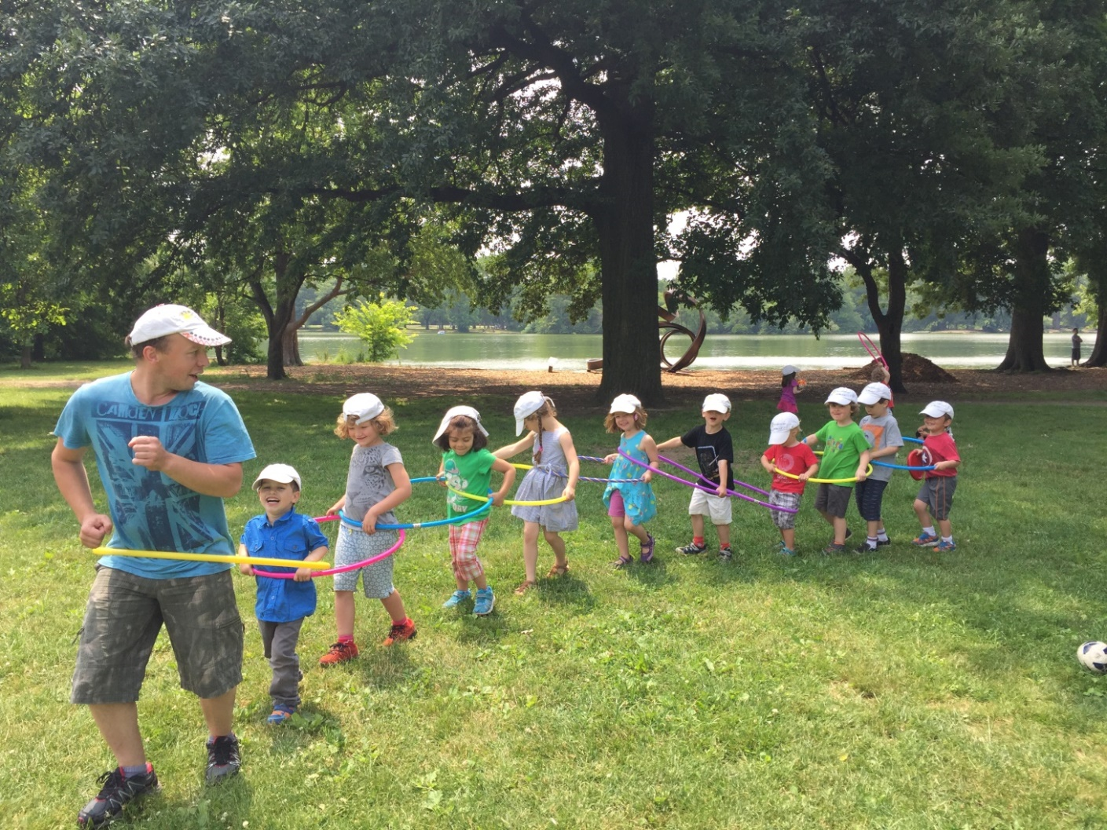
Summer Program Highlights

The summer 2018 program is created and designed for hands-on exploration and fun. The students engage in exploratory activities which promote positive preschool experiences and encourage learning. The program is carefully planned with a variety of activities including arts and crafts, music and creative movement, sports, non-swimming water activities, organized games, and trips for children born in 2013 and 2014.
Summer Program Theme: From Farm to Table

Through fun hands-on activities, students will learn how food gets to our tables. As we study agriculture, we will plant, grow, harvest, prepare and eat grains and vegetables, make real butter, hatch chicken eggs, and much more.

In addition to visiting Prospect Park, older children will participate in taking field trips to:
- Queens County Farm Museum
- Green Meadows Farm
- Prospect Park Zoo
- Brooklyn Botanical Garden
- Chocolate factory
- “Two Boots” Pizzeria.
Early Childhood Development Center Kaleidoscope provides daily breakfasts, lunches and afternoon snacks.
Children do not have to attend Kaleidoscope Preschool in order to sign up for the Summer Program.

Staffing

Each group is led by our full time staff: one teacher and one assistant. All staff have completed a screening process that meets the requirements set forth by the Department of Health and Mental Hygiene.

The program and staff are supervised by Oksana Grebenyuk, Executive and Education Director and Pavlo Bouniatian, Director Assistant.

DROP-OFF & PICK-UP PROCEDURES

In the interest of safety for all campers, parents are asked to escort their child(ren) to and from the assigned rooms to sign their child(ren) in and out of camp.

We strongly encourage you to drop-off no later than 9:00am. Once the day’s activities have begun, older campers (born in 2013 and 2014) and staff maybe located throughout Prospect Park and may not be available for sign-in.

Children may not be dropped off prior to 8:00am, and must be picked up no later than 6:00pm. A late pick-up fee of $5.00 per camper will be incurred at every five minute increment of your pick up time. Continued late pick-up may result in dismissal from the camp program without refund.

ABSENCES

Please notify the camp if your child will be absent by calling or texting 347-889-1848 or email ecdckaleidoscope@aol.com. If your child is absent due to a contagious condition, please notify the office, so that other parents can be notified that their child may have been exposed. Please consult with your physician before notifying us, so that we may give accurate information.

NOTE: There will be no fee reduction, make up, or reimbursement for absences.

What to bring to Kaleidoscope Summer Camp
Clothes
- Small Backpack
- Complete extra set of comfortable weather appropriate clothing - shorts, t-shirt, socks and underwear. Please, put them in a re-sealable plastic bag.
Swim Gear
Playing with water is a daily activity at camp. Your child will need:
- Bathing suit
- Towel
- Water Shoes
- Plastic bag - include a plastic bag for wet swimsuits and towels.
Other Necessities
- Refillable Water Bottle
- Sunglasses
- Sunscreen Spray. Please, apply before coming to camp and we will help your child apply it throughout the day.
- Hat
- Lip balm with SPF
- Bug Repellent
It's the little things...
- Label everything. Please make sure all items are clearly labeled with your child’s name. Neither ECDC Kaleidoscope nor its staff is responsible for lost, stolen or damaged property.
- Dress your child in sneakers or tennis shoes, and socks (we will walk and run a lot and would like to make sure children’s feet are protected accordingly). Please note that flip flops/ open toe and /or heel shoes are not permitted.
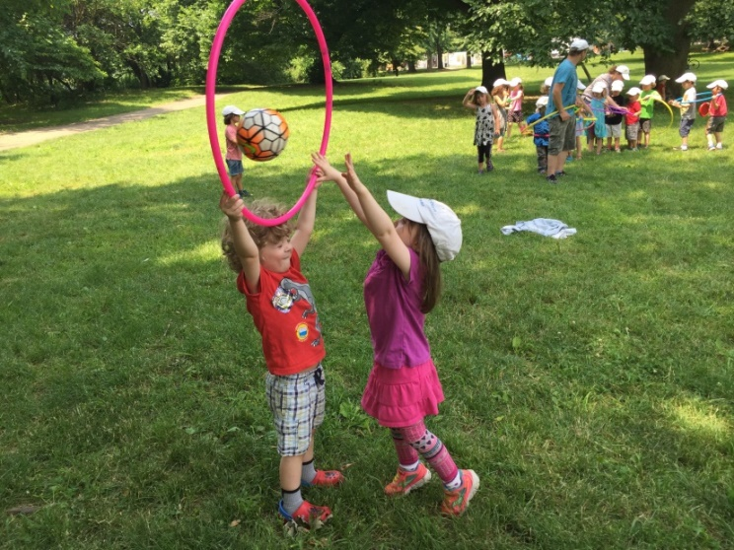
- Please apply sunscreen to your child daily before you bring your child in.
With this day camp packing list, both you and your child can relax and enjoy the different pace that summer brings.

What not to bring to Kaleidoscope Summer Camp

- Electronics
- iPods, cell phones
- Toy weapons, “bad guys,” and violent books (about “bad guys”)

If a child brings a prohibited item to camp, the item will be taken away and returned to his/her parent at the end of the day. These items are prohibited in order to eliminate any disruption or safety concern that may arise from their use.

BEHAVIOR/DISCIPLINE POLICY

Appropriate behavior is expected of all participants during the summer camp programs. Respectful interactions between program participants and staff are essential to having a successful program experience. Camp staff will do their best to redirect any misbehavior and resolve any issues to achieve a positive outcome for all involved. If positive outcomes cannot be achieved, or if a camper exhibits continuous disruptive or dangerous behavior, Kaleidoscope reserves the right to dismiss the camper from the program without refund.

MEDICAL INFORMATION

It is extremely important that we have all necessary medical information concerning your child. A current Health Examination Form stamped and signed by a licensed physician must be submitted by the first day of your child’s attendance (See Attachment 1).

The responsibility for administering medications rests with the camper’s parent or legal guardian. No camp staff is permitted to administer medication. It is important that all medication be taken at home. No medication is to be sent to camp unless it is a prescription drug for preventive reasons or emergency conditions such as seizures, heart conditions, asthma, or allergy conditions.

Written Instructions from the child’s doctor and parent consent is required for Kaleidoscope’s staff to administer EpiPen and Asthma Inhalers (See Attachment 3).

These preventive or emergency medications may be sent to camp if the rules listed below are followed:
- Note from the doctor stating name of medication, how it is to be given, amount, time and diagnosis of illness. The medication must be presented in the original package with prescription label attached.
- Note from parent or legal guardian giving approval for the medication to be administered by the camper under staff supervision.

Kaleidoscope’s staff may administer over-the-counter topical ointments, including sunscreen lotion and topically applied insect repellant, upon the written instructions of the parent (See Attachment 2). Such administration will be consistent with any directions for use noted on the original container, including but not limited to precautions related to age and special health conditions.

TRANSPORTATION AND FIELD TRIP INFORMATION

Transportation is available from/ to Park Slope, Windsor Terrace, and Kensington. To arrange a pick up and drop off, please e-mail Pasha at ecdckaleidoscope@aol.com.
All campers born in 2013 and 2014 are invited to participate in field trips, but participation is not mandatory. If your family chooses not to participate in a field trip, it is the responsibility of the parent to make alternate arrangements for the day. Reductions to the camp fee will not be granted due to absence from a field trip.

Field trips are scheduled to leave from the camp site at various times. Please be sure that your camper is on time for camp. This is very important on a scheduled field trip. We cannot delay departure to accommodate latecomers. Refer to the camp calendar for trip days.

For safety reasons, parents are not permitted to drop-off or pick-up their child from a field trip site. Campers should wear the camp cap on all field trips, and no spending money is needed.
Signed permission slips for transportation and field trips are required for a child to go on a trip (See Attachment 4 and 5).

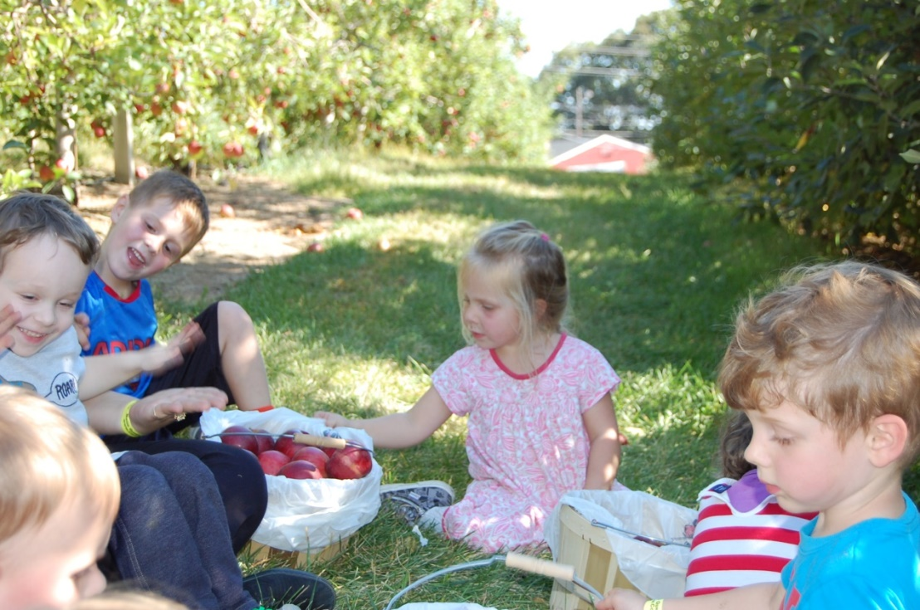

REFUND POLICY
No refunds will be issued for camp cancellations.
Daily Schedule for 2 and 3 year olds
(Children born in 2015 and 2016)
8:00 – 9:00 (60 min) Arrival/Outdoor Play Time (Water Table, Building Blocks, scarves, balls, hula hoops, tricycles, table activities, cloud watching, etc.)
9:00 – 9:05 (5 min) Transition from Outdoor Play (Children use the bathroom and wash their hands)
9:05 – 9:30 (25 min) Breakfast
9:30 – 9:45 (15 min) Fun Group Learning Games (math, science, literacy, social/emotional)
9:45 – 10:50 (65 min) Choice Time (children may choose to play in Dramatic Play, Block, Art, Sensory, Train Table, Math or Science, Literacy Centers)
10:50 – 11:20 (30 min) Enrichment Activity (Story Time, Art, Music and Movement)
11:20 – 12:00 (40 min) Lunch
12:00 – 2:00 (120 min) Rest
2:00 – 2:15 (15 min) Transition from Rest/Table Toys
2:15 – 2:30 (15 min) Snack
2:30 – 2:45 (15 min) Read Aloud
2:45 – 4:00 (75 min) Outdoor Play Time (Water Table, Building Blocks, scarves, balls, hula hoops, tricycles, table activities, cloud watching, etc.)
4:00 Regular Day Dismissal
Extended Day
4:00 – 4:30 (30 min) Music
4:30 – 4:45 (15 min) Snack
4:45 – 6:00 (75 min) Outdoor Play
6:00 Extended Day Dismissal
Daily Schedule for 4 and 5 year olds
(Children born in 2013 and 2014)
8:00 – 9:00 (60 min) Arrival/Choice Time (children may choose to play in Dramatic, Block, Literacy, Art, Sensory, Math or Science Centers)
9:00 – 9:15 (15 min) Fun Group Learning Games (math, science, literacy, social/emotional)
9:15 – 9:35 (20 min) Breakfast
9:35 – 9:40 (5 min) Transition to Outdoor Play/Informal Reading
9:40 – 11:40 (120 min) Prospect Park Play (Vanderbilt Playground, Lookout Hill, Peninsula, Wollman Rink, Breeze Hill, Lincoln Rd. Playground, Audubon Center)
11:40 – 12:00 (20 min) Transition and Read Aloud
12:00 – 12:30 (30 min) Lunch
12:30 – 1:30 (60 min) Quiet Time (children born in 2014 will have a nap; children born in 2013 will play quiet games)
1:30 – 1:45 (15 min) Transition/Table Toys
1:45 – 2:15 (30 min) Musical Theater
2:15 – 2:30 (15 min) Snack
2:30 – 3:45 (75 min) Outdoor Play (Water Table, Building Blocks, scarves, balls, hula hoops, tricycles, table activities, cloud watching, etc.)
3:45 – 4:00 (15 min) Read Aloud
4:00 Regular Day Dismissal/ Extended Day begins
Extended Day
4:00 – 4:30 (30 min) Music
4:30 – 4:45 (15 min) Snack
4:45 – 6:00 (75 min) Outdoor Play
6:00 Extended Day Dismissal

