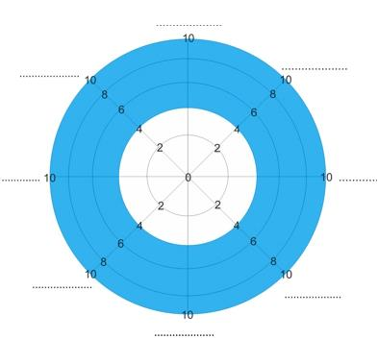

WHEEL OF LIFE INSTRUCTIONS
The 8 sections in the Wheel of Life represent the eight most important areas in your life to you, for example health or fitness, relationship with partner, spirituality, work, confidence, time spent with children and so forth. Label the eight sections individually.
Next, mark your level of satisfaction (or frustration etc) with each area out of 10 by shading in the section and then draw a straight or curved line to create a new outer edge (see example).
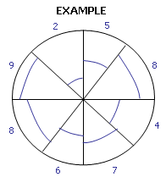
This creates a clear picture of what parts of your life you need to stop and re-evaluate.

