https://www.youtube.com/watch?v=Iou5LV9dRP0
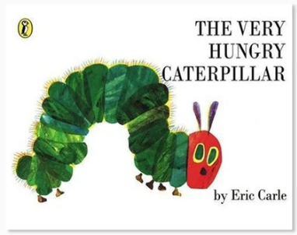

https://www.google.com/search?q=hungry+little+caterpillar&rlz=1C1GGGE_en-gbGB597GB597&oq=hungry+little+cate&aqs=chrome.0.0j46j69i57j0l5.6680j0j8&sourceid=chrome&ie=UTF-8

