

Vonzel’s

World of Art

*Putting the* ***FUN*** *back into* ***ART****!*

Memories of the Fair

*Ever since I was a child, I have had fond memories of going to the fair. One of my favorite things at the fair was the Spin Art booth. No matter how many times I visited the fair, I always looked forward to creating another one-of-a-kind piece of art work. It is truly a timeless activity.*

*I have been providing this same fun experience for those young and old alike for over twenty-five years. As in the memories of my youth, Spin Art continues to fascinate, excite, and amaze everyone who participates.*

***“Imagination is everything…”***

**~** [**Albert Einstein**](http://www.brainyquote.com/quotes/authors/a/albert_einstein.html)

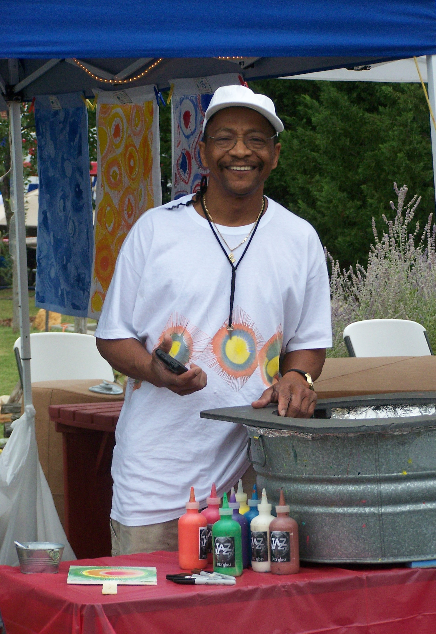

**Vonzel’s World of Art**

**4 Old Farm Lane**

**Greenville, SC 29605**

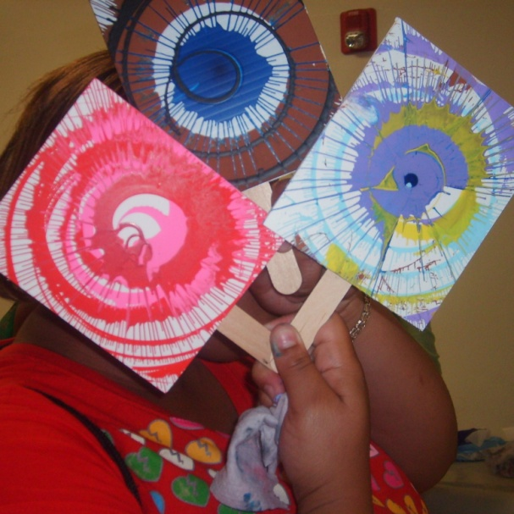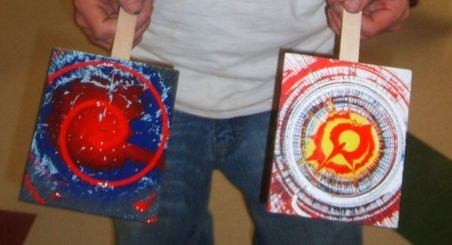

SPIN

ART

*~ Theodore Vonzel Mickens ~*

**(864) 320-2025**

**www.VonzelsWOA.com**

**Vonzel@VonzelsWOA.com**

***“Easy…Creative……Hands-On!”***

**“It’s just AWESOME!”**

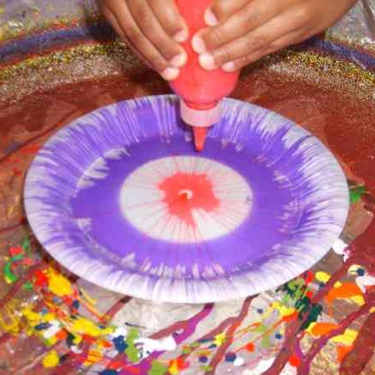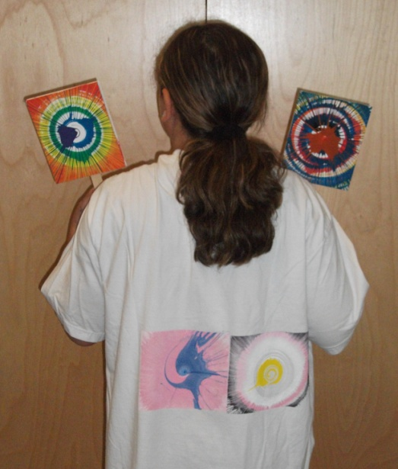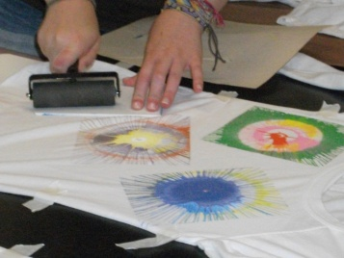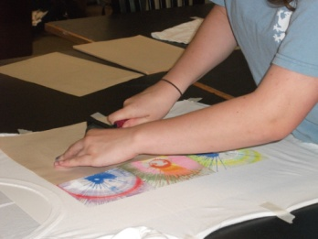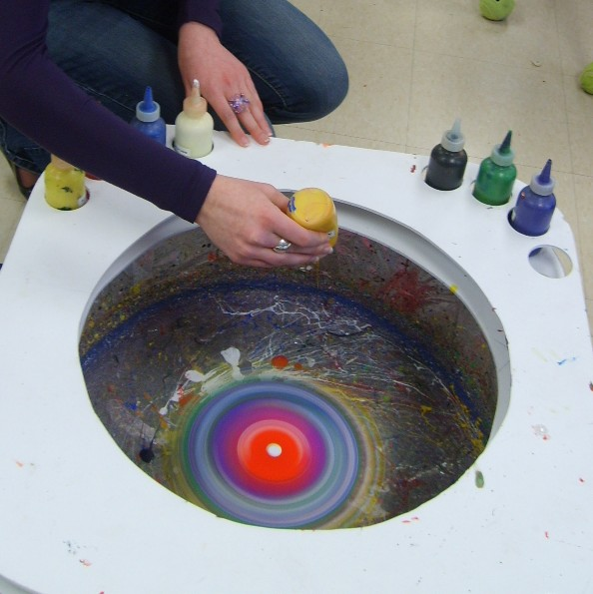

Add Spin Art to your next activity…

BIRTHDAY PARTIES

FAMILY/CLASS REUNIONS

FESTIVALS

SCHOOL EVENTS

AFTER-SCHOOL PROGRAMS

DAY CARE CENTERS

NURSING HOMES

COMMUNITY CENTERS

RELIGIOUS ORGANIZATIONS

BOY SCOUTS & GIRL SCOUTS

*No distance too far!*

*Ask me about*

*Leaf Blower Art, Marble Art, Printmaking, Custom T-Shirts and other FUN activities!*

Here’s a new

“SPIN” on Spin Art!

Creating Spin Art

To create spin art, the participant drips paint onto foam-core board that is secured to a platform that can be rotated at high speeds. Once the board is secure, the participant can begin spinning the board& dripping paint.

As the board rotates, [centrifugal](http://en.wikipedia.org/wiki/Centrifugal) forces draw the wet paint outwards, creating intricate patterns. The participant can drip more paint onto the board while it is spinning, thus layering paints on top of each other, creating different effects. Using different colors, a skilled Spin Artist can blend colors together into subtle designs.

At any point, the participant can stop the spinning platform to view the board. Since the board is usually rotating at a high rate of speed, it is difficult if not impossible to view the image on the board until the machine has stopped, thus creating a sense of surprise and uncertainty during the creation process.

***“A Spin Art Machine helps one and all experience the fun of creating abstract works of art! INSTANT ARTIST! What could be more fun than that?”***

**~ Vonzel**

PRINTMAKING

Want to take Spin Art to brand-new heights? Create one-of-a-kind works of art on tote bags, t-shirts, pillow cases, or ANYTHING you would want to customize and individualize with a vivid splash of color. Let your inner creativity shine bright through Spin Art!

**Let us CUSTOMIZE a**

**PRINTMAKING PARTY**

**just for YOU!**

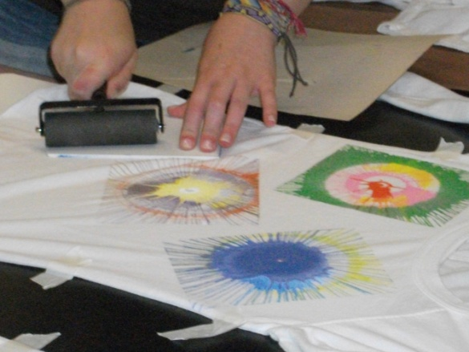

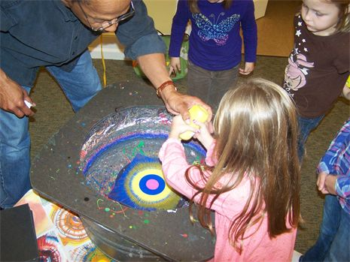

**HISTORY OF SPIN ART**

The Father of Spin Art, the first known artist to produce, display and promote Spin Art, was **Eugene R. Pera**. He appeared on US network TV on the shows "What's My Line" & "I've Got a Secret" in New York in 1958 with his "Painting Machine" which utilized a vertical spinning canvas at which he carefully lobbed paint from small paint cans. The show's hosts, Jack Parr & Hugh Downs, as well as their celebrity guests, were enthralled. Mr. Pera's statement to the art world at the time was effectively, *"We are living in the Machine Age. Since machines have taken over so many tasks previously done by the human hand, my Painting Machine enables anyone to make dramatic abstract art."*