Key Stage Two

Enjoy Reading for Pleasure and Enjoyment
- Did you choose this book? Why?
- What did you like about the text? Why? What did you dislike about the text? Why?
- Would you read the book again? Why? Why not?
- Would you recommend the book to your friend? Why? Why not?
- What will you read next?
- What books do you like to read?
- Do you have a favourite book that you like to read?
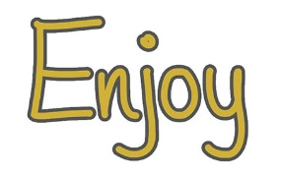
- Is this a new book that you haven’t read before? Do you know anything about it already?
- Do you enjoy reading?
- What do you read at home?
- Who is your favourite author?
- Which books have you enjoyed that we have read together? And why have you enjoyed them?

Decode Word reading and decoding skills
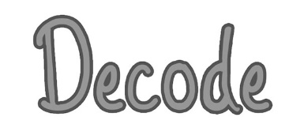
- What do you do if you are stuck on a word?
- Where do you start reading the word? Where do you look first?
- When you blend those sounds together, what word does it say? Can you tell me the word?
- Are there any clues in the word?
- Does it look like any other words you know?
- Can the pictures help you?
- Do you know what the word means or can you work out what it means (in this sentence)?
- What other word could the author have used that means the same sort of thing?
- Does the sentence make sense with that word?

Define 2a: Give/explain the meaning of words in context
- Explain two things that the words ___, ____ suggest.
- Find and copy a word/two words/a group of words/a sentence that shows/tells you _________
- In this sentence __________ is closest in meaning to ________?
- The author uses _________. _________ has two different definitions, use each definition to write a sentence.
- The author uses _________. Why do you think they chose this word?
- The author uses _________. Which of these words could be used to give a similar meaning in the sentence?
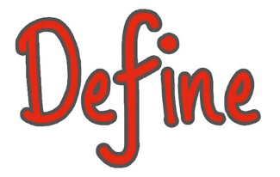
- Which word best describe _________?
- Find and copy one word that suggests that ___________
- What does this word/phrase/sentence tell you about ____________?
- Highlight a key phrase or line. By writing a line in this way what effect has the author created?
- Why does the author use ________ repeatedly?
- The writer uses words like _______ to describe ________. What does this tell you ________?
- What other words/phrases could the author have used?
- The writer uses _________to describe ________ How does this make you feel?
- Can you find an example of a word that means ______?
- Which of the following words is closest in meaning to…?
- Which of the following words is closest in meaning to…as it is used here?
- Find and copy a group of words that means the same as (enter phrase/idiom rather than word).
- What do the words (enter phrase/idiom etc) mean?
- Find and copy one word that shows that…is not easy.

Retrieve 2b: Retrieve and record information/identify key details from fiction and non-fiction
Which…? What…? How…? Where…? When…? Why…? Who…?
- Identify how ______
- Give two reasons why _______
- True/False
- Fact/Opinion
- Circle the option to complete the sentence.
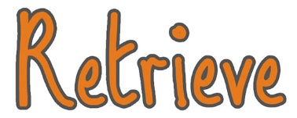
- When did ________ take place?
- From whose point of view is the story told?
- Which part of the story best describes _______? Explain why.
- Which words and /or phrases __________?
- What evidence do you have to justify your opinion?
- Find the paragraph where _________
- How do you know that…had not…? Give two ways.
- What is one…?
- According to…
- In ______’s opinion… (retrieval that looks like inference)
- Complete the table with one piece of evidence from the text to support each statement.

Summarise 2c: Summarise main ideas from more than one paragraph
- What is the main message of the text?
- Number the sentences below to show the order they happened
- Which of these events happened first?
- Which of these events happened last?
- What happened after?
- What happened before?
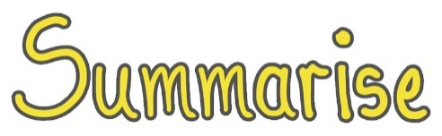
- What’s the main point in this paragraph?
- Can you sum up what happens in ______?
- Sort the information in these paragraphs.
- Which is the most important point in these paragraphs? How do you know?
- What part of the story do you think is the most important? Explain why you think this.
- Which of the following would be the most suitable summary of the whole text?
- Which sentence best describes the…?
- Which statement is the best summary for…?

Infer 2d: Make inferences from the text/Explain and justify inferences with evidence from the text
- Explain how ______?
- Explain why ______?
- Why did _______?
- Why is ________?
- How does ______?
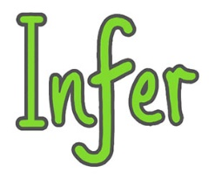
- Why do you think _______? Explain using the text.
- How do you know _______? Explain using the text.
- When do you think________? Explain using the text.
- How can you tell that ______? Explain using the text.
- True/False
- What makes you think that?
- Which words give you the impression that _____?
- How do you feel about ________? Why?
- Can you explain why_______?
- Which word tells you that _____?
- Quotation from the text. What conclusion does ________ draw from this?
- How can you tell that…was…? Give one piece of evidence that shows…
- What impressions do you get of…at this point in the extract? Give two impressions, using evidence from the text to support your answer.
- Give two reasons why…does not want to…
- How can you tell there was something strange about…? Explain two ways, using evidence form the text to support your answer.
- What suggests that…was not…?
- Explain what the…finds…about…
- The experience in the last…could best be described as…
- Tick the two…that are mainly about…
- What other impressions do you get of… in…?
- What else in the text tells us…
- Which words best complete the question?
- What is _______ thinking? Tick one thought (thought bubbles).
- How does _______ react?

Predict 2e: Predict what might happen from details stated and implied
- What do you think will happen next?
- What do you think would happen if _______?
- Based on what you have read, what does the last paragraph suggest might happen next?
- Can you think of another story, which has a similar theme, e.g. good vs evil? Do you think this story will end in a similar way? Why?
- Why did the author choose this setting? Will that influence how the story develops?
- How is __________ like someone you know? Do you think they will react in the same way?
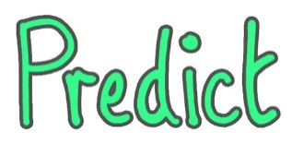
- What might happen next? Why?
- Choose one character from the book and predict how you think they will behave/react?
- Can you predict several possible outcomes and explain your answer?
- What if…?
- If there was a sequel, what might happen? Why do you think this?

Relate 2f: Identify/explain how information/narrative content is related and contributes to the meaning as a whole
- At what point did the characters mood change? Justify your answer using the text.
- What caused the characters to change their actions?
- What caused a change in events?
- Explain why _______
- What is similar/different _______ and ________?
- Why is _______ important in the story?
- Does this story have a moral or a message? Explain how you know using the text.
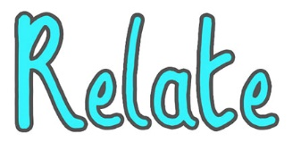
- Why do you think the author chose to use ________ to present the information?
- How does the _______ encourage you to read on/find information?
- Where does it tell you that _______?
- Why has the writer written/organised the text in this way?
- In what ways do the illustrations support the instructions?
- Who do you think this information is for?
- What atmosphere is the author trying to create? What words/phrases help to create that feeling?
- Why did the author write this story? Find a group of words to show that … has changed.
- What has the author done to make you want to read on? Explain your answer using the text.

Explore 2g: Identify and explain how meaning is enhanced through choice of words and phrases
- What does ________ tell you about ______________?
- What words help the reader to _______?
- What impact does the phrase __________ have on the reader?
- Find and copy words from the paragraph that show it was ________
- Highlight a key phrase or line. By writing a line in this way what effect has the author created?
- The writer uses words like ________to describe _______. What does this tell you about ________?
- What other words/phrases could the author have used?
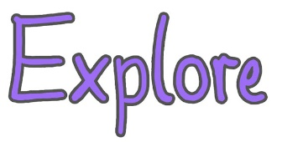
- What technique has the writer used?
- How are these words effective?
- What do you think the writer meant by ‘________’?
- When the author uses this sort of sentence, what is the impact?
- Why did the author ______?
- Why has the author used this word/phrase/sentence?
- How does the author create this mood/atmosphere?
- What is the effect of ________?
- Quotation from the text. What conclusion does ________ draw from this?
- Give one example of the use of humour in the ______.
- The word ____ suggests that ______ (followed by a tick box).

Compare 2h: Make comparisons within the text
- How does the characters mood change throughout the text?
- What words would you use to describe the main character at the start and end of the text?
- Compare and contrast different characters, reactions, settings, themes within the text.
- How are the lives of the people different as a result of _______?
- How is it similar to _______?
- How is it different to ________?
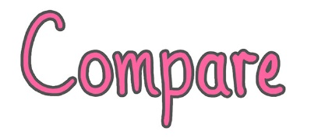
- Compare your book to another on the same topic. Which do you prefer and why?
- Would you like to read more books by this author? Explain your reasons.
- If you have read other texts by this author, can you see any similarities/differences between them?
- Give one way…are similar to…
- Give one way…are different from…

Content Domain | Examples from Recent KS1 SATs
2a – define

2b – retrieve

2c – summarise

2d – infer

2e – predict

2f - relate
2g - explore
2h - compare

Question Type | Examples from Recent KS2 SATs
Tick box

Short response

Extended response

Matching

Sequencing

True or False

Fact and Opinion
Find and Copy

Other

