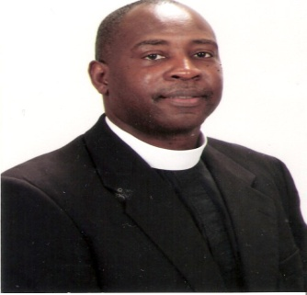 “Continued Perseverance and Growth”
Newsletter Contents
Welcome………….. 1
From the Pastor’s Desk…… 2
Weekly Services………..2
Donations/Offerings… 3
Word/Scripture of Month …. 3
A New Year, New Commit….4
Transportation…5
Elder Leroy Ealy, Pastor
Welcome
And let us not be weary in well doing; for in due season we shall reap if we faint not. Galatians 6:9 KJV
What an honor and privilege it is to worship in the Spirit of the true and living God. If you want to experience a life changing event this is where you need to be. With our hands lifted up and our voices raised we shout to the Lord, our only wise God and Savior! Together, we're striving to become the kind of church described in the Bible, where there's relevant teaching, heart-felt worship, Holy Ghost moving, Pentecost Revival, and compassionate care for those in need.
If you are bound by chains-chains of drugs, alcohol, addictive personalities, sex, lies, cheating….this is where you can come and be delivered and set free! If you are still checking out the “scene” look no further. Thank you for allowing us to help you in your search.
We are located at 6805 West Canal Blvd, Shreveport, Louisiana, 71108
Come and experience a powerful move of God!

Welcome
From the Pastor’s Desk
The Fruit of Perseverance
2 Corinthians 4:1-18
The apostle Paul often wrote about perseverance. He urged believers not to tire of following Christ and doing good, even when persecuted. The reason was that in time, their faithfulness to plant seeds would produce an amazing harvest.
If anyone had a right to say that, it was Paul. He'd been beaten, stoned, whipped, and driven out of town. He'd survived riots, shipwrecks, illness, and abandonment. He had a thousand reasons to be disheartened and want to give up, yet he knew his obedience to God wasn’t in vain. Some might surmise, Well, it doesn't look as if he reaped much: he was persecuted, moved from prison to prison, and eventually executed. But if we assume that rewards come only in material terms, we miss a powerful truth.
Consider the awesome harvest that actually resulted from the apostle's faithfulness. For one thing, the gospel spread across the Roman Empire, and the early church grew far beyond the Jewish world. And the seeds Paul planted by writing his epistles resulted in billions of lives being radically changed. Any strength we draw from these letters is fruit of the hardships he endured. Yet when he urged believers never to tire of obeying the Lord, he didn't know the full extent of the impact his life would have. He just believed in the power of faith.
Do you realize how impactful your life is? Don't be deceived by Satan's lie that your suffering or obedience will amount to nothing. Here's the truth: Your faithfulness to God never goes to waste--it's making an eternal difference in someone's life, whether you know it or not.

Weekly Services
- Sunday School every Sunday Morning starting at 8:50 a.m.
- Sunday Morning Worship starts at 10:30 a.m. / Children’s Ministry at 10:30 a.m.
- Sunday Evening Y.P.W.W. at 6 p.m.
- Sunday Evening Worship at 7 p.m.
- Tuesday Night Services at 6:30 p.m.
- Wednesday Morning Prayer at 9:30 a.m.
- Friday Night Services (to be determined)
- Friday Night Youth Outings (every 2nd & 4th)
Visit us on the web at www.bryanttemplecogic.net

Donations, Tithes, Offerings may be given online! Find the tithing page on our website…www.bryanttemplecogic.net

Thought: It is our natural tendency to look to the future, but we should never forget the past. It is important that we remember all that God has done in shaping us into the persons we are today.

Word of the Month:
Created
Scripture of the Month:
For by him were all things created, that are in heaven, and that are in earth, visible and invisible, whether they be thrones, or dominions, or principalities, or powers: all things were created by him, and for him. Colossians 1:16 (KJV)

A New Year, A New Committment
Practice gratitude – Cultivating a grateful heart is the hallmark of a Christian steward. Every day, express thankfulness to the Lord and to others. Seeing the good in your life will allow you to keep your heart compassionate and loving.
Encounter the Lord each day – Find time to be with the Lord each day, whether it be for an hour or ten minutes. Have a conversation with the Lord. Give your joys and worries to Him as well. Allow God's love to transform them. Our encounters will keep our eyes and ears open to the presence of Christ in our midst.
Be present to others – There is much celebration and mourning, joy and sorrow in peoples' lives. What a blessing it is to be able to share those times and not let others experience them alone. The gift of your presence to others is much more valuable than you realize.
Resist overwork – There is a pressure to produce, meet goals, be successful. But activities that lead us to overwork, constant fatigue and worry do not give glory to God. What God calls us to do we can do well. Be mindful that life requires balance, down time and letting go of unrealistic goals.
Nurture friendships – Our friends are those we choose to be with, those with whom we spend our evenings, with whom we vacation, to whom we go to for advice. Friends are gifts from God who give us a greater appreciation of God's love for us. Friends need our time and love.
Give more – Good stewards realize that everything they have is entrusted to them as gift to be shared. There is no better place to begin than sharing with the community that gathers around the Lord's table at Mass. Consider what you are giving to your parish and local diocese and commit to an even greater contribution as circumstances allow.
Make a difference in your parish community – Believe it or not, your parish community can use your talents. Offering your talents to your faith community is one of the most effective ways to feel useful and connected to others, and it is a potentially life-changing New Year's resolution.
Consider living more simply – We cannot find fulfillment in possessions. They add nothing to our self-worth. Jesus blessed the "poor in spirit" in his Sermon on the Mount; and Saint Francis of Assisi urged us to live with only what was necessary, for that is how we begin to find God.
Get healthy – Studies show that most people in North America are accelerating their own decline into premature old age, owing to poor diet and lack of physical activity. Be a good steward of your body. Plan a complete overhaul of your diet and exercise habits.
Don't give up – People give up their New Year's resolutions because of perfectionism and unrealistic expectations. So take it slow, be kind to yourself and keep trying. Resist the urge to throw your hands up and quit. You succeed through small, manageable changes over time.
Turn to the Lord – Ask the Lord for guidance, strength and perseverance in achieving your resolutions. In his letter to the Phillipians, Saint Paul writes: "I can do everything through Him who gives me strength" (Phil 4:13). If God is the center of our New Year's resolutions, they have a better chance for success.

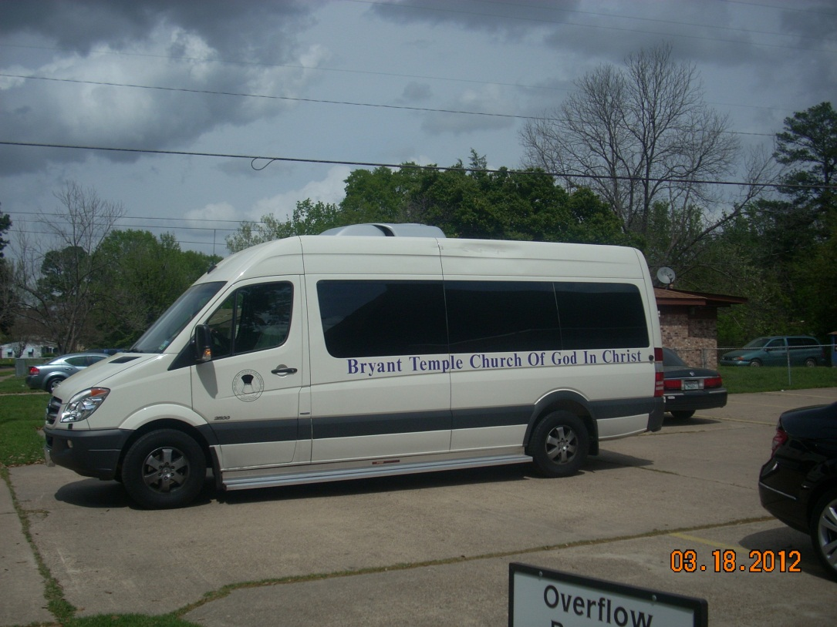 Want to come to church but don’t know how you will get there?
Need a ride?
If you are struggling with any of these questions give us a call and we will come pick you up!
318-631-3211

