Post-Accident and After Hours Testing
Encompass Workplace Testing, LLC
21017 NYS Rt. 12F
Watertown, NY 13601
315-788-8701

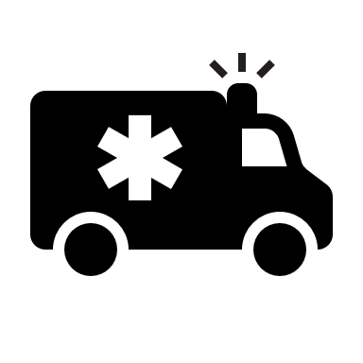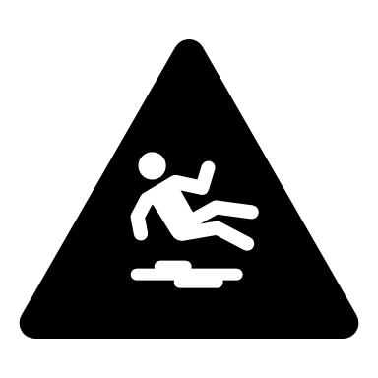

Encompass Workplace Testing provides post-accident and after hours testing. If you need a post-accident or after hours test please call our office at 315-788-8701. If we are not in the office our voicemail will provide you with our on-call number.

We are available 24 hours a day every day.

