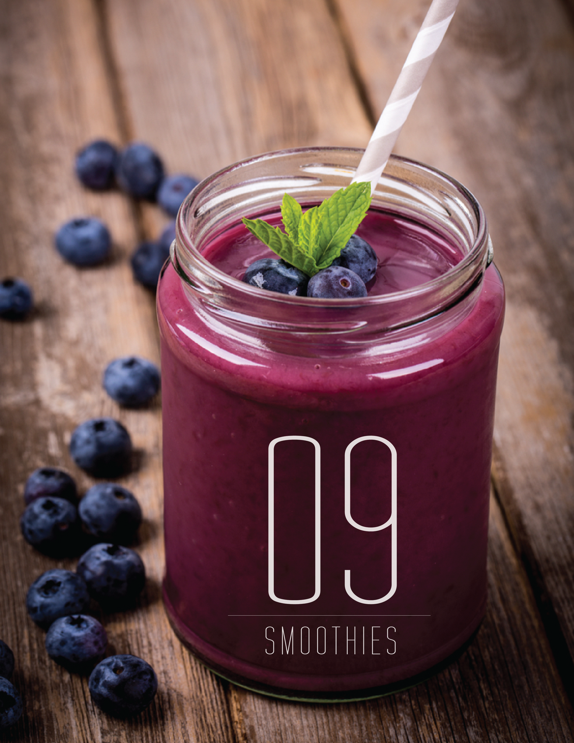
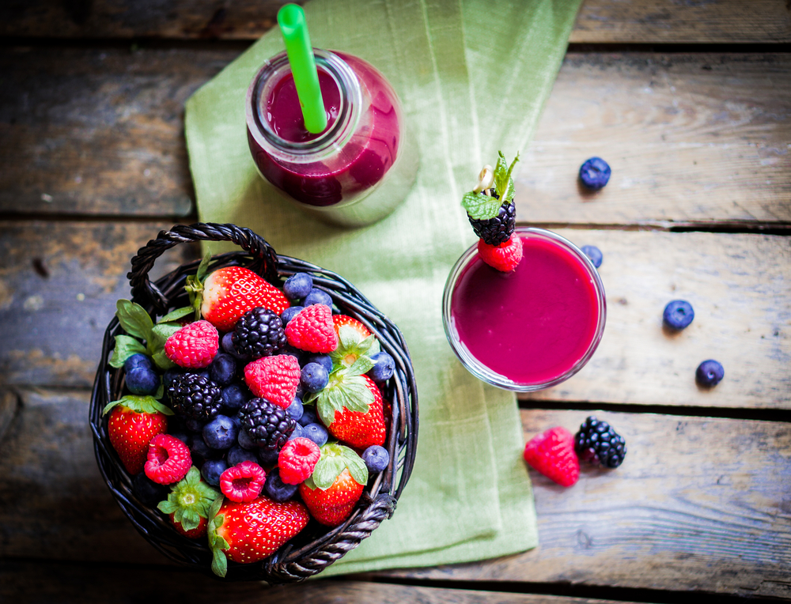

HELLO MY WELLNESS WARRIOR!

Welcome to VEEFIT. I am Vee McKey and I am a health coach.

Welcome to the world I live in. Here are nine smoothie recipes that will change your life. Drink your way to a magnificent body, more vitality, and feeling fabulous with every step.

I am guessing that this is why you are here – you want to have more energy, fewer cravings, less bloat, and glow from the inside out!

Say goodbye to diets and to feeling hungry or deprived, because I am giving you the tools you need to ditch the afternoon crash, stop eating your kids’ chocolate and candy, and avoid hitting the vending machine at 4 p.m.

As a health and wellness coach specializing in strength training and fat loss, I am here to guide you towards making the right food choices in order to boost your metabolism and improve your digestion.

If you are inspired by what you read, then I have done my job. If you start drinking a smoothie a day and feel more energy than you can handle, that makes me really happy!

I want you to have the endless energy I have. Are you ready?

Meet nine smoothies that will change your life,

SO WHAT IS THE DEAL WITH SMOOTHIES?
WHY ARE THEY GOOD FOR YOU?

Smoothies are:
- Chock full of vitamins, enzymes and minerals
- Easy to digest, which mean optimal assimilation of your nutrients
- Great for stabilizing blood sugar (you will see each smoothie here has a healthy fat, and fat is key for blood sugar stabilization)
- A fabulous way to consume a variety of different fruits or vegetables at one time
- Terrific for cleansing the body of toxicity
- An easy way to add more fiber to your diet for optimal bowel function

Smoothies will give you more energy
& are the best on-the-go meal known to man.

WHY IS BLENDING YOUR SMOOTHIE BENEFICIAL?

- The health of your body depends on your digestion. When you blend your foods, you are supporting the digestion process. Your body does not have to work so hard to break down the nutrients as they are in a pre-digestible state.
- Did you know that 80% of your energy is spent digesting and assimilating your nutrients? So why not support your body to do less work?
- Instead of having to prepare and eat cup after cup of healthy greens or fruits, you are packing them into one nutrient-dense smoothie.

CHOOSING A BLENDER:

- Vitamix is a super-powerful blender with a very strong motor that not only can blend smoothies, but also can make nut butters and even soups; however, it is an investment at around $499.
- Health Master is another option similar to Vitamix and costs about $350.
- Nutribullet is an amazing alternative as it costs only $99.
- A blender at Masters, Gorhams, Wal-Mart or Target will typically cost you around $40.

Remember any blender is amazing because we want you
to start drinking smoothies to support your body for ultimate healtH

Choose the liquid – water, coconut water or a dairy-free milk

Choose your greens – kale, spinach, parsley, Swiss chard, collards or lettuce

Choose your fruit – banana, apple, berries, mango and more

Choose your fat/protein – hemp seeds, hemp protein, nut butters, avocado, coconut oil, flax or chia seeds

Superfoods – maca, raw cacao, bee pollen, shredded coconut, goji berries and more

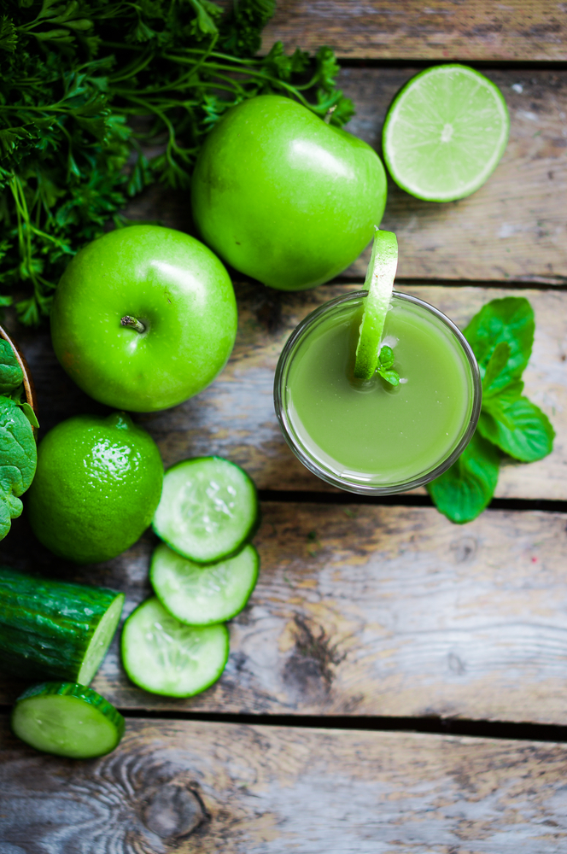

TODAY IS THE DAY TO CHANGE YOUR LIFE.

During my studies at the Institute for Integrative Nutrition, I learned the importance of smoothies and now I drink one every day of my life. At the Institute I was able to study over 100 dietary theories and I also had the opportunity to study under respected teachers and leaders such as Andrew Weil, Mark Hyman, Geneen Roth and Deepak Chopra.

If you are reading this and wondering what is going to put you into your new shoes, then get ready because TODAY is the day I will share my most favored secrets with you to set you on your path to success.

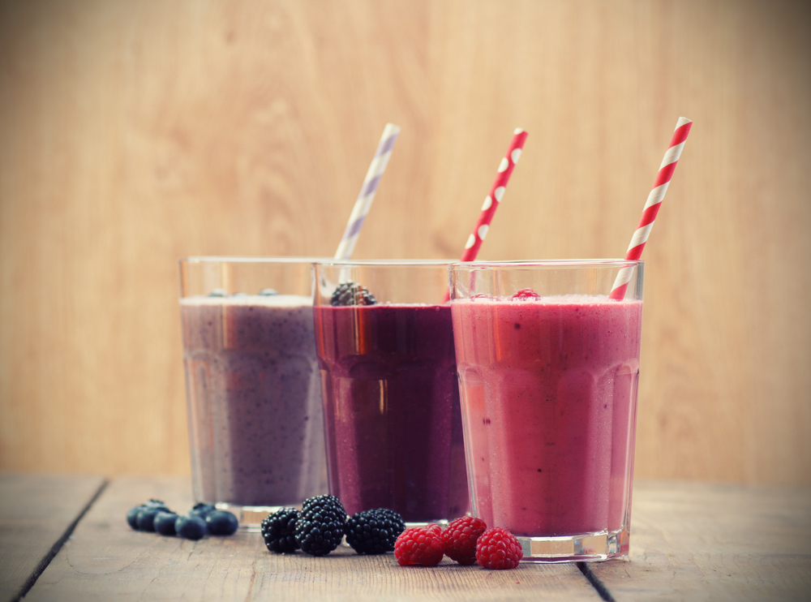

STRAWBERRY BLISS

1 cup coconut water or almond milk
½ cup frozen strawberries
1 banana
1 Tablespoon coconut oil
1 Tablespoon hemp seeds
1 Tablespoon flax meal or chia seeds
Pinch of cinnamon
Stevia or raw honey to sweeten
Ice (optional)

A GINGERBREAD COOKIE

1 cup almond or coconut milk
1 Tablespoon flax meal or chia seeds
1 Teaspoon cinnamon
1 banana
1 cup of spinach
1 Tablespoon of almond butter
Stevia to taste (optional)
Ice (optional)

KIDNEY NOURISHING SMOOTHIE

1 cup almond or coconut milk
1⁄2 large cucumber peeled and sliced
1 cup fresh/frozen blueberries
1 Tablespoon flax meal or chia seeds
1 Tablespoon raw, organic honey
or stevia to taste (optional)
Ice (optional)

* Cucumbers are a wonderful kidney cleanser and provide you with bounds of energy.

CRANBERRY SWEETNESS BLISS SMOOTHIE
1 cup unsweetened almond/coconut/hemp or rice milk
1 cup of mixed berries
1⁄4 cup unsweetened cranberry juice concentrate
1⁄4 avocado
1 Tablespoon flax meal or chia seeds
1 Teaspoon ginger
1 Teaspoon cinnamon
Ice (optional)

GINGERBREAD HOUSE SMOOTHIE

1 cup unsweetened almond/coconut/hemp or rice milk
1 ripe banana
2 teaspoons freshly grated ginger
1/2 cup fresh orange juice
2 Tablespoons honey or stevia
Ice (optional)

CHOCOLATE BANANA BLISS SMOOTHIE

1 cup almond or coconut milk
1 ripe banana
½ cup kale
2 Tablespoons cashew butter
or almond butter
1 Tablespoon raw honey or stevia
2 Tablespoons unsweetened cocoa powder or raw cacao
Ice (optional)

MOOD STABILIZER

1 cup almond or coconut milk
1 cup fresh or frozen blackberries
1 Teaspoon maca powder
1 Tablespoon almond butter
1 handful of spinach
1 Tablespoon raw, organic honey
or stevia to taste (optional)

NEED MORE ENERGY SMOOTHIE

1 cup unsweetened almond/coconut/hemp or rice milk
2 tablespoons hemp seeds
½ avocado
1 banana
1 Teaspoon cinnamon
1 Tablespoon flax meal or chia seeds
Stevia to taste (optional)
Ice (optional)

MANGO DREAM

1 cup almond or coconut milk
1/2 cup coconut water
2 leaves kale or Swiss chard, coarsely chopped
1/4 avocado
1/2 cup mango chunks (the freezer section is great for this)
Ice (optional)

LIFE WILL NEVER BE THE SAME ONCE YOU BEGIN DRINKING YOUR SMOOTHIES – TRUST ME!

NOW THAT YOU ARE DRINKING SMOOTHIES CHECK OUT MY NEW PROGRAM….
HOW TO QUIT SUGAR FOR LIFE!

Do you ever feel like you are constantly not fitting into your clothes no matter what you do?

It can leave you feeling off for the entire day and not to mention completely uncomfortable.
That icky bloated feeling, trapped gas, puffy eyes, achy joints, unpleasant taste in your mouth, not to mention exhaustion….to name a few of the side effects of eating sugar!

Those feelings just hold you back from really enjoying your life!!

Are you ready to finally say good-bye to ALWAYS catching that cold, feeling tired and sore all the time or coming down with brutal headaches?
Of course, you are! That is why I have designed my new program to help you rid your body of the culprit (the one you didn’t know was causing you all the damage) once and for all!

Learn How to “Quit Sugar For Life” and take back your health with this special program designed with your health in mind. My new program will help you take back your health and finally feel free to enjoy life everyday!

HERES HOW!
GO TO MY WEBSITE WWW.VEEFIT.COM CLICK ON THE HEALTH COACHING TAB THEN PROGRAMS! READ ALL ABOUT IT!

CHECK OUT MY WEBSITE WWW.VEEFIT.COM FOR MORE INFORMATION & TESTIMONIALS!

