Easter Egg Counting

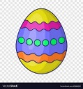

Easter Egg Counting Parents Guide

This activity can be printed out or completed on a laptop.
Child to count from left to right and to touch each egg with their finger. If they miss one or make a mistake, then restart.
Child to count out loud each time they touch an egg.
ANSWERS
Depending on ability answers can be:
- Written/typed in boxes independently by child
- Written/typed in boxes hand over hand
- Child can verbally give answer
- Digits below can be printed and individually cut out. The child then places the answer in the box.
- Be positive and praise good effort.
- Child me be fit to go to ten, if not go until you sense the child is struggling and build on thus

1 2 3 4 5 6 7 8 9 1
Easter writing

Easter Writing Parents Guide
- Print page out.

- Child to draw a horizontal line between the matching objects.

- Focus on the child holding the pencil at the bottom.

- Practice hand over hand until child confident to attempt independently

- Repeat several times

Easter Colouring in sheets
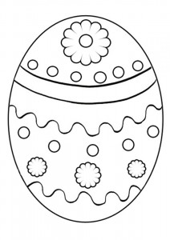

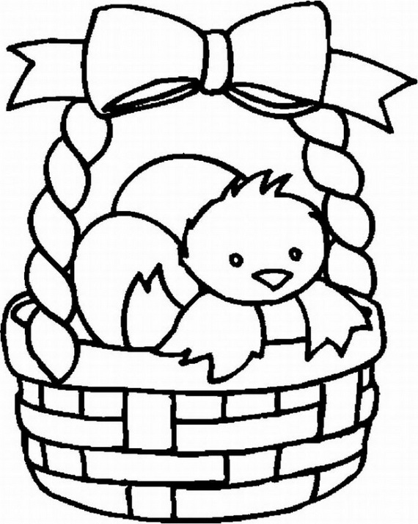

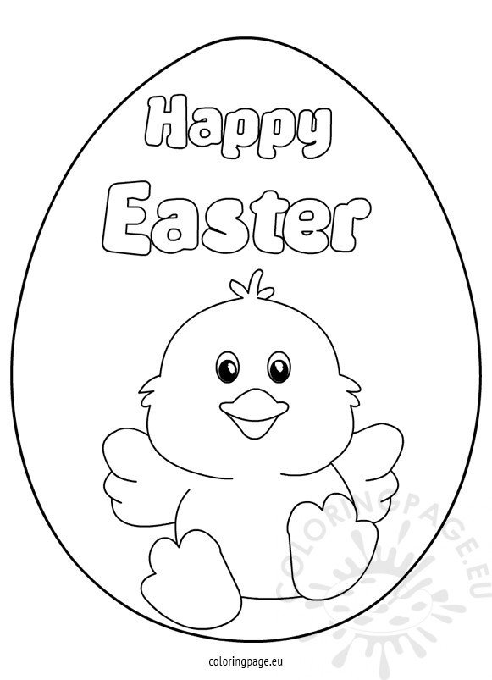
Easter Resources
www.twinkl.co.uk
Enter Easter activities in search.

https://www.youtube.com/watch?v=D7z-aJqTw1U&feature=youtu.be

What is Easter?
Use pictures as a visual aid to talk to your child about Easter. I.e. the religious aspects, associated activities and fun.

