The Impact of Organizational Culture on Employee Burnout
John W. Rosengrant
Submitted in partial fulfillment for the Completion of
The Master of Public Administration Program

Marywood University
2018

Abstract
The aim of this study will be to describe the impact that organizational culture has on burnout syndrome among employees at a human services agency with multiple office locations. Burnout syndrome is a serious dilemma that affects the professional as well as personal wellbeing of people in the helping professions. The study utilized a self-report in person survey, administered through email, to measure the burnout variable and characteristics of organizational culture that may be present for each subject in their individual workplace. No demographic information was collected within the process except for the location of the office that each employee works, and their respective role within that office because both factors could help to contribute to an employee’s reported level of burnout. There was also an open ended question on the survey asking subjects to describe their workplace in a few words or phrase. The study was distributed to employees working within 14 office locations and participants fell into one of three roles: Administrative, Supervisory and Direct Service. Organizational culture score was computed based on the results of each survey and compared against reported level of burnout for any significant correlation. The findings of this study imply that organizational culture has a significant impact on an employee’s level of burnout, and certain preventative measures can be taken to improve culture within different offices in order to decrease their level of burnout and thus, contribute to increasing employee retention at this particular organization.

Dedication
It is with my genuine gratefulness and warmest regard that I dedicate this work to several sources of support for which the completion of my studies would not have occurred without. I want to thank my advisor, Dr. Alexander Dawoody for his unwavering support and endorsement throughout my trek within the Master of Public Administration program.
I also want to thank my employer, Valley Youth House, whose substantial support of my research topic has singlehandedly made this project a success. I want to particularly recognize Lisa Weingartner and Andrew Palomo who both contributed to the success of this project. At the very foundation of this research is improving employee retention which I only became passionate about because of Lisa’s dedication to Valley Youth House’s organizational goals. I can only hope to not only emulate her as a fellow administrator, but also as a Social Worker.
Andrew is also the sole reason that I have become passionate about this project in particular as his excitement for research resonates within me. It is through this project that I see the path to creating real change in the world, and it became clear through Andrew’s mentorship toward me.
To my mother, I hope I still make you proud through this work. To my daughter Ericka who I know has spent the last few years needing more of my attention than I had been willing to give. Finally, to my wife and best friend, Jodi, who at many times was my rock and determination to reach the finish line. Not only has she stood by me to the end, but I owe the entire decision to advance my education to her as she was the main source of support for my decision to do so. The love and support she has provided to me far outweighs the gratitude I could ever display toward her. Finally, all friends and peers, especially Matthew Bartos who rode this train with me for four years, especially at times when I wanted to get off. Thank you all, now and forever.

TABLE OF CONTENTS
- CHAPTER ONE, INTRODUCTION…………………………………...…………….1
Statement of the Problem………………………………………………………1
Research Questions………………………………………………………..…...1
Purpose of the Study………………………………………………………..…..2
Background…………………………………………………………………….3
Significance of the Study…………………………………………………..…..4

- CHAPTER TWO, LITERATURE REVIEW……………………………………..…..5
- CHAPTER THREE, RESEARCH METHODOLOGY……………………………..17
Theory………………………………………………………………………...17
Conceptual Model…………………………………………………………….19
Research Design………………………………………………………………20
Population……………………………………………………………………..21
Sample………………………………………………………………………...21
Example of Questionnaires…………………………………………………...22
Codebook/Hypothesis/Variables……………………………………………...24
Confidentiality………………………………………………………………...26

- CHAPTER FOUR, DATA PRESENTATION………………………………………27
- CHAPTER FIVE, DATA ANALYSIS……………………………………………...42
- CHAPTER SIX, CONCLUSION……………………………………………………48
Summary……………………………………………………………………...48
Recommendation……………………………………………………………...51
Challenges to the Research……………………………………………………54
Suggestions for Future Research……………………………………………..56
REFERENCES………………………………………………………………………………58
APPENDIX……………………………………………………………………………………..

Chapter One: Introduction
Thesis Statement
The nonprofit sector is faced with unique challenges administratively compared to the for-profit and business sectors. One unique challenge is in its ability to hire, train and retain staff. The turnover rate for the sector in general continues to hover around 19% (Nonprofit HR, p. 4). There are certainly other factors at play in that figure, but two factors in particular are the focus of this study.
Valley Youth House, a nonprofit organization based in Bethlehem, PA has 14 different office sites within its organization. They also suffer from high turnover rates at or slightly higher than the industry standard. This research attempts to examine the cause of those high rates by studying employees’ level of self-reported burnout, and in this case, the culture of all 14 offices at this organization. By administrating a survey to all employees at the organization, and asking them to reveal what office location they work in, and what role they have within the office, this research will attempt to prove that one affects the other, and hope to improve retention rates at this organization.
Research Questions
- How is it that 14 office locations in a moderately sized nonprofit agency form their own individual personality (culture)?
- How is it that the personality (culture) of each office contributes to the satisfaction or burnout of its employees?
- How much variance occurs in employees’ reported level of burnout when levels are examined by an employee’s role (ie: Administrative, Supervisory and Direct Service)?
- How much does workplace culture and employee burnout contribute to an employee’s likelihood of quitting their job?
Purpose of Study
Valley Youth House is a 45 year old nonprofit organization based in Bethlehem, PA. Their primary service population is homeless youth between the ages of 16-25. Some of the youth are adjudicated dependant and/or delinquent, and some are literally homeless and living on the street or in unstable housing situations. Their staff includes about 400 employees who fall into one of three categories: Administration, Supervisors and Direct Service Workers. Nonprofit HR (2016) has conducted surveys on nonprofit practices annually since 2007 (Nonprofit HR, 2016, p. 2). According to their survey conducted in 2016, nonprofit employee turnover rates have increased from 16% to 19% between 2015 and 2016 (Nonprofit HR, 2016, p. 4). The largest area of reported turnover occurs within the direct service professional group. This is especially concerning as they report that despite this rising number, 84% of the participating nonprofit organizations in the study report having no formal retention plan for their employees (Nonprofit HR, p. 11). In terms of Valley Youth House, according to their 2018 Organizational Goals, their current turnover rate for full time employees is 25%, and for part time staff it is 60% (Harrington, 2017). They also have no formal retention plan for their staff.
With this in mind, this researcher decided to help in finding strategies that will indirectly contribute to raising the retention rate for Valley Youth House employees. By focusing on how organizational culture can contribute to an employee’s reported level of burnout, the study hopes to provide feedback to leadership within the organization on how to assess and improve culture at each of its 14 offices, and possibly transfer positive culture practices to other offices, thereby increasing employee work conditions, and lower their level of burnout. One of their goals for 2018 is to improve retention from 75% to 80% for full time staff and from 40% to 50% for part time staff. It is the hope of this researcher that this research can be a positive first step to reaching that goal.
The purpose of this study is to examine how organizational culture of individual satellite offices at a moderately sized non-profit agency contributes to an employee’s self-reported level of burnout. It is the hope of this researcher that this study will lend itself to a greater understanding of the causes of burnout amongst human service professionals; furthermore, once a greater understanding is facilitated, interventions can be designed to improve organizational culture, thereby helping professionals to practice self care, and also mitigate and increase positive outcomes for the clients being served, as well as relationships between co-workers within the same office
Background
Valley Youth House began in 1973 as a shelter for homeless youth. Today, that shelter is still in existence, and still operates as a shelter. Over the last 45 years, the organization has expanded to 14 different counties and has offices in 14 different locations. Over the last four years alone, the company has condensed 5 separate office locations into one larger one in an effort to be more fiscally responsible, and have seen two different CEO’s lead the organization. The current CEO has brought energy and stability to the company with his vision and enhanced the mission and core values of the organization over the last three years. He has instituted a branding process and gave new direction to fundraising and expansion. His strategic plan involves forming a Quality Assurance and Quality Improvement program for the first time in 45 years.
Along with the organization’s growth come unique challenges. Expansion of regions and condensing of certain offices has created unique opportunities to study the culture of each office. Another opportunity is the reported 25% turnover rate which has its own place in the CEO’s strategic plan. The goal is to be able to recruit and retain highly qualified staff (which includes licensed professionals), increase training for supervisors, and examine salaries of all staff in order to remain competitive. Another goal within this section of the strategic plan calls for improving workload balances where possible in an effort to increase staff satisfaction. At its core, these elements are consistent with Belias’ & Varsanis’ reasons for burnout syndrome (Belias & Varsanis, 2014, p. 51).
The organization has made strides just over the past few years in an effort to ensure best practices and quality improvement. The interest in this research contributes not only to quality improvement but also to the organizational goal attainment of staff retention.
Significance of the Study
Burnout is no new phenomenon to social service workers, but at Valley Youth House, the effects have never been studied except for in illustrating and promoting self care. Likewise, there has been no internal research on organizational culture, especially with regard to individual offices. The research looks to examine especially how culture is formed in each of those 14 offices and how that culture contributes to the satisfaction or burnout of its employees.
This study is significant because it takes what is known about burnout and extends it to organizational culture; according to Goodman & Boss (2002), employees are more likely to terminate their employment based on higher phases of burnout (Goodman & Boss, 2002, p. 45). More importantly, Kim, Soloman & Jang (2012) attest that positive organizational culture can contribute to an employee’s desire to stay with an organization (Kim, Soloman & Jang, 2012, p. 38).
The research intends to uncover mean burnout rates for all participating staff which can be generalized across the population of all employed staff, and examined by not only their office location but also their role. This is important as trends will be uncovered demonstrating variance in an employee’s level of burnout based on their role. Trends will also be uncovered for each office location, and individual culture traits can be examined for each office which contribute to either a positive or negative culture. Those traits can then be eradicated or encouraged at other offices. Strategies can be implemented to encourage self care and lower burnout rates for employees, thus increasing retention of staff and outcomes of the youth served.
Chapter Two: Literature Review
There is a plethora of relevant literature related to burnout as it pertains to organizational culture as this is an area that is gaining much interest in recent years. However, there is a paucity of research as it pertains to organizational culture in an organization with multiple office locations. The literature can be organized in three dimensions: Burnout, Organizational Culture, and Impact of Culture on Staff Retention/Turnover.
Defining Burnout
Christina Maslach has long been a pioneer in the field of burnout. Her research has spanned four decades, and has focused on every sector of the workforce. According to research that she conducted in 1986, she found that there were three levels of impairment in workers whose occupations were primarily with people. Those three levels of impairment were referred to as emotional exhaustion, depersonalization, and reduced personal accomplishment (Maslach & Jackson, 1986). The impact of her study and research on burnout has become a primary focus of human service employees in particular. Leiter & Maslach (2001) identified six areas of work life that contribute to professional burnout syndrome. These six areas are workload, control, reward, community, fairness and values (Leiter & Maslach, 2001). Her identification of aspects of work life began the shift in believing that burnout was more a result of effects in an employee’s work environment rather than by internal forces.
The impact of burnout is not only felt by employee’s mental health and throughout the workplace, but across systems as it can contribute to higher employee turnover, less job/school satisfaction, negative employee relationships, negative income generation for businesses and increased medical bills (Thomas, 2016). Thomas explains that stressors related to burnout can have a negative impact on a worker’s mental and physical health, which in turn also impacts a worker’s ability to give effective service to clients (Thomas, 2016). The importance of developing impactful interventions to help human service workers deal with high levels of stress can be seen if one looks at the above ramifications. Human service workers lose their ability to be helpful to others if they cannot manage their stress levels.
Research indicates that burnout is a serious problem among social workers and within human service agencies in general. In pursuance of the Code of Ethics written by the National Association of Social Workers (2017), in order to effectively be of service to others, practice competency, integrity, and promote the importance of human relationships one must effectively manage stress and burnout (NASW, 2017).
With regard to specific work that human service workers perform, Barford & Whelton (2010) conclude that providing care to high risk children and youth in residential settings is stressful, yet very little research is available to examine the causes as to why (Barford & Whelton, 2010). They cite a myriad of complex factors specific to youth residential facilities including behavioral disorders, clients reliance on psychotropic medications, client self harm, sexual acting out and defiant and explosive behaviors as factors that can affect human service workers’ level of burnout within these settings (Barford & Whelton, 2010). This is relevant because most of Valley Youth House’s programming is of a residential nature, and these factors can contribute to the participants’ reported burnout levels. The present research can examine the burnout levels of these employees within the residential programs at Valley Youth House and solicit responses qualitatively regarding their perceptions of these workplaces for consistency within this literature.
The literature speaks to a greater understanding and knowledge of burnout as well as its prevalence, but it is a much more difficult task to assess an organization’s response to employee burnout. According to Schaufeli, Leiter & Maslach (2008), today’s companies are beginning to realize that burnout prevention is no longer enough to ensure positive outcomes with clients and organizational health. The concept of employee engagement is becoming more and more prevalent in today’s world, especially in the nonprofit sector (Schaufeli, Leiter & Maslach, 2008). Maslach wrote a book in 1997 that was based off extensive research of organizational dynamics and employee burnout levels. She claimed that it was a myth that burnout was caused by intrinsic factors in the worker, and set into motion vast amount of research to follow that would examine the link between employee burnout and workplace dynamics. Her research was groundbreaking in the sense that for the first time, burnout was shown to be a sign of major dysfunction within the organization, and not so much about its employees (Maslach & Leiter, 1997). She examined eight areas of management and workplace environment and their impact on burnout among employees. Those eight areas became the foundation for this present research as qualities of workplace culture closely parallel those defined by Maslach. Those eight areas are: Perceptions of Change, Mission and Goals, Management Structure, Supervision, Communication, Performance Appraisal, Health and Safety and Work and Home Balance (Maslach & Leiter, 1997)
According to a recent Gallup poll taken in 2018, Wigert & Agrawal (2018) state that regardless of the cause, the organizational impact of employee burnout is substantial. They polled 7,500 full time workers across all sectors and found that 2/3 of those surveyed claim to have experienced burnout on the job either sometimes, very often or always (Wigert & Agrawal, 2018). They also found that those participants were 63% more likely to take a sick day, 23% more likely to visit the emergency room, and almost 3 times as likely to leave their job than their counterparts who answered rarely or never (Wigert & Agrawal). This promotes the fact that organizations are beginning to become more aware of the need for increased employee engagement. This becomes a primary factor in this research since Valley Youth House has defined one of their organizational goals around Employee Retention and Engagement. Measuring burnout scores becomes highly relevant if medical issues rise when employees sometimes, very often or always experience burnout. The loss of productivity would assume to decrease the amount of times spent with clients, thus by proxy, reducing the success of clients through outcome measurement.
Defining Organizational Culture
Most current research on burnout focuses on the helping professions. However, little research has been done on organizational culture in different office locations and how it correlates to professionals’ level of burnout. According to Belias & Varsanis (2014), organizational culture is defined as “a set of values, beliefs, standards, assumptions and thoughts handed down to all members of an organization”. (Belias & Varsanis, 2014). The authors continue to attest that organizational culture exists within the realm of the behaviors of the members of the organization, the values held by the organization and its members, and assumptions and policies which guide those behaviors (Belias & Varsanis, 2014). This is significant to the present study because barriers such as communication and differences in administrative leadership at each location could lend itself to varying degrees of workplace culture when there are multiple office locations. Studying the relation between organizational culture and employee burnout, Maslach & Jackson (1986) found positive relationships between emotional exhaustion and role conflict, personal accomplishments and support provided to the total number of employees, and negative attitude in the workplace and lack of individual support (Maslach & Jackson, 1986). This finding led to the development of the Maslach Burnout Inventory which is widely used today. Furthermore, as the literature will show, most of the definitions and features of organizational culture as described by other authors can be credited to Maslach and her six areas of work life that contribute to burnout syndrome.
To expand upon Belias & Varsanis, a group of authors named Kheirandish, Farahani & Nikkhoo (2016) attempted to define workplace culture by identifying 10 features. The features are: Individual Creativity, Risk Taking, Leadership, Integration with Organization, Management Support, Control, Identity, Reward System, Compromise with Conflict and Communicative Pattern (Kheirandish, Farahani & Nikkhoo, 2016). These features are also consistent with the six proposed by Maslach in her early research on Burnout and helped to form the basis for defining features of workplace culture that were represented within the questionnaire in this present study. The theoretical framework for their study showed that employees can have a heightened sense of satisfaction and commitment to the organization when they have more awareness of the organization’s values and strategy, and productivity can increase when supported by management (Kheirandish, Farhani & Nikkho, 2016).
Culture of Mental Health and Human Service Organizations
With regard to the organizational culture of community based mental health and human service organizations in particular, a descriptive study was performed by Green et al. (2014), where they defined organizational culture as “climate” and determined indicators to consist of role overload, role conflict, role clarity, growth/advancement, and cooperation (Green et al., 2014). They concluded that organizational climate and leadership were better indicators of burnout than demographic information such as age, education level, role and length of tenure. This finding lends credence to the current study as demographic information will not be examined. Rather, dimensions of culture such as leadership/supervision, safety and teamwork will be assessed.
Understanding Staff Turnover
To feel the full impact of burnout, one must understand that burnout can contribute to higher employee turnover and negative income generation for businesses. In order to fully understand burnout and turnover, one must examine the factors that lead employees to quit their jobs. Identifying factors that lead to either staff turnover or retention is important to human service organizations across sectors. For purposes of this study, this researcher examines factors such as workload, role clarity, motivators to work, attachment to clients and the work, commitment to organizational mission, opportunities for growth, perceptions of support, teamwork and fairness and their impact on retention and turnover of employees.
High Workload
Hiring, onboarding and training staff can and is expensive. In their study, Thomas, Kohli & Choi (2014) found that as employees experienced rising and unbearable levels of burnout, they were more likely to leave their organization (Thomas, Kohli & Choi, 2014). Their burnout levels were correlated to high unmanageable workload sizes. Also of note is that this research was designed from a convenience sampling of human service workers in a rural area. These findings can be generalized to Valley Youth House in the sense that they operate in both urban and rural areas of the state. It can also be assumed that urban areas could show variance in burnout levels given differences between urban and rural environments.
Role Clarity
The present study will attempt to examine three different levels of roles among employees at Valley Youth House: Administrative employees, Supervisors and Direct Care Workers. The implication being that an employee’s role could impact their level of burnout. A captivating study was performed by Gray & Muramatsu (2013) where they examined the burnout levels of direct care workers only and attempted to connect their desire to quit their jobs based on their burnout levels. They designed a cross sectional survey of 323 direct care workers from five community based human service organizations that serve individuals in the areas of: Intellectual Disabilities, Residential Programs, Vocational Rehabilitation, Outpatient Counseling and Respite and Foster Care services. What they concluded was that direct care workers who had more decision making ability, perceptions of supervisor support, and role clarity led to low intentions to quit (Gray & Muramatsu, 2013). Furthermore, work stress was reduced when the above factors were present. A significant percentage of Valley Youth House’s workforce is in the Direct Care realm, so this study lends special importance to the purpose of the present study.
Intrinsic Factors of Motivation on Employee Retention
Throughout the course of this literature review, several themes have emerged that can help to describe workplace culture and variables contributing to burnout. Another study, performed by Yoon & Kelly (2008) discussed the importance of organizational excellence and retention of social workers. Their findings concluded that although conditions of low wages, inadequate benefits and lack of resources were all factors in decreased employee satisfaction, there were factors overriding those that led to employee retention. These factors were enjoyment and importance of their work, recognition, and ability to pursue quality. When these factors were present, organizations experienced lower turnover rates, and in turn built stronger organizational dynamics (Yoon & Kelly, 2008). This study is significant because it points to intrinsic factors of employee motivation rather than extrinsic factors. The present research conducted at Valley Youth House will examine both for prevalence in not only burnout but as indicators or staff intention to quit.
Client and Job Embededness
Another study in support of intrinsic motivators in human service employees tried to define the concept of client embededness and job embededness. Treuren & Frankish (2014) refer to client embededness as an attachment the employee has to their clients, and job embededness as the employee’s attachment to their organization and work life (Treuren & Frankish, 2014). The purpose of their research was to assess one’s level of client embededness and compare it to their level of pay (dis)satisfaction. What they found was that when client or job embededness was present, pay was less associated with dissatisfaction. Furthermore, as embededness was present at higher levels, employee retention was more present (Treuren & Frankish, 2014). This could be a significant factor in Valley Youth House’s employee retention strategy. The implication being that the more connected one feels to Valley Youth House and its clients, the less likely they are to quit their job.
Commitment to Mission and Vision
Using the concept of job embededness, one concept that contributes to attachment to the organization is in its mission and vision. Mission and vision are important to nonprofit organizations, as it drives all of their decisions. The programming that the organization ushers out and the performance standards are all driven by its Mission. When discussing intrinsic motivators, nonprofit organizations rely more on delivering its message through its mission than other sectors (Dawoody, 2018). Brown & Yoshioka (2003) found that those who felt satisfied about their work were more likely to indicate that they believed in the mission of their organization, and thus, more likely to stay with the organization (Brown & Yoshioka, 2003). In addition, the more the organization made employees aware of its mission, the more employees were likely to agree with the mission (Brown & Yoshioka, 2003). This is relevant to Valley Youth House in being a nonprofit organization. The level of commitment to their mission and vision could have an impact on their employees’ desire to quit their job. It could be important to examine the level of commitment employees experience, and from a management standpoint, work to increase that level of awareness to the mission of the company.
Development/Growth
Other intrinsic motivators can have an impact on employee retention as well. One such factor is in staff and leadership development. Beudean (2009) explains that when employees were given opportunities to develop leadership or other general skills, organizational commitment increased. They also stated that these opportunities should be designed around the organization’s needs. In sum, when a development plan was designed with an employee in mind, commitment and retention both increased (Beudean, 2009). Intrinsic motivators are present in employees, but it could be challenging to find what it is that motivates individuals. The implication to this research is that nonprofit organizations and Valley Youth House in particular can naturally increase retention by forming a commitment to staff by identifying their motivators and values and offering growth potential.
Perceived Organizational Support
Another factor that can contribute to an employee’s level of burnout, and to its end, employee turnover, is the support that an employee perceives to receive. Perceived Organizational Support (POS) is a concept measured by a pair of Canadian researchers named Marchand & Vandenberghe (2016). In their study, they concluded that an employee’s POS was positively correlated to their likelihood of quitting their job. In defining Perceived Organizational Support, employees were asked to rate the level to which they received adequate resources to perform their jobs, adequate guidance and supervision when needed, and access to their closest superior as indicators of POS. There was a strong positive correlation between the Perceived Organizational Support within the participants and their intention to remain at their job (Marchand & Vandenberghe, 2016).
Teamwork
Teamwork and belongingness is a concept that, when thinking about nonprofit organizations, comes to mind when thinking of intrinsic motivators. Westbrook, Ellis & Ellett (2008) qualitatively studied over 300 employees from the Child Welfare system and their perceptions of the nature of their work. What they found was that employees who were given the opportunity to bond with co-workers and given opportunities to positively reminisce about things “that used to work” alleviated feelings of burnout over the societal issues facing these workers. In other words, many of the participants associated their occupation as being “dangerous”, “traumatic” and “difficult”, but feelings of togetherness and teamwork alleviated these attitudes and beliefs (Westbrook, Ellis & Ellett, 2008). Workers who associated with the negative attitudes experienced higher levels of burnout and lack of satisfaction in their work and were more likely to quit their jobs. Human service work is often associated with producing high levels of compassion fatigue and vicarious traumatization. The implication here is that if employees are given opportunities to feel like part of a team, this could alleviate burnout symptoms and thus, improve retention. Interesting to note, Valley Youth House has Outstanding and Valued Team Members as organizational values.
Social Justice/Fairness
The final concept to be examined within the literature is that of social justice and organizational fairness. Kim, Solomon & Jang (2012) examined social workers in particular and their attitudes on their ability to both deliver and receive social justice within their workplace. Their study showed three major conclusions: (1) higher levels of burnout correlate to increased intention to leave their job, (2) higher levels of perceived fairness relate to decreased intention to leave, and (3) perceived fairness moderated the impact of burnout on those participants (Kim, Solomon & Jang, 2012). Social workers have an inherent need to advocate for clients and promote social justice. When they were given opportunities to share their voice, they also experienced less levels of burnout (Kim, Solomon & Jang, 2012). This is one other factor that can be classified as an intrinsic motivator among human service employees. This is relevant to the present research study because although this can also be attributed to perceived support, this is more about workers having a voice and being treated fairly, thus eliminating perceptions of bias and prejudice.
In designing the research, this researcher draws upon the literature to understand burnout and organizational culture and how both can tie into employee retention. The literature helps to design the research and be able to assess factors such as perception of fairness, support, pay satisfaction, supervision, teamwork, opportunities for growth, having a voice, and size of workload as all factors contributing to workplace culture.
The impact of culture on burnout in the literature is vast, but the amount of research regarding multiple office locations is virtually nonexistent. The lack of relevant research pertaining to multiple office locations is of concern to this researcher noting the nature of organizations today having multiple satellite offices. This lends itself to challenges in management and leadership as it becomes difficult to uphold organizational mission when different offices can present with different cultures.
One final and significant piece of literature is in examining the exit interviews of recently departed staff from the company being studied. The interviews examined demographics such as region worked in, role of the employee and tenure, but also measured various aspects of workplace culture such as: role clarity, hiring practice, training/orientation, feelings of belongingness, pay satisfaction, benefits, time off, organizational events, understanding of policy, discipline policies, aspects of supervisor/supervision, performance evaluations, physical environment, flexibility of schedule, teamwork/cooperation, morale, work/life balance, development/growth, meaningful work, effective leadership and overall satisfaction. Of the 18 participants surveyed, 15 were direct service workers in some capacity, which is consistent with the literature stating turnover affects direct service workers more. Another surprising finding was that eight of the 18 polled were employed by the company for 10 years or longer, with three of those eight being employed over 15 years. The data did not show whether retirement was a factor in any of these employees. They reported satisfaction (above 75%) in the areas of benefits, time off, organizational events, policy understanding, knowledge of supervisor, performance evaluations, teamwork, and positive meaning of work. The surveys reflected dissatisfaction in the areas of pay, salary increases, training opportunities, discipline policies, supervisor responsiveness, work schedule, morale, work/life balance, opportunities and support for advancement, agency leadership and workload. This is significant data as this could have value when assessing what is important to employees.
Chapter Three: Methodology
Theory
Conservation of Resources theory was developed as a stress theory by Steven Hobfoll in 1989. It attempted to explain why individuals experience stress and equated it to either a loss of resources or a threat of loss of resources. In sum, Hobfoll et al. (2018) posits that individuals are motivated to both maintain their current resources and obtain new ones. When a threat of loss of resources occurs, individuals compensate with anger, defensiveness, and increased investment in resources to protect against loss. Resources could be objects (cars, homes, tools, etc), conditions (tenure, seniority, safety, etc), personal resources (skills, personality traits, values, etc), or energy resources (knowledge, money, etc), There are four main principles that underlie Conservation of Resource Theory:
- Loss of resources is more important to individuals than resource gain
- Individuals will invest resources to protect against resource loss, recover from resource loss and to attempt to gain resources.
- Resource gains become more important and valuable when resource loss circumstances are high
- When individuals’ resources become exhausted or threatened, they will enter a stress response to attempt to prevent resource loss. This may look like defensiveness, aggressiveness or irrationality (Hobfoll et al., 2018).
A second theory of importance to organizations is Crossover of Resource Theory which is a sub theory of Conservation of Resources. Crossover of Resources explains how attitudes, ideas and constructs can be transferred from individual to individual - the more significant the relationship between individuals, the higher the likelihood of crossover. This theory helps to explain work/home balance and how positive and negative emotions can be transferred between partners through empathic understanding. Crossover is not limited to intimate relationships however. Much research has been conducted on Conservation of Resources as well as Crossover of Resources in organizational settings between supervisors and their subordinates. In this example, supervisors exchange important resources such as support, praise and decision making to the employee. What results is the accumulation of more resources by the employee, and thus, an increase in worker performance.
This research applies Conservation of Resource Theory and the closely related Crossover of Resources Theory to help in describing burnout and employee turnover patterns within the organization of Valley Youth House. It could be argued, that when employees experience burnout (stress response), some aspect of resource loss is perceived. The most likely resource being threatened is self efficacy, and when turnover occurs, self efficacy becomes even more depleted. Individuals in these situations respond with a stress response (termination of employment) in an effort to regain their efficacy. Crossover of Resources Theory underlies this research also in the fact that resource loss can be passed onto co-workers within the same office setting in the same way that positive resources are transferred between supervisors and subordinates. Likewise, individual components of workplace culture can be viewed as resources which can also be passed on between individuals. What results is a burnout epidemic, a positive or negative workplace culture, and a rising turnover rate among employees. It then becomes incumbent to facilitate employee engagement and crossover of resources in an effort to alleviate burnout and foster positive workplace culture.
Conceptual Model
Figure 3.1 (Appendix)
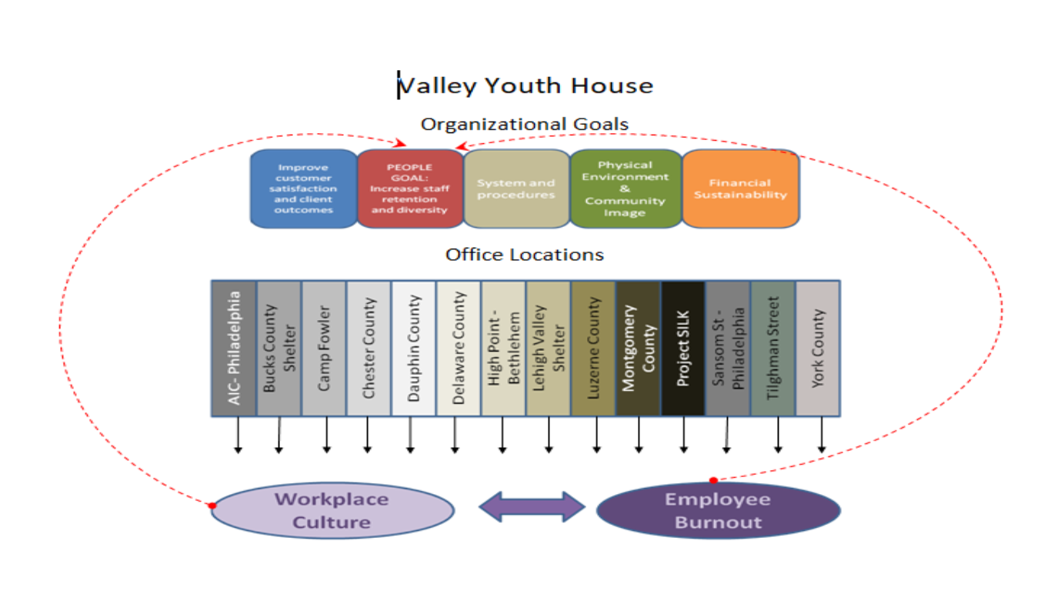
When viewing Figure 3.1, it can be seen that as an organization, Valley Youth House has organizational goals in place for 2018. The goals are: Improve Customer Satisfaction and Client Outcomes, Increase Staff Retention and Diversity, Improve Systems and Procedures, Improve Physical Environment and Community Image, and Increase Financial Sustainability. Those goals apply to every office location (there are 14 of them) within Valley Youth House. Within each location contains a Workplace Culture, which contributes to employee burnout, which then in turn, feeds into workplace culture based on Conservation of Resource and Crossover of Resource Theory. Both workplace culture and burnout then both contribute to the Organizational goal of Improving Employee Retention.
The intended purpose of this research is to draw conclusions about workplace culture from each office as it correlates to employees’ reported level of burnout. Themes to be examined are going to be culture of each of the 14 offices, burnout of each of the 14 offices, as well as how various questions were answered by the employees of those offices.
Research Type and Design
The preferred design for this type of research was a mixed design consisting of quantitative and qualitative components. It was a quasi-experimental design that took place in a natural workplace setting. The data collection used a cross sectional method of probability sampling where the survey was distributed at a single point in time. It was issued to all employees of Valley Youth House from 14 different office locations. The quantitative component consisted of 28 survey questions based on a Likert Scale based on various levels of agreeing or disagreeing with each question (See Figure 3.2 in appendix). The questions were based on various characteristics of workplace culture as found in the literature. The qualitative component was an open ended 29th question asking the participant to describe their workplace culture in a two words or phrases.
This design was chosen in an effort to define workplace culture and burnout quantitatively yet solicit important information about culture from the participants in their own words. Although the qualitative question does not ask about any specific characteristic of workplace culture, it brings value to the research in the sense that it gives the participants a voice.
There were strengths and weaknesses of this design type. The benefits of this type of research are that it forced the participants to assess the presence of characteristics of workplace culture from within their office. It also forced them to assess their present level of burnout. In terms of weakness, some of the offices were very small and made data analysis difficult and somewhat irrelevant for those offices based on small sampling size. The population spanned across 14 offices and individuals were classified either as Administrative, Supervisory or Direct Service Workers. This added an element of being able to compare burnout scores and perception of culture between the various roles.
Target Population
The target population of the study was approximately 400 current employees of Valley Youth House. This consisted of Full Time, Part Time and Per Diem Staff. Only current employees were polled. The survey was distributed to all staff in an email containing the survey. No former employees were asked to participate, and all employees needed to be able to identify with one office location and a defined role. The specified roles they had to choose from were Administrative, Supervisory or Direct Service. This was done to allow for broader analysis based on the employee’s role within their office location to examine if there was any difference in scores depending on their role.
Sample
The survey was distributed via an agency wide email that contained approximately 400 email addresses of current employees. The employee email addresses were for Full Time, Part Time and Per Diem staff members. The survey was distributed at a single point in time, and all employees were given the opportunity to participate if they desired. Likewise, all employees had the opportunity to decline participation by simply not completing the survey. The survey was housed electronically and responses were recorded automatically using Google software. This was a probability sampling meaning every employee had the same opportunity to participate. It was also a convenience sampling in the fact that this researcher is also employed at this company, so participants were naturally occurring rather than needing to be recruited.
The qualitative component was contained within the same questionnaire, so the sampling method was also probability only because it was contained on the same battery. Out of the approximately 400 employees to whom the questionnaire was distributed, a total of 135 participated. This researcher was informed by Human Resources that out of the 400 email addresses contained within the agency wide email address, approximately 100 of them were part time or per diem with less likelihood of participating.
Questionnaires and Instruments
Figure 3.2 illustrates the questionnaire that was used in this study. Questions were designed around all the characteristics describing workplace culture that were found in the literature. The questionnaire which was used was entitled Workplace Culture Questionnaire which was designed by this researcher and tailored questions around characteristics defining workplace culture as found in the literature. The questionnaire was broken down into three parts. One part asked participants to answer the questions with responses listed on a Likert Scale. The first section assessed the presence of culture characteristics within the participant’s workplace. The second section assessed the feelings about one’s workplace qualitatively using an open ended question designed to solicit that particular response. The third section asked participants to assess their current level of burnout again, using a Likert Scale. This was used to compute burnout scores which represent the dependent variable in this study. Participants were asked to supplement their questionnaire with demographic data which would assist the researcher in sorting the data according to workplace location and their role within their office at Valley Youth House.
The office culture was measured by 28 questions, and each answer was given “1”, “2”, “3”, or “4” points depending on if the participant disclosed that they do not agree at all, do not agree entirely, agree to some degree or agree entirely with the presence of each characteristic of workplace culture. In the second section, the participant was asked to answer a qualitative question, “What do you feel are two words or phrases that would best describe your particular working environment?” The responses can be found in the appendix as Figure 3.4. In the third section, the question read, “On a scale from 0 to 10 where 0 is nonexistent and 10 is always present, how would you rate your present level of burnout?” Again, responses were collected using a Likert Scale, with the list of responses ranging from “0” to “10”.
The characteristics used to formulate the questions were: Being treated fairly (which includes discrimination, bias and privilege), role clarity/job description, development and growth opportunities (which also included all genders having equal opportunity), pay satisfaction, accessibility of supervisor, adequate resources to perform job, decision making ability, client and job embededness, adaptability to change, adequate communication, work environment (positive or negative), enforcement of policies and change, sense of community, attachment to mission, having a voice within the office, giving and receiving respect, opportunities for supervision and team meetings, workload, perception of support (from co-workers and superiors) and impact of psychological stress (burnout). A full size version of the survey can be found within the appendix.
Figure 3.2 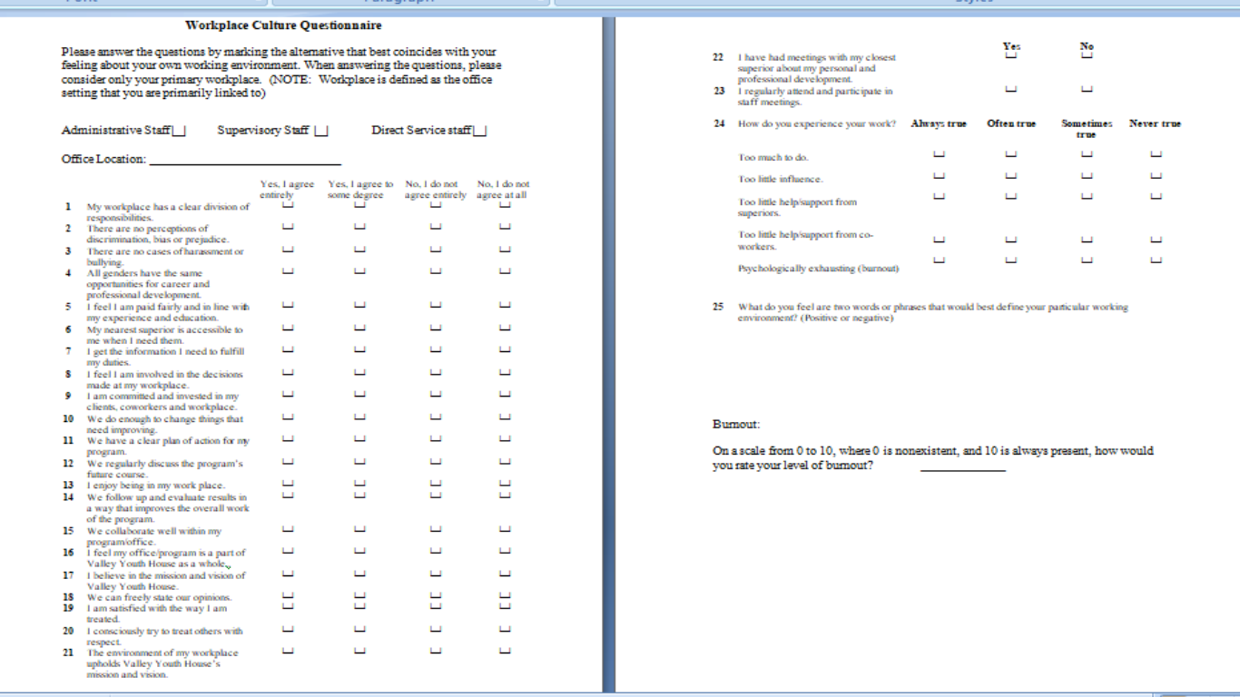
Codebook, Variables and Hypothesis
Figure 3.3 shows key terms found within the research (see appendix for full size version). The terms were taken directly from the qualitative responses of the participants to the open ended question of, “What do you feel are two words or phrases that would best define your particular working environment”? The meanings behind the words were created by this researcher. This is not a comprehensive list of responses. This codebook contains the main classifications that the responses were placed in as well as terms that were not as easily defined as some other terms. Each term presented in the Codebook was then classified according to Positive or Negative Culture. The concepts defined within the codebook were taken directly from the Qualitative Response Chart, which encompasses all responses. The Qualitative Response Chart can be found listed as Figure 3.4 in the Appendix. The Appendix also contains Figure 3.5 which represents word frequencies for Responses solicited about People, the Work performed at Valley Youth House and the Culture of Valley Youth House Workplaces. Figure 3.5 also contains a Word Cloud depiction of responses.
Figure 3.3
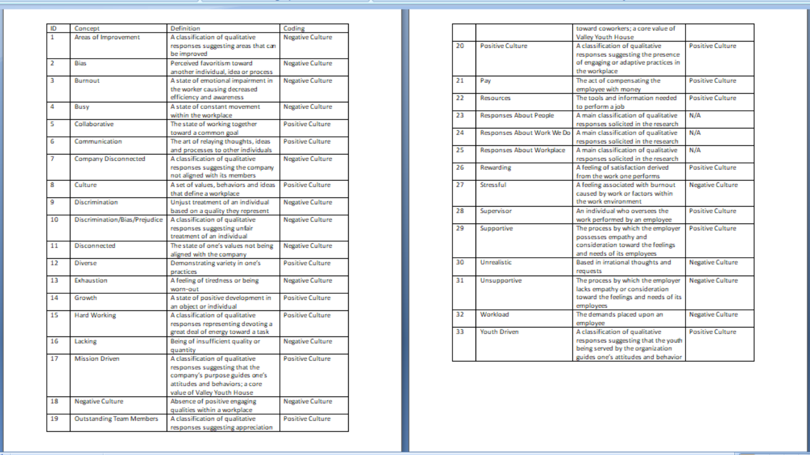
Hypothesis
The hypothesis of the current research is “A negative workplace culture, as present in each of the 14 offices at Valley Youth House will contribute to an employee’s level of burnout”. The implication here is that settings with lower culture scores will be associated with higher burnout in its employees. Likewise, a higher culture score will be associated with lower burnout. A second hypothesis is, “A direct service employee will experience higher levels of burnout than either Supervisor or Administrative personnel”. The implication being, as found in the literature, that Direct Service staff will experience higher levels of burnout because they are directly working with clients and experiencing Crossover of Resources from client to worker.
Independent and Dependent Variables
The Independent Variables associated within the research are Role of Employee, Location of Workplace, and Culture Score. These are independent because these figures are constant and will not change. The dependent variable is Burnout Score. This is dependent because it can vary depending on how the Independent Variables are presented. Thus, burnout can fluctuate depending on the role of the individual, the location they work in and the culture presented within the workplace.
Confidentiality and other Ethical Considerations
This research follows IRB and federal guidelines in establishing confidentiality, protecting human subjects, assuring the voluntary nature of participation, and establishes a procedure in data collection and storing that adheres to strict confidentiality guidelines as outlined by IRB and the federal government. In order to comply with these guidelines, this research has been conducted in a private work setting. All participants were given the option to decline participation. Records of self reporting as well as all results maintained confidentiality throughout the process. The records have only been viewed by this researcher and are the sole property of this researcher unless data is transferred to Valley Youth House for use in Policy Implementation. Records will be kept for the period of one year and then disposed of by paper shredding. The study, which was conducted, received approval from the Exempt Review Committee at Marywood University. This process ensured that all ethical values were adhered to during the course of the study. No harm or duress was placed upon the participants. Participants were informed of where to go in the event that they experienced any sort of duress, that there would be no incentive given for participation in the study, and they were informed of their right to confidentiality.
Chapter Four: Data Presentation
Data Collection
The questionnaire which was used was entitled Workplace Culture Questionnaire which was designed by this researcher and tailored questions around characteristics defining workplace culture as found in the literature. The office culture was measured by 28 questions, and each answer was given “1”, “2”, “3”, or “4” points depending on if the participant disclosed that they do not agree at all, do not agree entirely, agree to some degree or agree entirely with the presence of each characteristic of workplace culture. Therefore, a participant’s score in this section could range from 28 (Low Culture) and 112 (High Culture). In the second section, the participant was asked to answer a qualitative question, “What do you feel are two words or phrases that would best describe your particular working environment?” The responses can be found in the appendix as Figure 3.4. In the third section, the question read, “On a scale from 0 to 10 where 0 is nonexistent and 10 is always present, how would you rate your present level of burnout?” Again, responses were collected using a Likert Scale, with the list of responses ranging from “0” to “10”.
Descriptive Statistics
Frequencies
135 total participants were surveyed, 20 of which were administrative staff, 33 supervisors, and 82 who identified as direct service workers (see Figure 4.1)
Figure 4.1
Role
 |  | Frequency | Percent | Valid Percent | Cumulative Percent
Valid | Administrative | 20 | 14.8 | 14.8 | 14.8
 | Supervisory | 33 | 24.4 | 24.4 | 39.3
 | Direct Service | 82 | 60.7 | 60.7 | 100.0
 | Total | 135 | 100.0 | 100.0

Additionally, Figure 4.2 illustrates the amount of employees who participated from each of 14 office locations.
Figure 4.2
Location
 |  | Frequency | Percent | Valid Percent | Cumulative Percent
Valid | AIC | 11 | 8.1 | 8.1 | 8.1
 | Bucks | 4 | 3.0 | 3.0 | 11.1
 | Camp Fowler | 1 | .7 | .7 | 11.9
 | Chester | 6 | 4.4 | 4.4 | 16.3
 | Dauphin | 5 | 3.7 | 3.7 | 20.0
 | Delco | 3 | 2.2 | 2.2 | 22.2
 | High Point | 66 | 48.9 | 48.9 | 71.1
 | LV Shelter | 7 | 5.2 | 5.2 | 76.3
 | Luzerne | 7 | 5.2 | 5.2 | 81.5
 | Montco | 3 | 2.2 | 2.2 | 83.7
 | Project SILK | 1 | .7 | .7 | 84.4
 | Sansom St | 10 | 7.4 | 7.4 | 91.9
 | Tilghman | 5 | 3.7 | 3.7 | 95.6
 | York | 6 | 4.4 | 4.4 | 100.0
 | Total | 135 | 100.0 | 100.0

No other demographic data was solicited from the responses. The Role of the employee as well as the office location each became Independent variables in the study. A third independent variable, Culture Score, was computed using the scale described above. Figure 4.3 illustrates the frequencies of the Culture Scores as reported by the participants.
Figure 4.3
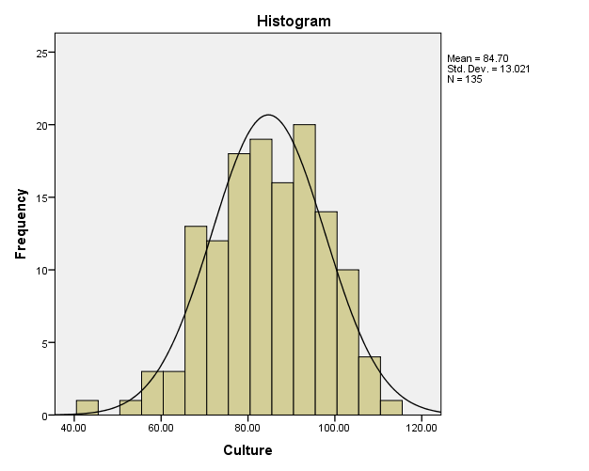

The dependent variable, Burnout Score, was collected from all 135 participants who subjectively self reported their burnout levels in the present time based on a Likert Scale ranging from 0 to 10. 63.6% of participants reported burnout levels of 6 or above. Figure 4.4 displays the frequencies of burnout score.

Figure 4.4
Burnout
 |  | Frequency | Percent | Valid Percent | Cumulative Percent
Valid | .00 | 5 | 3.7 | 3.7 | 3.7
 | 1.00 | 3 | 2.2 | 2.2 | 5.9
 | 2.00 | 8 | 5.9 | 5.9 | 11.9
 | 3.00 | 12 | 8.9 | 8.9 | 20.7
 | 4.00 | 5 | 3.7 | 3.7 | 24.4
 | 5.00 | 16 | 11.9 | 11.9 | 36.3
 | 6.00 | 23 | 17.0 | 17.0 | 53.3
 | 7.00 | 28 | 20.7 | 20.7 | 74.1
 | 8.00 | 27 | 20.0 | 20.0 | 94.1
 | 9.00 | 6 | 4.4 | 4.4 | 98.5
 | 10.00 | 2 | 1.5 | 1.5 | 100.0
 | Total | 135 | 100.0 | 100.0

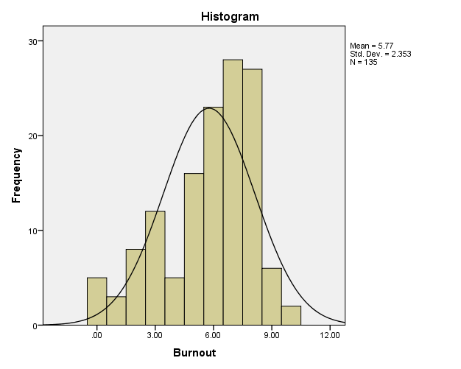

Additionally, the data was sorted to be able to give a view of the frequency of burnout scores for each office location. See Figure 4.5.
Figure 4.5
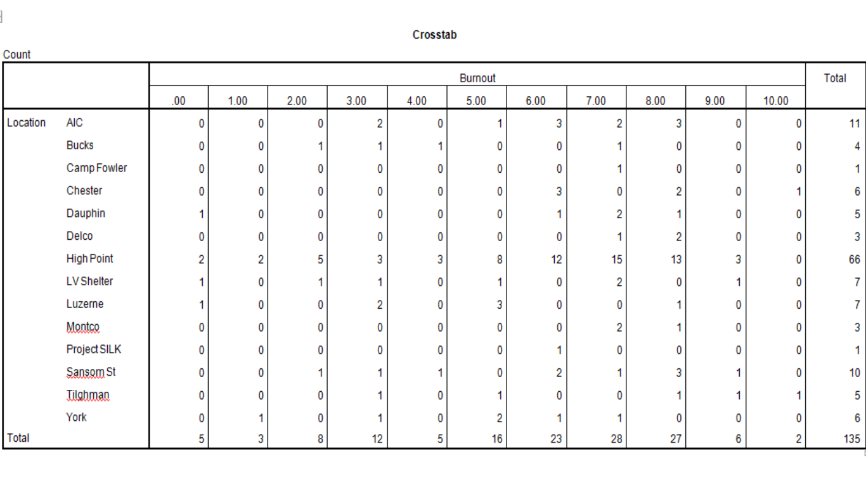
Figure 4.6 displays culture scores for each office location in three separate parts.
Figure 4.6
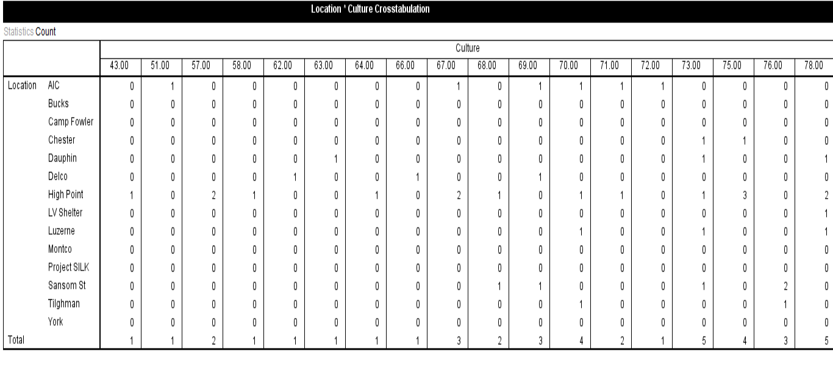
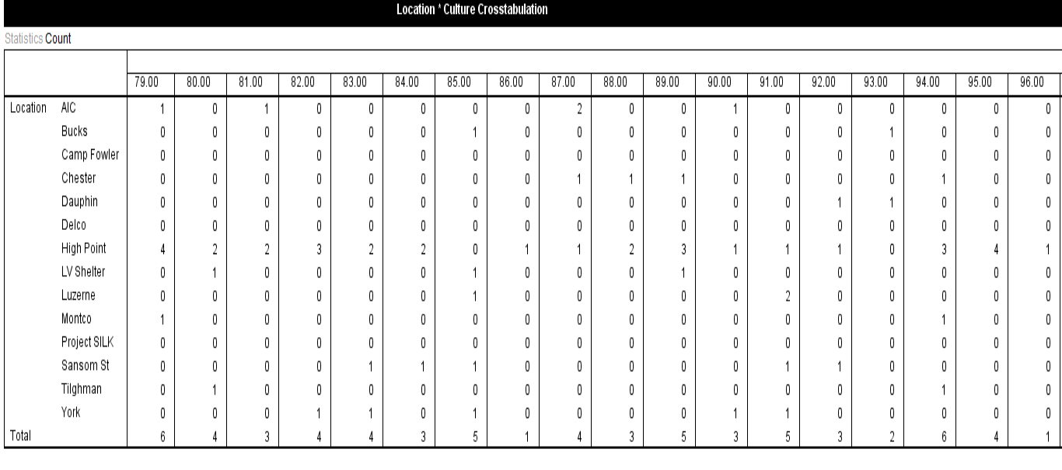
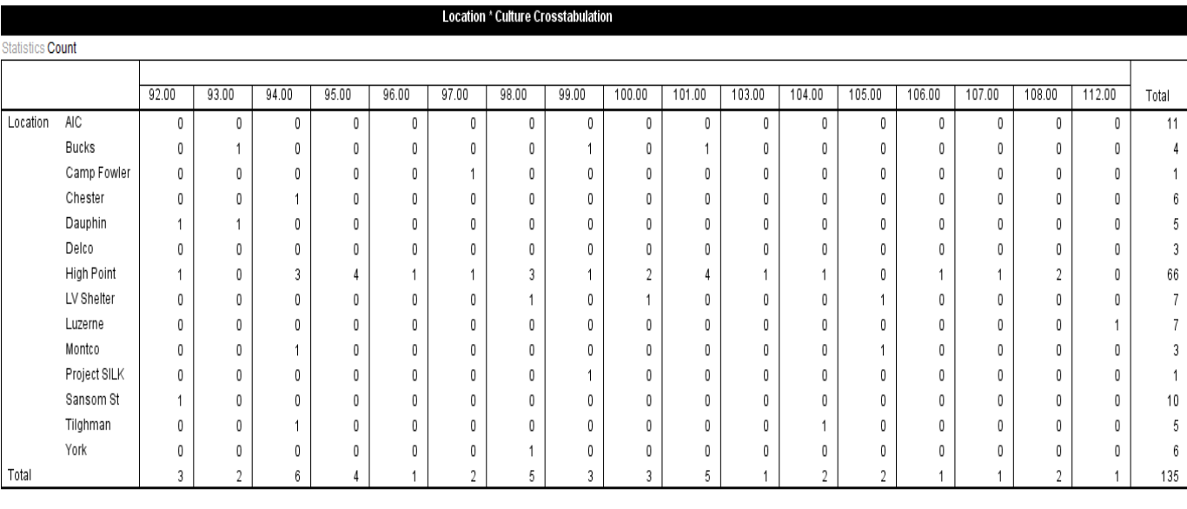
Similarly, frequency of burnout scores and culture scores were examined for each of Administrative, Supervisor and Direct Service role. See Figures 4.7 and 4.8 respectively.
Figure 4.7
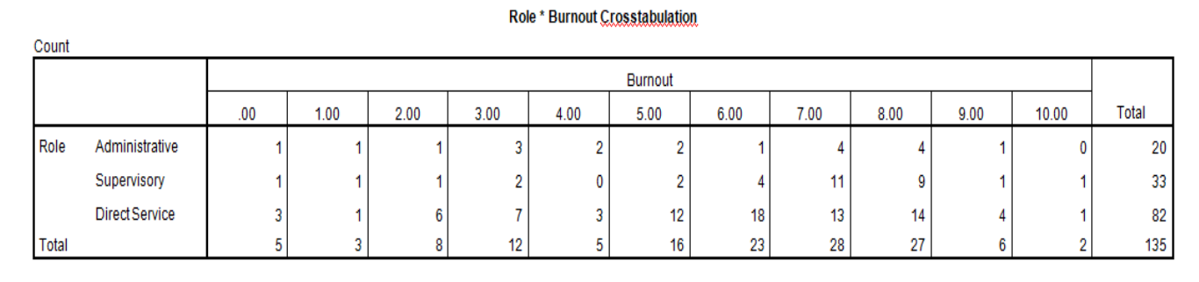
Figure 4.8
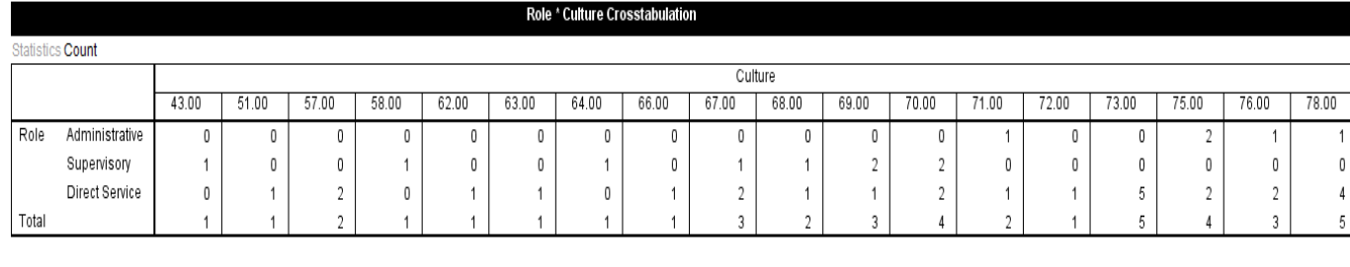
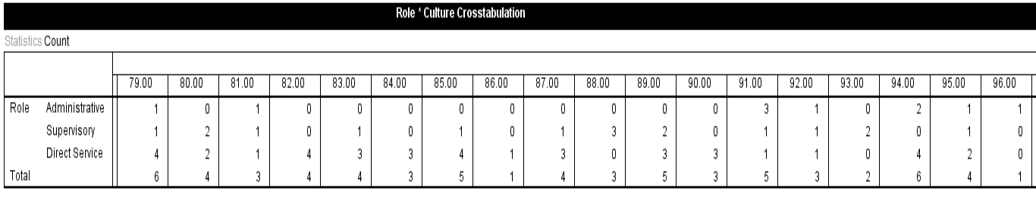
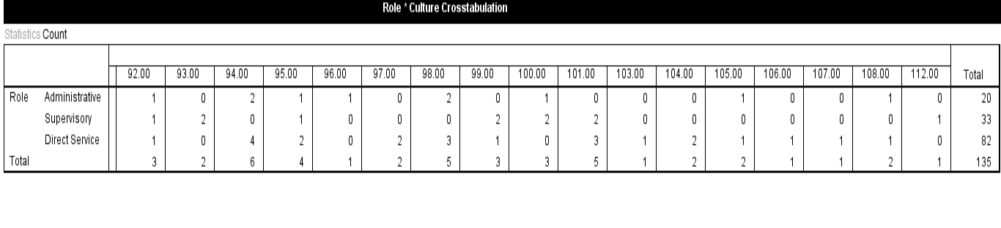

Response Frequency in Individual Question Samples
Several individual questions were also examined for trends in frequency of positive or negative response. Figure 4.9 represents 31.8% of respondents reporting some level of discrimination, bias or prejudice in their workplace.

Figure 4.9
No discrimination, bias, prejudice
 |  | Frequency | Percent | Valid Percent | Cumulative Percent
Valid | No I do not agree at all | 6 | 4.4 | 4.4 | 4.4
 | No I do not agree entirely | 37 | 27.4 | 27.4 | 31.9
 | Yes I agree to some degree | 46 | 34.1 | 34.1 | 65.9
 | Yes I agree entirely | 46 | 34.1 | 34.1 | 100.0
 | Total | 135 | 100.0 | 100.0

Figure 4.10 illustrates 59.2% of respondents reporting being dissatisfied to some degree with their rate of pay for their education and experience
Figure 4.10
Paid fairly/in line w/edu & exp
 |  | Frequency | Percent | Valid Percent | Cumulative Percent
Valid | No I do not agree at all | 33 | 24.4 | 24.4 | 24.4
 | No I do not agree entirely | 47 | 34.8 | 34.8 | 59.3
 | Yes I agree to some degree | 37 | 27.4 | 27.4 | 86.7
 | Yes I agree entirely | 18 | 13.3 | 13.3 | 100.0
 | Total | 135 | 100.0 | 100.0

Figure 4.11 shows that 33.3% of participants stating they don’t receive the resources they need to perform their job.

Figure 4.11
Gets info needed to do job
 |  | Frequency | Percent | Valid Percent | Cumulative Percent
Valid | No I do not agree at all | 7 | 5.2 | 5.2 | 5.2
 | No I do not agree entirely | 38 | 28.1 | 28.1 | 33.3
 | Yes I agree to some degree | 55 | 40.7 | 40.7 | 74.1
 | Yes I agree entirely | 35 | 25.9 | 25.9 | 100.0
 | Total | 135 | 100.0 | 100.0

Figure 4.12 showing that 40% of participants report not being involved in decisions in their workplace
Figure 4.12
Involved in decisions @ work
 |  | Frequency | Percent | Valid Percent | Cumulative Percent
Valid | No I do not agree at all | 16 | 11.9 | 11.9 | 11.9
 | No I do not agree entirely | 38 | 28.1 | 28.1 | 40.0
 | Yes I agree to some degree | 56 | 41.5 | 41.5 | 81.5
 | Yes I agree entirely | 25 | 18.5 | 18.5 | 100.0
 | Total | 135 | 100.0 | 100.0

Figure 4.13 illustrating that 48.2% feel that when things need improving in the workplace, changes are not made.

Figure 4.13
Change things that need improving
 |  | Frequency | Percent | Valid Percent | Cumulative Percent
Valid | No I do not agree at all | 17 | 12.6 | 12.6 | 12.6
 | No I do not agree entirely | 48 | 35.6 | 35.6 | 48.1
 | Yes I agree to some degree | 48 | 35.6 | 35.6 | 83.7
 | Yes I agree entirely | 22 | 16.3 | 16.3 | 100.0
 | Total | 135 | 100.0 | 100.0

Figure 4.14 showing 32.5% of respondents feel there is no discussion about the future of the program to some degree
Figure 4.14
Discuss program's future
 |  | Frequency | Percent | Valid Percent | Cumulative Percent
Valid | No I do not agree at all | 11 | 8.1 | 8.1 | 8.1
 | No I do not agree entirely | 33 | 24.4 | 24.4 | 32.6
 | Yes I agree to some degree | 55 | 40.7 | 40.7 | 73.3
 | Yes I agree entirely | 36 | 26.7 | 26.7 | 100.0
 | Total | 135 | 100.0 | 100.0

Figure 4.15 shows 40.7% of participants report that results are not followed up in an effort to improve

Figure 4.15
Follow up and evaluate results to improve program
 |  | Frequency | Percent | Valid Percent | Cumulative Percent
Valid | No I do not agree at all | 6 | 4.4 | 4.4 | 4.4
 | No I do not agree entirely | 49 | 36.3 | 36.3 | 40.7
 | Yes I agree to some degree | 57 | 42.2 | 42.2 | 83.0
 | Yes I agree entirely | 23 | 17.0 | 17.0 | 100.0
 | Total | 135 | 100.0 | 100.0

Figure 4.16 shows 34% report feeling that their office is not connected to the organization as a whole
Figure 4.16
Identify as part of VYH as a whole
 |  | Frequency | Percent | Valid Percent | Cumulative Percent
Valid | No I do not agree at all | 11 | 8.1 | 8.1 | 8.1
 | No I do not agree entirely | 35 | 25.9 | 25.9 | 34.1
 | Yes I agree to some degree | 50 | 37.0 | 37.0 | 71.1
 | Yes I agree entirely | 39 | 28.9 | 28.9 | 100.0
 | Total | 135 | 100.0 | 100.0

Figure 4.17 shows that 70.1% of participants feel they have too much to do always or often
Figure 4.17
Has too much to do
 |  | Frequency | Percent | Valid Percent | Cumulative Percent
Valid | Always true | 55 | 40.7 | 40.7 | 40.7
 | Often true | 40 | 29.6 | 29.6 | 70.4
 | Sometimes true | 32 | 23.7 | 23.7 | 94.1
 | Never true | 8 | 5.9 | 5.9 | 100.0
 | Total | 135 | 100.0 | 100.0

Figure 4.18 shows that 59.2% of respondents experience burnout always or often
Figure 4.18
Experiences burnout
 |  | Frequency | Percent | Valid Percent | Cumulative Percent
Valid | Always true | 18 | 13.3 | 13.3 | 13.3
 | Often true | 62 | 45.9 | 45.9 | 59.3
 | Sometimes true | 51 | 37.8 | 37.8 | 97.0
 | Never true | 4 | 3.0 | 3.0 | 100.0
 | Total | 135 | 100.0 | 100.0

In addition to the preceding negative trends, there were also positive trends in responses, particularly with regard to feeling attachment with the agency mission (97%), as well as client and job embededness (93.3%). This is consistent with what the literature stated about why employees at human service agencies will remain in their jobs despite dissatisfaction in other areas. Figures 4.19 and 4.20 illustrate these concepts.

Figure 4.19 97% Feel Attachment to Mission
Believes in Mission and Vision of VYH
 |  | Frequency | Percent | Valid Percent | Cumulative Percent
Valid | No I do not agree at all | 1 | .7 | .7 | .7
 | No I do not agree entirely | 3 | 2.2 | 2.2 | 3.0
 | Yes I agree to some degree | 30 | 22.2 | 22.2 | 25.2
 | Yes I agree entirely | 101 | 74.8 | 74.8 | 100.0
 | Total | 135 | 100.0 | 100.0

Figure 4.20 93.3% Client and Job Embededness
Committed/invested clients,coworkers,workplace
 |  | Frequency | Percent | Valid Percent | Cumulative Percent
Valid | No I do not agree at all | 2 | 1.5 | 1.5 | 1.5
 | No I do not agree entirely | 7 | 5.2 | 5.2 | 6.7
 | Yes I agree to some degree | 30 | 22.2 | 22.2 | 28.9
 | Yes I agree entirely | 96 | 71.1 | 71.1 | 100.0
 | Total | 135 | 100.0 | 100.0

The agency also scored positive responses in areas of teamwork/collaboration (80%), help from co-workers (87.4%), having an influence in their work (80%), participating in team meetings (96.3%), discussing their development (83.7%) and 80% stating that they enjoy being in their workplace which is a sign of job satisfaction. With regard to discussing development however, the researcher will allude to this later in the conclusions because the other research as that figure can be misleading. (See appendix for responses of all questions)

Means
The mean burnout and culture scores for the entire agency were computed and displayed in figure 4.21. Since this was not a normal distribution, it is important to note that the median in this data set was 6 and the mode was 7. Overall, 63.6% of participants reported burnout levels of 6 or above.
Figure 4.21
Report
 | Burnout | Culture
Mean | 5.7704 | 84.6963
N | 135 | 135
Std. Deviation | 2.35296 | 13.02138

Similarly, the means were broken down according to program office and role. The offices with the highest average Burnout Scores were Delaware County (7.667), Chester County and Montgomery County (each with 7.33), Camp Fowler and Tilghman Street (7.00), Sansom Street (6.10) and AIC at 6.09. See figure 4.22 and 4.23.

Figure 4.22

Burnout Culture * Location
Location |  | Burnout | Culture
AIC | Mean | 6.0909 | 74.9091
 | N | 11 | 11
 | Std. Deviation | 1.81409 | 11.36182
Bucks | Mean | 4.0000 | 94.5000
 | N | 4 | 4
 | Std. Deviation | 2.16025 | 7.18795
Camp Fowler | Mean | 7.0000 | 97.0000
 | N | 1 | 1
 | Std. Deviation | . | .
Chester | Mean | 7.3333 | 84.3333
 | N | 6 | 6
 | Std. Deviation | 1.63299 | 8.38252
Dauphin | Mean | 5.6000 | 79.8000
 | N | 5 | 5
 | Std. Deviation | 3.20936 | 12.79453
Delco | Mean | 7.6667 | 65.6667
 | N | 3 | 3
 | Std. Deviation | .57735 | 3.51188
High Point | Mean | 5.7727 | 85.9242
 | N | 66 | 66
 | Std. Deviation | 2.28571 | 13.89113
LV Shelter | Mean | 4.7143 | 90.7143
 | N | 7 | 7
 | Std. Deviation | 3.19970 | 10.45170
Luzerne | Mean | 4.1429 | 85.7143
 | N | 7 | 7
 | Std. Deviation | 2.47848 | 14.23276
Montco | Mean | 7.3333 | 92.6667
 | N | 3 | 3
 | Std. Deviation | .57735 | 13.05118
Project SILK | Mean | 6.0000 | 99.0000
 | N | 1 | 1
 | Std. Deviation | . | .
Sansom St | Mean | 6.1000 | 79.7000
 | N | 10 | 10
 | Std. Deviation | 2.37814 | 8.56414
Tilghman | Mean | 7.0000 | 84.8000
 | N | 5 | 5
 | Std. Deviation | 2.91548 | 13.89964
York | Mean | 4.5000 | 88.1667
 | N | 6 | 6
 | Std. Deviation | 2.16795 | 6.04704
Total | Mean | 5.7704 | 84.6963
 | N | 135 | 135
 | Std. Deviation | 2.35296 | 13.02138

Figure 4.23

Burnout Culture * Role
Role |  | Burnout | Culture
Administrative | Mean | 5.2500 | 89.4000
 | N | 20 | 20
 | Std. Deviation | 2.63329 | 10.81617
Supervisory | Mean | 6.3939 | 83.9697
 | N | 33 | 33
 | Std. Deviation | 2.26301 | 14.83131
Direct Service | Mean | 5.6463 | 83.8415
 | N | 82 | 82
 | Std. Deviation | 2.29531 | 12.63883
Total | Mean | 5.7704 | 84.6963
 | N | 135 | 135
 | Std. Deviation | 2.35296 | 13.02138
Figure 4.23 shows Supervisors having a higher mean Burnout Score than either Administrative Staff or Direct Service Staff.

Chapter Five: Data Analysis
Results and demographic information were placed in the Statistical Package for the Social Science (SPSS) program to analyze the data. Results from the survey were collected and analyzed and correlations were examined. The intention of the research was to see if there was a difference between the burnout levels of Administrative, Supervisory and Direct Service Staff as well as between the 14 different office locations. Similarly, differences were examined in culture for the same variables. Finally, a correlation was sought between Burnout Scores and Workplace Culture. In the midst of examining the potential relationship, individual questions were analyzed for any correlations as well.

Figure 5.1
Correlations
 |  | Location | Role | Burnout | Culture
Location | Pearson Correlation | 1 | .028 | -.037 | .107
 | Sig. (2-tailed) |  | .747 | .666 | .218
 | N | 135 | 135 | 135 | 135
Role | Pearson Correlation | .028 | 1 | .001 | -.127
 | Sig. (2-tailed) | .747 |  | .991 | .142
 | N | 135 | 135 | 135 | 135
Burnout | Pearson Correlation | -.037 | .001 | 1 | -.450**
 | Sig. (2-tailed) | .666 | .991 |  | .000
 | N | 135 | 135 | 135 | 135
Culture | Pearson Correlation | .107 | -.127 | -.450** | 1
 | Sig. (2-tailed) | .218 | .142 | .000
 | N | 135 | 135 | 135 | 135
**. Correlation is significant at the 0.01 level (2-tailed).

Figure 5.1 shows potential relationships between Burnout Scores, Culture Score, Office Location and Role. The research showed a significant negative correlation between Burnout and Workplace Culture. This means that as participants recorded a higher burnout level, culture was lower, and vice versa. The implication in this case is that improving culture at individual office locations could potentially help to decrease burnout. There was no significant correlation between the different roles or different office locations and their impact on burnout or culture scores. See Figure 5.2 for scatter plot distribution.

Figure 5.2 showing a strong negative correlation in the data between burnout and culture

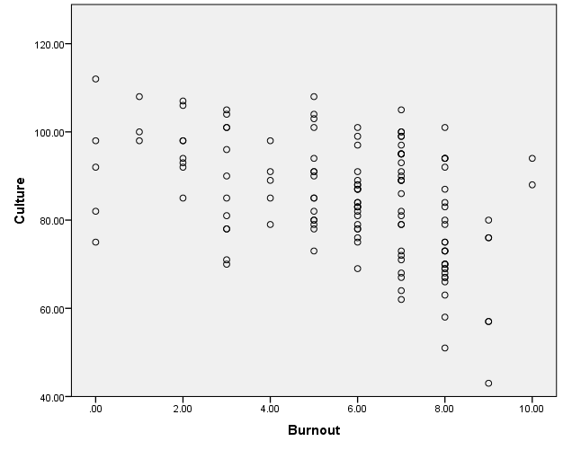

The next step in the process was to analyze specific questions that characterized workplace culture for any potential relationships between those characteristics and burnout.

Figure 5.3 depicting negative correlation between Burnout and upholding agency mission
Correlations
 |  | Burnout | Workplace upholds Mission and Vision of VYH
Burnout | Pearson Correlation | 1 | -.304**
 | Sig. (2-tailed) |  | .000
 | N | 135 | 135
Workplace upholds Mission and Vision of VYH | Pearson Correlation | -.304** | 1
 | Sig. (2-tailed) | .000
 | N | 135 | 135
**. Correlation is significant at the 0.01 level (2-tailed).

Figure 5.4 showing a correlation between burnout and having too much to do
Correlations
 |  | Burnout | Has too much to do
Burnout | Pearson Correlation | 1 | .285**
 | Sig. (2-tailed) |  | .001
 | N | 135 | 135
Has too much to do | Pearson Correlation | .285** | 1
 | Sig. (2-tailed) | .001
 | N | 135 | 135
**. Correlation is significant at the 0.01 level (2-tailed).

Figure 5.5 showing a negative correlation between Burnout and support from supervisor
Correlations
 |  | Burnout | Not enough help/support from supervisor
Burnout | Pearson Correlation | 1 | -.346**
 | Sig. (2-tailed) |  | .000
 | N | 135 | 135
Not enough help/support from supervisor | Pearson Correlation | -.346** | 1
 | Sig. (2-tailed) | .000
 | N | 135 | 135
**. Correlation is significant at the 0.01 level (2-tailed).

Figure 5.6 showing a negative correlation between clear division of responsibility and burnout
Correlations
 |  | Burnout | Clear division of responsibility
Burnout | Pearson Correlation | 1 | -.369**
 | Sig. (2-tailed) |  | .000
 | N | 135 | 135
Clear division of responsibility | Pearson Correlation | -.369** | 1
 | Sig. (2-tailed) | .000
 | N | 135 | 135
**. Correlation is significant at the 0.01 level (2-tailed).
Figure 5.7 showing negative correlation between pay and burnout
Correlations
 |  | Burnout | Paid fairly/in line w/edu & exp
Burnout | Pearson Correlation | 1 | -.238**
 | Sig. (2-tailed) |  | .006
 | N | 135 | 135
Paid fairly/in line w/edu & exp | Pearson Correlation | -.238** | 1
 | Sig. (2-tailed) | .006
 | N | 135 | 135
**. Correlation is significant at the 0.01 level (2-tailed).
Figure 5.8 showing negative correlation between burnout and being involved in decisions
Correlations
 |  | Burnout | Involved in decisions @ work
Burnout | Pearson Correlation | 1 | -.230**
 | Sig. (2-tailed) |  | .007
 | N | 135 | 135
Involved in decisions @ work | Pearson Correlation | -.230** | 1
 | Sig. (2-tailed) | .007
 | N | 135 | 135
**. Correlation is significant at the 0.01 level (2-tailed).
Figure 5.9 showing relationship between client and job embededness and burnout

Correlations
 |  | Burnout | Committed/invested clients,coworkers,workplace
Burnout | Pearson Correlation | 1 | -.209**
 | Sig. (2-tailed) |  | .209
 | N | 135 | 135
Committed/invested clients,coworkers,workplace | Pearson Correlation | -.209** | 1
 | Sig. (2-tailed) | .209
 | N | 135 | 135
**. Correlation is significant at the 0.01 level (2-tailed).
Figure 5.10 showing negative correlation between collaborating with the team and burnout
Correlations
 |  | Burnout | Collaborate well
Burnout | Pearson Correlation | 1 | -.207*
 | Sig. (2-tailed) |  | .016
 | N | 135 | 135
Collaborate well | Pearson Correlation | -.207* | 1
 | Sig. (2-tailed) | .016
 | N | 135 | 135
*. Correlation is significant at the 0.05 level (2-tailed).
Figure 5.11 showing negative correlation between burnout and having a voice
Correlations
 |  | Burnout | Can freely state opinions
Burnout | Pearson Correlation | 1 | -.285**
 | Sig. (2-tailed) |  | .001
 | N | 135 | 135
Can freely state opinions | Pearson Correlation | -.285** | 1
 | Sig. (2-tailed) | .001
 | N | 135 | 135
**. Correlation is significant at the 0.01 level (2-tailed).

Figure 5.12 showing negative correlation between being treated fairly and burnout level
Correlations
 |  | Burnout | Satsified with the way they are treated
Burnout | Pearson Correlation | 1 | -.367**
 | Sig. (2-tailed) |  | .000
 | N | 135 | 135
Satsified with the way they are treated | Pearson Correlation | -.367** | 1
 | Sig. (2-tailed) | .000
 | N | 135 | 135
**. Correlation is significant at the 0.01 level (2-tailed).

Chapter Six: Conclusion
Summary
The research began with the following research questions:
- How is it that 14 office locations in a moderately sized nonprofit agency form their own individual personality (culture)?
- How is it that the personality (culture) of each office contributes to the satisfaction or burnout of its employees?
- How much variance occurs in employees’ reported level of burnout when levels are examined by an employee’s role (ie: Administrative, Supervisory and Direct Service)?
- How much does workplace culture and employee burnout contribute to an employee’s likelihood of quitting their job?
In looking at the mean culture and burnout scores, we can conclude, based on the differences in the scores between offices, that each office does have its own culture. Characteristics of culture such as Perceived Organizational Support, Perceptions of Fairness, Communication and Teamwork all play a role in how that culture is formed. This is partially on account of the fact that Valley Youth House has 14 different offices, the expectation is that each office will acculturate differently just by the nature of having so many locations. The research answers the question that each office will establish its own culture pattern and assimilate that culture between staff at that office based on the office norms.
With regard to the second question, the research supports the fact that workplace culture does indeed affect burnout levels of its employees. The established culture patterns of each office dictate how characteristics of culture are formed, and employees will remain within that culture unless, and until the culture pattern is changed. The research did not look at who is responsible for setting the culture (whether it is individual or group), but a negative correlation of -.450 illustrates that as culture goes down, burnout will rise and vice versa. This is actually a very strong indicator that if burnout is an issue that this organization wants to address, it should look at culture within those offices.
The third question asks about variance between burnout levels and employee role. There was no significant correlation between an employee’s role and burnout or culture scores. That does not conclude that every employee develops burnout the same way, it simply means that we cannot draw any conclusions about role and burnout or culture.
The fourth and final question asked about an employee’s likelihood of quitting their job based on burnout score. There was a flaw in the research design in the capability of the researcher to analyze this impact because there was no scale of measurement in place to capture the likelihood. This could be seen as an implication for further research. Based on the exit interviews there was no conclusive evidence to support that there are generalized reasons why employees leave this organization. It is important to note that every participant in this survey were current employees. They represent the population of employees who remain at their jobs, and that is the direction this research stayed in.
The qualitative analysis provided a voice to current employees about the culture they experience in their workplace. What is interesting to note is that the question was soliciting feedback about office culture, but responses not only fit into the category of office culture, but respondents were compelled to provide feedback about their co-workers, clients and the nature of the work they perform as well. The responses generated were both positive and negative, indicating that employees freely expressed their voice. The bulk of the responses as seen on both the Qualitative Response Chart (Figure 3.4 in Appendix) and the Word Clouds (Figure 3.5 in Appendix) indicated feelings of being busy, stressed, involved in teamwork and widely supported. This upholds the quantitative research that concluded that people largely perceive themselves as having a lot of work to perform but they feel part of a team. Feeling supported was also something that, based on the frequency of responses, was not a concern to this organization.
Individual questions on the questionnaire substantially upheld the research in the areas of Attachment to Mission, Client and Job Embededness, Perceived Organizational Support, Social Justice/Fairness and Teamwork/Collaboration. Employees of this organization almost overwhelmingly identified in these areas as qualities being present in their workplace to some degree. This is also despite almost overwhelming dissatisfaction with pay, which is also an area the literature supported.
The one area that the literature stated would mitigate burnout levels was Development/Growth opportunities. Respondents in these areas answered the question about “All genders have equal opportunities” at 84.4% positive, and “having discussions with my nearest supervisor about personal and professional development” at 83.7% positive. Despite these responses, individuals still experience high burnout scores. To interpret this correctly, this researcher infers that having conversations is not the same as being given opportunities. This will be discussed more in the next section.
The areas of concern within the responses, were in the areas of “Being involved in decisions”, “Feeling of being part of the organization”, “Change things that need improving”, “Discussing program’s future” (which also ties into having a clear plan of action for the program), “Having resources to perform job duties”, “Having too much to do”, “Discrimination, Bias, Prejudice”, and “Clear division of responsibility” which ties into Role Clarity that the literature states can cause burnout if that isn’t present. These areas will each be addressed in the Recommendations section of this paper.
Burnout is a problem that affects all human service agencies, as the literature describes. This organization is no different. Mean burnout scores for the entire agency were 5.77, and that fluctuated slightly either way depending on role. It’s important to note that the scores were based on a scale from 0 to 10, and there were scores on either end. This indicates to the researcher that the indicated score is high for this line of work.
Policy Recommendations
Social Service agencies and nonprofit organizations in particular, are faced with unique challenges that other sectors do not suffer from as uniquely. One such challenge is in turnover. As learned from the literature, industry standard is roughly 19%, and 84% of the nonprofits that participated in the Nonprofit HR study did not have a formal retention plan in place (Nonprofit HR, 2016). This organization has a unique set of challenges in the fact that they operate 14 remote offices in 14 different counties. This is no small task. There is a large amount of responsibility to the leadership of each office to promote the Mission and Vision of the company while making sure the “double bottom line” of mission fulfillment and financials are being met. The greatest resource this organization has is in its employees. They have a substantial amount of attachment to the organization, and simply love the work they do as evidenced by the level of job and client embededness they possess.
The organization should form a formal Employee Retention Plan for several reasons. First, hiring, onboarding and training are expensive. It behooves the organization to retain the staff they have. Secondly, if that premise is true, then seasoned staff is even harder to replace, theoretically. Third, educated and licensed staff is difficult to find and recruit at the pay scale that most nonprofits are able to spend to attain them. Lastly, the employees at this organization are valuable in the sense that they are committed to the work and the organization. The longer they remain employed, the more of a net gain all parties experience. With that being said, the following recommendations are being made to this organization that can become part of a formalized retention plan.
- As stated at various parts in this research, employees’ values are different from individual to individual. It should not be assumed that every employee values money or opportunity the same. The research is showing that despite pay dissatisfaction, employees still feel committed to this organization. Time and effort should be taken to find out what each employee values. This can be done at performance evaluation time when establishing goals. Then, yearly thereafter, they should be re-evaluated to see if those values have changed, much like the performance goals.
- The above recommendation should be done by a member of the Organization’s Leadership team in an effort to establish a connection with its individual employees. The research shows that employees feel disconnected, or not part of the organization as a whole. There’s a natural roadblock in the way to improving that sentiment, which is 14 different office locations. The Vice President or higher can improve this by making more regular visits or phone calls to staff to improve the connection to staff. That individual should also try to make themselves available to all new hires as a “Meet and Greet”, much like the practice used to be with the original CEO.
- Members of each office should be allowed, as permitted, to take part in the decision making process for the program/region. Employees feel like they are not involved enough, and the literature shows that allowing employees a voice can alleviate burnout. Team meetings offer a forum to be able to collaborate on treatment goals, but programs should be regularly evaluated for satisfaction, and members given an opportunity to express what needs improving.
- Two responses tied together, “Too much to do” and “Have resources to perform job” are difficult to solve when money is an obvious concern to nonprofit organizations. However, the sentiment was that almost overwhelmingly, people identified with having heavy workloads. A finite amount of workers is always going to be a barrier to more manageable workloads, but ensuring that employees are receiving the necessary resources is thereby essential.
- Offer more leadership training on cultural competence. The organization strives for diversity and cultural competence. Leadership should be better trained to be able to identify practices of discrimination, racism, favoritism and bullying. Being aware of cultural differences is not the same as practicing awareness and instilling in others.
- Design a workgroup to make job descriptions clearer and easier to understand. There are many dimensions to the roles performed within the organization, and many duties can come up spontaneously in an effort to manage situations in the moment. The research shows employees feel confused about their role and at least to some degree, feel that there is an imbalance in job duties. A workgroup to clarify descriptions would help to mitigate this.
- This ties into the first few recommendations, but it is essential to work with employees to establish their development and support opportunities for growth. It is this researcher’s opinion that if employees remain engaged in the process of their own development, they will value those opportunities and remain committed to the organization. It becomes a Two-Way relationship, with both parties receiving a return on their investments. Holding consistent with Conservation of Resources Theory, employees will try to protect their resources or obtain new ones when the current ones are threatened. In this case, growth is the resource. The research shows that individuals can have discussions about their growth, but at some point, employees are leaving to go elsewhere. If employees had opportunities within the organization, theoretically, they would remain at their jobs.
- The employees of this organization are committed and invested in the Mission, the Clients and the Work they do. Offering new ways to practice that mission would most likely help to develop new opportunities. This can be in the form of practicing and learning new skills, being given volunteer opportunities or being asked to take on new and exciting tasks like outreach in the community. The organization should identify the Mission Drivers and utilize them to spread the mission more fully throughout the 14 office locations.
Challenges to the Research
Although several interesting trends were noticed, the original intention of the study was get an idea of burnout and culture scores for each of 14 offices. The first limitation was that some offices were represented in very small numbers and conclusions simply could not be reached. Originally, every office was invited to participate. However, due to the nature of having 14 offices, this investigator is simply not known to all employees of the organization. Those who did respond could have recognized the researcher and were therefore more likely to participate, and possible exhibit bias in their responses.
Another limitation was in the fact that the sample only contained current employees. This researcher intended to tie in findings about how burnout affects staff turnover, but because all participants were current employees, the only conclusions that were able to be drawn were on factors affecting retention. There also was no question asking about length of tenure at the organization, or gender, although deciding against the inclusion of gender was intentional. Still, this could have lent itself to differences in responses and values when analyzed based on length of employment and gender.
A final limitation was in the fact that this research became a continuation in its own right on previous research conducted in the Master of Social Work program. Had the researcher began with a totally different research concept, the design may have changed to be more conducive to the research questions.
The final limitation was that research conducted was cross sectional in the sense that it was taken at one point in time, as opposed to longitudinal. A study of this nature would have yielded more significant results if conducted over a period of time to see how likely a participant was to quit their job and if they actually did. Time constraints and accessibility to the population did not make this possible however.

Suggestions for Future Research
When the researcher thought of the idea to study Burnout in employees at this organization, it was rooted in personal experience as both an employee and co-worker, experiencing burnout in both facets. Through word of mouth among the cohort, it was known that there were other employees who felt a sense of being overwhelmed within the agency. Give the knowledge the researcher has of self care and burnout, the assumption was that the phenomenon was widespread. The research that was conducted produced evidence of stress and burnout among all office locations. What needed to be examined further was why employees quit their jobs, and whether burnout actually led them to that end. There are a few obvious variables present within the current sampling group, most notably that they are still employed at the organization. Future research should look at the likelihood of employees leaving their job and if burnout is a factor in that decision.
Secondly, every office location assimilates differently to their own culture. It is extremely difficult to have a consistent culture pattern across all office locations. However, future research could examine how that culture is formed, whether by a single individual who expresses such culture, or as a group process. The research could examine individual offices separately, perhaps in qualitative form to generate responses about how that process takes place.
Another implication is to study other demographics in addition to role and office location. Different genders hold different values in the workplace. Future research can examine the values of each individual to examine if certain values align more closely or easier to the organization’s values. Not only to what extent does one’s gender and education level affect burnout levels, but also to explore other variables like length of employment and how big or small each location is, employee wise. Stress is a constant in everyone’s life, to varying degrees. Working in human services can increase secondary traumatization and compassion fatigue, which are stressors in themselves, and is expected to impact one’s functionality. It warrants further study in order to create a more fulfilling experience for the employees of human service agencies where the likelihood of these phenomena are high. There is expected to be a wealth of information contained within a longitudinal study, which would follow an employee to examine burnout patterns and intensity, and see how their stress level fluctuates or remains static, and whether it leads to job turnover. There was simply not enough time to study every variable that could have come into play throughout the course of the research.
It would also be interesting further research to examine burnout and culture trends across sectors of government and for-profit companies. To a nonprofit organization, Mission drives all programming. It would be interesting to see how employees respond when the company holds other values like making money and getting work done as efficiently as possible.
Finally, it warrants further study simply because there is not enough research conducted in the area pertaining to individual office locations and burnout. Much was found in the Literature Review regarding organizational culture and burnout, but there was an extreme lack of research where an organization has multiple office locations.

References
Barford, S.W., & Whelton, W.J. (2010). Understanding burnout in child and youth care workers.
Child & Youth Care Forum, 39(4), 271-287

Belias, D. & Varsanis, K. (2014). Organizational culture and job burnout– a review.
International Journal of Research in Business Management. (2) pp. 43-61

Beudean, P. (2009). Employee retention. Building organizational commitment.
Recommendations for nonprofit organizations. Transylvanian Review of Administrative Sciences, Vol 5, Iss 25, Pp 40-50 (2009), (25), 40.

Brown, W. A., & Yoshioka, C. F. (2003). Mission attachment and satisfaction as factors in
employee retention. Nonprofit Management & Leadership, 14(1), 5–18.

Goodman, E.A., & Boss, R.W.. (2002). The Phase Model of Burnout and Employee
Turnover. Journal of Health and Human Services Administration, (1), 33.

Gray, J. A., & Muramatsu, N. (2013). When the Job Has Lost Its Appeal: Intentions to Quit
among Direct Care Workers. Journal of Intellectual & Developmental Disability, 38(2), 124–133.

Green, A. E., Albanese, B. J., Shapiro, N. M., & Aarons, G. A.(2014). The roles of individual
and organizational factors in burnout among community-based mental health service providers. Psychological Services, 11(1), 41–49. https://doi.org/10.1037/a0035299

Harrington, T. (2017) Valley youth house organizational goals for 2018. Retrieved from:
https://docs.google.com/document/d/1RGSkHLPKXoWCj8KMcrSQA36qUa5FF_WlQLAL7bzKao/edit

Hobfoll, S.E., Halbesleben, J., Neveu, J.P., & Westman, M. (2018). Conservation of resources in
the organizational context: The reality of resources and their consequences. Annual Review of Organizational Psychology and Organizational Behavior, 5, 103-128

Kheirandish, M., Farahani, A., & Nikkhoo, B. (2016). The impact of organizational culture on
employees’ job burnout. International Academic Journal for Science and Technology, 3(10), 1-15.

Kim, T.K., Solomon, P., & Jang, C. (2012). Organizational justice and social workers’ intentions
to leave agency positions. Social Work Research, 36(1) 31-39.

Leiter, M. P., & Maslach, C. (2001). Burnout and quality in a speed-up world. Journal For
Quality & Participation, 24(2), 48.

Marchand, C., & Vandenberghe, C. (2016). Perceived Organizational Support, Emotional
Exhaustion, and Turnover: The Moderating Role of Negative Affectivity. International Journal of Stress Management, 23(4), 350–375. https://doi.org/10.1037/str0000020

Maslach, C. & Leiter, M.P. (1997). The truth about burnout: How organizations cause personal
stress and what to do about it. San Francisco, CA: Jossey-Bass

Maslach, C. & Jackson, S.E. (1986). Maslach burnout inventory (2nd ed.). Palo Alto, CA:
Consulting Psychologists Press

Morgen Stahl, R. (2013). Talent philanthropy: Investing in nonprofit people to advance
nonprofit performance. Foundation Review, 5(3), 35

National Association of Social Workers. (2017). Code of ethics of national association of social workers. Washington, DC: Author. Retrieved from http://www.naswdc.org/pubs/code/code.asp
Nonprofit HR. (2016). 2016 nonprofit employment practices survey results. Retrieved from: http://www.nonprofithr.com/wp-content/uploads/2016/04/2016NEPSurvey-final.pdf
Schaufeli, W.B., Leiter, M.P., & Maslach, C. (2009). Burnout: 35 years of research and practice. Career Development International, 14(3), 204-220
Thomas, J. T. (2016). Adverse childhood experiences among msw students. Journal of Teaching
in Social Work, 36(3), 235-255. doi: 10.1080/08841233.2016.1182609
Thomas, M., Kohli, V., & Choi, J. (2014). Correlates of job burnout among human service workers: Implications for workforce retention. The Journal of Sociology & Social Welfare, 41(4), 69-90
Treuren, G. J. M., & Frankish, E. (2014). Pay dissatisfaction and intention to leave. Nonprofit Management & Leadership, 25(1), 5
Westbrook, T.M., Ellis, J., & Ellett, A.J. (2008). Improving retention among public child welfare
workers. Administration in Social Work, 30(4), 37-62. doi: 10.1300/J147v30n04 04

Wigert, B. and Agrawal, S. (2018). Employee burnout, part 1: The 5 main causes. Retrieved
from: https://www.gallup.com/workplace/237059/employee-burnout-part-main-causes.aspx
Yoon, D. P. & Kelly, M. J. (2008). Organizational excellence and employee retention in social
work. Professional Development (10974911), 11(3), 30.

