Newsletter #6

Welcome to Edition 6 of our 2019/20 LPCC newsletter.

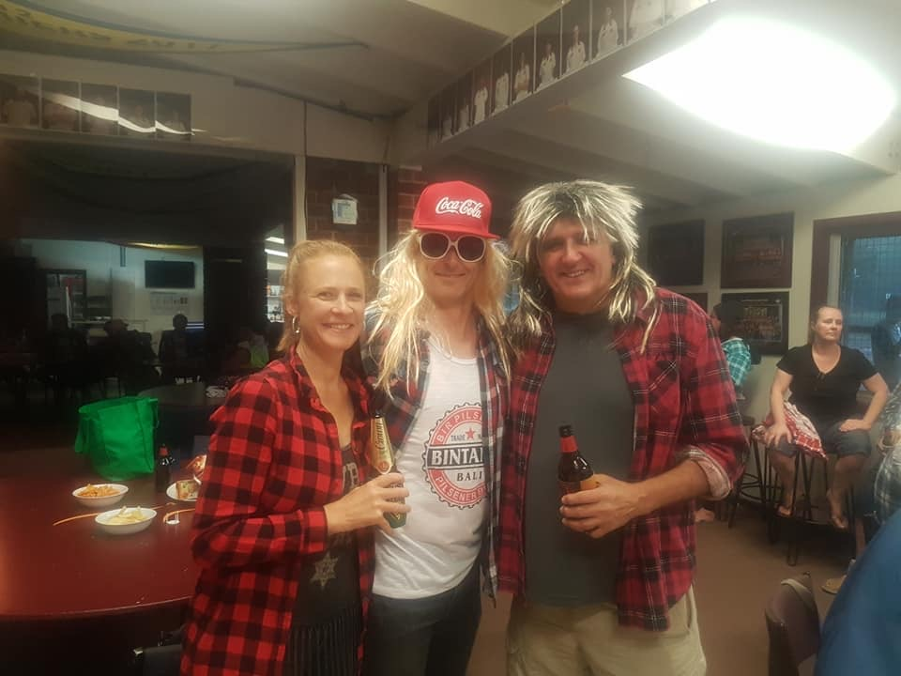

What a great night we had at Bogan Bingo recently!

Thanks to everyone who participated to make it heaps of fun, though many were waaaay to comfortable in their mullets, flannels and boardies….

Although he certainly looked the part, our 2s Captain (yes that’s him in the middle above) was the first to be knocked out in the quiz to find the biggest bogan. No surprises there, and equally no surprise that it was won by our immediate past president!

News
We’ve got a Lions’ Den day at home this Sat (15 Feb) where we hope to get a crowd down to the home of cricket to support the First XI. It’s the annual Pink Stumps day, where the boys wear the sponsored pink shirts, and we’re running a raffle to raise funds for the McGrath Foundation, so please drop in and help make it a successful day on and off-field.

Congrats to Liam Chilcott on making his first century (and in fact, first 50) v Mont in the U18s last week. This is greatly deserved after significant work and training, and consistent scores in the 18s and 2nds. Great stuff Chilli!

Next round
- Money Shield v Banyule (home)
- C Grade v Banyule (away)
- F Grade v Lower Eltham (away)
- G Grade v Bye
Latest results
The past two close (away) losses, which both could have easily gone our way, have placed the 1st XI in a perilous relegation position. All is not lost however and the coming match v 2nd placed Banyule is a vital for us to stay in Money Shield.

Bill’s back in touch with the bat, so let’s get around him and aim to bat 80 overs next match.

The 2s were in a strong position overnight in the rain-interrupted match v BU. Rosh, Max and Willo did the damage with the ball. Chilli, Trav and Gilly got us in a great position with the bat – 2/123, chasing 186 – before a collapse saw us all out for 155, effectively putting us out of the finals race. There’s plenty to be gained in the coming weeks though, so let’s finish strongly.

The 3s were unable to chase down Heidelberg’s 170 at Lower. Occa and Ed Dumbrell did the job with the ball but Al Campbell (30 no) didn’t get enough support with the bat and were all out for 109. Our fate is in our own hands as victories in the final two matches should still see us scrape into finals.

The 4s made a more-than-respectable 7/148, led by skipper Geoff’s brisk undefeated 62, supported by AP (30) and Gus Hughes making his highest senior score of 20 – great stuff Gus! One experienced Lalor batsmen was the difference however as the passed us three-down, with the old (AP) and the young (Alex Preston & Brodie James) taking the wickets.

Juniors
Welcome back everyone and I hope everyone who attended enjoyed the novelty of the Sunday morning games last week. With three wins from four maybe we should request them more often.
We are now getting into the business end of the home and away season and I am pleased to report that we have three teams in very strong ladder positions (U18s in first, U16s also in first and U14s in second) and two with an outside chance (both U12 teams). The U10 season has also restarted.
Although this was the first round of games for juniors, many of the boys played senior cricket over the break across all four of our senior teams. Current U18s player, Max Hughes, also made his first XI debut - well done Max.
I would also like to draw your attention to a number of other things going on in the junior space that we would love you to get involved in:
- Junior Presentation Night - Friday March 20 at LPCC - please save the date and we will send out details nearer the time. Hopefully one or more of our teams will be in finals action so we have gone with this date as it will be the first Friday after the Grand Final weekend.
- MyCricket and regos for next year - we will send out more details in due course but many of you will be aware of some major technical issues with MyCricket this season.
We will be running an entirely online rego process from next season but we will still be having rego nights as well so you can meet the coach, collect uniforms..etc. If you're not sure on what grade your son or daughter should be in next season, just message me at juniors@lowerplentycricketclub.com and I'll let you know. I will be consulting with all coaches about next year's teams shortly. If you are unaware of your MyCricket log in details, let us know and we can look them up for you before next season.
- Used equipment and clothing - we had great success in re-homing all the donated equipment and clothing at the start of the season and we'd love to do the same again coming into the end of the season. if you want to donate any of your clothing or equipment, bring it on Junior Presentation night and we will collect it all ready for next season.
- Pink Stumps Day and Prize Draw for the McGrath Foundation - we have our annual Pink Stumps Day fundraiser this weekend and we are also selling raffle tickets for the same cause with some great prizes including a $900 Genesis bat. Please contact Michael Ryan or myself for details.
Luke Preston

Social events

Bogan Bingo
As mentioned above, a fun night with plenty of highlights. We’ll do this one again in the future… Photos on the Facebook page

Pink Stumps /Lions Den Day
The famous LPCC Lions Den day is back this week: Sat 15 Feb

Given our Pink Stumps luncheon speaker is now unfortunately unavailable, we'll change tact and instead Sira and Eggy will host a supporters day.

Our 1st XI are wearing the sponsored Pink Shirts as we take on old foe Banyule at home. The boys are still a slim chance to avoid relegation, so hopefully our support can spur them on to an important victory.

$50/head for complimentary drinks 2-6pm, plus some of Sira and Eggy's culinary delights. Drinks are also available at bar prices if you want to just drop in for one or two.

We're running a raffle to raise funds for the McGrath Foundation, which we'll draw straight after play, so please make an effort to support that.

Old Man v Redneck Cafe
Becoming an institution at Lower - it's fine dining v the BBQ crowd as we wrap up the season for those not in finals.

Bogan v Bourgeois: Melbourne v Merlot, Dim Sim v Double-cooked pork, Barnes v Bocelli…. which camp are you in? Sat 1 Mar at the club. Come on down.

Presentation Night
It’s a lock - 28 March at Greensborough RSL. $40 for a two-course meal and drinks at bar prices.

This will be a special evening as we will be introducing a Lower Plenty Cricket Club ‘Hall of Fame’ and we will induct an initial three on-field legends.

It would be great to get as many members as possible to attend and make it a special night for three LPCC legends and their families. Please, reply to operations@lowerplentycricketclub.com to help us confirm booking numbers.

The remaining 19/20 Social Calendar is available on our website at: https://www.lowerplentycricketclub.com/2019-20-social-events

Club Apparel
The club still has a range of club apparel available – playing shirts, social shirts, shorts, hoodies, beanies, stubby holders etc. See Josh Ryan for orders or requests.

Good Sports
Sporting Clubs such as ours play a significant role in the community and have a responsibility to their members and their families. We have chosen to join over 9000 clubs across Australia taking part in the Good Sports Program. Through Good Sports we are committed to managing alcohol responsibly and ensuring smoke free areas, which we believe will help us to provide a healthy, safe and family friendly environment. Together, we are helping inspire a healthier sporting nation.

Speak to the Club Committee about what being a Good Sports Club is all about or visit Good Sports

Business Partners

The LPCC thanks the following generous business partners, whose support is vital to sustain our operations.

We encourage all club members to be aware of these organisations and utilise their services whenever possible.

Genesis Cricket Australia

