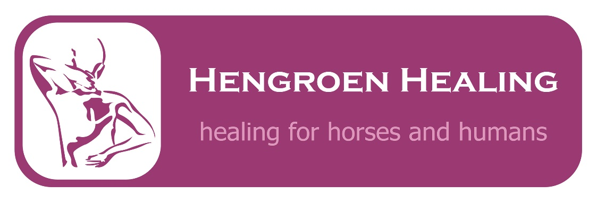
Are you feeling tired, stressed or run down?
Do you have a bad back or other aches and pains?
Would you just like a bit of pampering?

Hengroen Healing specialises in taking a holistic approach to helping you heal. I am fully qualified in a range of therapies to help you deal with your physical and emotional aches, pains and stresses. All treatments begin with a lifestyle consultation, looking at all aspects of your life and any areas of concern. This allows me to adapt the treatment specifically to suit your needs. Gift vouchers and a range of organic therapy products are also available to buy.
So if you would like some help to get your health back, just call or email me to book an appointment today.
I also offer services for animals, please contact me for further details.
Deborah McGovern 0787 655 1264
www.hengroenhealing.co.uk

Based at: Chatteris Osteopaths, 24 West Park Street, Chatteris, PE16 6AL
March Podiatry Practice, 47-49 High St,
March PE15 9JJ

Reiki/Reiki for animals
Reiki is a simple Japanese energy-balancing method. It is most well known today as a hands on treatment. Reiki can produce deep relaxation, reduced stress & anxiety and a speeding up of the natural healing process.

Holistic Massage
A traditional deep tissue massage, designed to relax and detoxify the whole body. Massage can help to boost the immune system, increase circulation, help natural recovery and ease aches and pains.

Aromatherapy
Aromatherapy uses essential oils extracted from plants to improve physical and emotional well being. It helps promote health and vitality by stimulating the body to heal itself and by reducing stress.

Reflexology
Reflexology involves the application of pressure to specific points, known as reflexes, on the feet to encourage the body to heal from within. Deeply relaxing, reflexology can help the body heal and regain its natural state of balance.

Sports massage
Sports massage is the management, manipulation and rehabilitation of soft tissues of the body including muscles, tendons and ligaments. You do not need to be a sports performer to benefit from a sports massage, as it can also benefit repetitive strain injury, sprains, tension and fatigue.

Face the weekend
Get rid of the stress of the week with a 30 minute back, neck and shoulder massage, then look your best with a 30 minute aromatherapy facial using premium Neal’s Yard Organic products.

Facebook/HengroenHealing
Facebook/HengroenHealingHorseandRider

