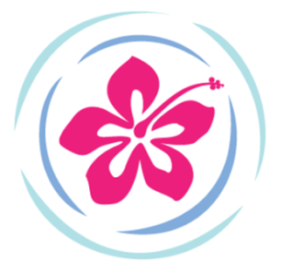

July 2018 MaryJoBrown.org

Summer is flying by!! Soon it will be time for our annual Indoor Luau Fundraiser!
If you have not already done so, please mark your calendars for:
Sunday October 14, 2018 3PM Saugus Elks Hall 401 Main Street Saugus
Follow our page on Facebook for updates and a sneak peak at our great silent auction items.
ALSO: Don’t forget about our Kindness Campaign! We are still open to nominations until September 1. Forms can be found and submitted on our website. Help us find these outstanding young citizens who deserve recognition for their compassion for others.

Since our last newsletter…
MAY
May 20th we had a wine tasting and class at Total Wines in Everett. We learned about and sampled red and white varietals from California. Paired with some delish appies provided by Christina we had a fun and informative afternoon.

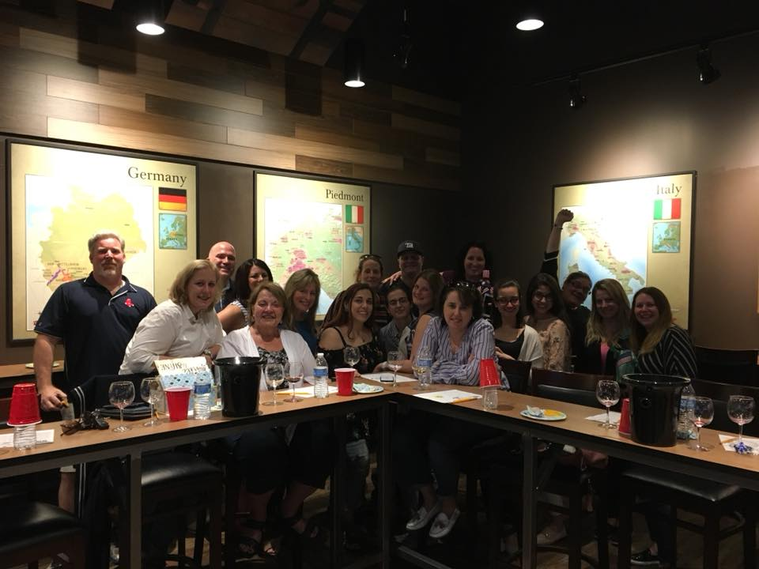

May 30th was pickup day for our collection of textiles by the Epilepsy Foundation. A huge thank you to all who donated so many items from their closets and bureaus. We amassed a whopping 165 bags weighing over 2200 pounds!! (That poor truck!) Combined with some other donations we raised $507 to add to our contribution to Child Life Services at Floating Hospital for Children at Tufts Medical Center. This has proven to be a successful endeavor for us and will be an annual event so please remember us with any further items you may have.

July:
Our July Herobox shipment was mailed out by Christina to Shannon Hunter and her group of 16 deployed servicemen and women. We are sure they will enjoy all the treats, games and items that were sent, some of which are pictured here:

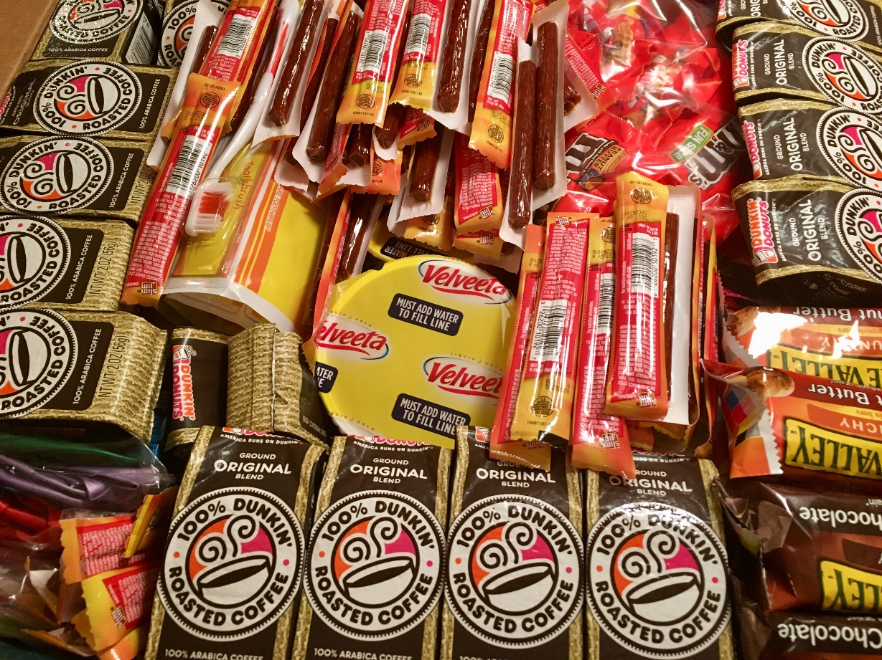

While we are on the subject of our military and Heroboxes and Care Packages for our Troops, we would like to end this newsletter with the following thank you and photo that we received. It is with your support that we are able to provide these small measures of comfort to these heroes.

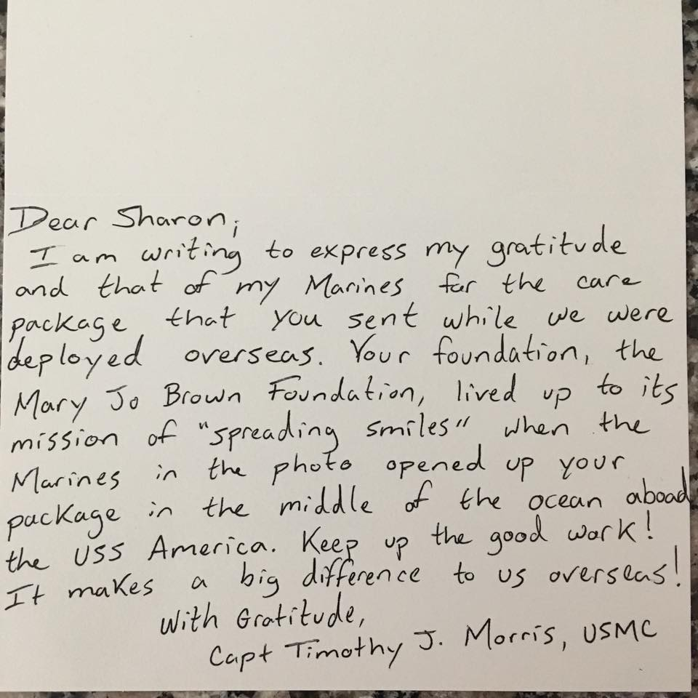

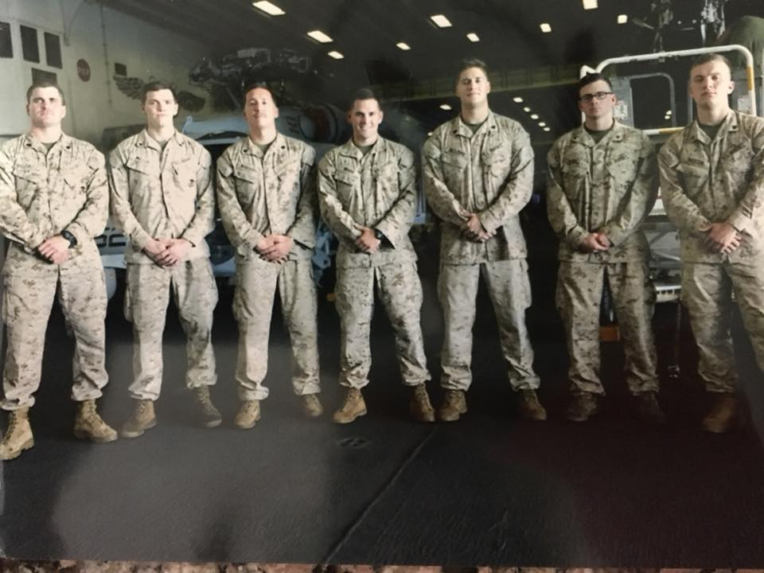

That’s it for now! Enjoy the rest of this steamy summer and, as always:

May all your dreams come true!

