Pesticides
And Their Effects on the Endocrine System
By Maddelene Karlsson
December 11, 2017

Introduction
The first uses of pesticides can be traced back to as early as 2500 BC, when the Sumerians discovered the benefits of rubbing foul-smelling Sulphur compounds on the skin to protect themselves against insects. (Banaszkiewicz, 2010). Pesticide usage then continued for both insect repellant purposes as well as agricultural purposes across different societies and eras; The ancient Egyptians, Greeks, Romans and Chinese dynasties all the way through the middle ages until present. (Taylor et al., 2007). The composition of the pesticides changed over time and by the end of the 19th century a wide range of inorganic compounds were used in agriculture. Later, in the middle of the 20th century “the real revolution in chemical control of pests took place […] when a Swiss chemist, Miller, discovered and demonstrated the properties of the insecticide DDT.” (Banaszkiewicz, 2010). During World War II, the use of DDT was widespread to stop the spread of vector borne diseases, and more pesticides were being developed, but first for warfare intentions, until the agricultural benefits were recognized. (Taylor et al., 2007). The toxicity of pesticides and its long-term consequences on the ecosystem became a thought-provoking subject for people deeply engaged in environmental health. Marine biologist, Rachel Carson notified the significant effects that pesticides had on the environment and wrote the bestselling book about the issue: Silent Spring (1962). In her book she describes her observations of the naive overuse of pesticides; “After several years of DDT spray, the town is almost devoid of robins and starlings; chickadees have not been on my shelf for two years, and this year the cardinals are gone too: the nesting population in the neighborhood seems to consist of one dove pair and perhaps one catbird family.” In the latter half of the 20th century, DDT along with other pesticides were banned, after the toxic outcomes to both humans and wildlife was documented. (Taylor et al., 2007). The use of pesticides is still widespread, and the quantities are greater than ever before, still exposing all living beings through different sources such as water, soil and foods and putting them at risk for adverse health effects. (Mnif et al., 2011). One of the most discussed questions today is how pesticides acts as endocrine disruptors, causing severe developmental and reproduction problems in aquatic and terrestrial wildlife and humans.
Background
Pest management have been practiced for centuries, but it wasn’t until the agricultural revolution in Europe in 1750 to about 1800 that crop protection became vital. (Taylor et al., 2007). By using pesticides, farmers could ensure bigger yields that in turn also would make greater profits. On a global scale, about 30% of expected crop yield is destroyed by pests, disease and weeds, to which 15% of losses occurs during transportation and storage. (Banaszkiewicz, 2010). For agriculturalists, pesticides are essential in order to meet the human needs of food and fiber while trying to preserve nonrenewable resources, protect the environmental quality for future generations, and safeguard profits and long-term feasibility. (Taylor et al., 2007). Although many harmful pesticides have been banned throughout the last few decades, to decrease the number of health implications caused by them, many that are still being used today are not safe enough to guarantee humans and wildlife that there is no threat to their optimal health. According to World Health Organization, about three million cases of pesticide poisoning occur every year globally, that results in an excess of 250,000 deaths. Most of these cases happens in developing countries, where they are for most part depending on agriculture, and have not established policies and regulations. (WHO, 2004). Although the big numbers of health implications that are caused by pesticides are frightening, today’s greatest concern is the potential endocrine system disruption caused by pesticides. The first links between pesticides and endocrine disruption was when DDT was widely used and the men involved in the aerial application had low sperm counts. (Anwer, et al., 2016). According to the Environmental Protection Agency, it was in the 1990’s that scientists reported that certain chemicals could be disrupting the endocrine system in both humans and wildlife. (US EPA, 2015). There are more than 100 different pesticides that have been identified as endocrine disruptors, and exposure to those have been suspected to cause conditions such as reproductive disorders, miscarriages and certain cancers. (Anwer, et al., 2016). In addition, age is a sensitive factor, where fetuses, infants and young children are significantly more vulnerable than adults. (Mnif et al., 2011).
Health Implications
Endocrine disruptors act primarily by interfering with natural hormones. They can bind to and activate as well as inhibit numerous hormone receptors, and interfere with the body’s management of synthesis, transport, metabolism and elimination of hormones. (Mnif et al., 2011). DDT was the first documented endocrine disruptor, as it caused calcium management ailments in birds and therefore led to thinning of eggshells and in consequence cracking before hatching. It has also been detected to accumulate in both wildlife and human adipose tissue, carrying out hormonal effects. (Banaszkiewicz, 2010). The observed hormonal effects of DDT are its competitive binding to androgen receptors, activation of androgen-sensitive cells production, stimulation of estrogen receptor production, estrogen receptor agonist and progesterone receptor antagonist. (Mnif et al., 2011). DDT have been found in adipose tissue of women diagnosed with breast cancer, and it has been associated with a statistically significant higher rate of prostate cancer among farmers who has been chronically exposed to the chemical. In fact, studies in Sweden and USA showed that farmers and commercial pesticide applicators had a higher rate of prostate cancer than the general population. (Mnif et al., 2011). Atrazine is another pesticide that is known to interfere with reproduction and development, and it may also cause cancer. It was banned in Europe because of its toxicity, but is still being widely used in the USA. (Sass et al., 2006). The endocrine disruptions associated with exposure to atrazine include: Androgen inhibition, weak estrogenic effect, disruption of the hypothalamic control of luteinizing hormone and prolactin levels, induction of aromatase activity, increased estrogen production, adrenal glands damages and reduction of steroid hormone metabolism. (Mnif et al., 2011). These hormonal changes results in decreased primary male sex hormones that are involved with development of the reproductive system as well as secondary sex characteristics, and instead an increased production of estrogen in males. Furthermore, some sources have found that exposure to atrazine is associated with an increased risk of certain cancers in humans, such as bladder-, colon-, ovarian-, lung cancer, leukemia and non-Hodgkin’s lymphoma. (Sass et al., 2006). Studies have also shown a reduction in semen quality due to decreased sperm concentrations and motility in men exposed to atrazine. (Sass et al., 2006).
Methodology
In the USA, the Environmental Protection Agency (EPA) is responsible for handling most of the regulatory issues regarding pesticides as their mission is to protect human health and the environment. Within the EPA, there is the Endocrine Disruptor Screening Program (EDSP), which uses a two-tiered approach to screen pesticides, chemicals and environmental contaminants for their potential effects on estrogen, androgen and thyroid hormone systems. (US EPA, 2015). In tier 1, screened data is used to identify those substances that possible could interact with the endocrine system. Any substances that are of significance proceed to tier 2, where any adverse endocrine-related effects caused by the substance are identified and the dose-response relationship is being determined. The results of the screening, together with other hazard information and an exposure assessment on a given chemical, then ends in a risk assessment. (US EPA, 2015). The EDSP is necessary since there are strict policies and regulations in regards of endocrine disrupting pesticides, that are established by the EPA. In addition, the congress has also passed acts such as Food Quality Protection Act, Federal Food, Drug and Cosmetic Act and the Safe Drinking Water Act, which all have set standards of how much pesticide residue that is allowed in food, water and personal care products. (US EPA, 2015).
Furthermore, in addition to the fundamental studies on the basic chemistry of pesticides, there are also experimental studies on laboratory animals such as amphibians and rodents, field studies on wildlife species and human epidemiological studies. (Anwer, et al., 2016). To reach accurate results that can be applied to real life circumstances and probabilities, researchers must take many factors into consideration. The most important is a thorough exposure assessment, that considers all possible sources of exposure to toxic substances, mirroring real world conditions. Studies that focus only on isolated pesticide exposure, may misjudge the actual health risks associated with pesticides and endocrine disruption. (Sass et al., 2006). Human exposure to pesticides has many pathways, for example; household use of pesticides, residues of pesticides in ingested foods and beverages, and exposure to agricultural usage of pesticides. Pesticides can be found in human samples of breast milk, maternal blood and serum, urine and sometimes in umbilical cord blood, and today’s technique advances allows to find very small amounts of pesticides, such as traces, which helps to make more comprehensive evaluations. (Mnif et al., 2011).
The most discussed studies on pesticides and their effects on the endocrine system are the ones conducted by University of California professor Tyrone Hayes, who in countless studies have found male amphibians going through a complete feminization. Similar conditions were observed by Hayes in wild amphibians that lived in sites with contaminated water. (Sass et al., 2006).
Feminization in Frogs Caused by Pesticide Exposure
In a study conducted by Tyrone Hayes et al., 10% of frogs that originally hatched as males, and was exposed to atrazine went through a complete feminization and became females upon sexual maturation (Figure 1. in the appendix). The femininized frogs were able to reproduce and lay viable eggs. The remaining male frogs that had been exposed to atrazine, were demasculinized, had a suppressed mating behavior, and decreased fertility. (Hayes, et al. 2010). Their study complemented other similar studies that had been vague in regards of terminology and method and led to confusions in what effects atrazine has on the endocrine system. Hayes et al. also compared their study to other similar studies, that used fish and reptiles as study subjects in the experimentation with atrazine. The results were the same for the different studies, which led them to the conclusion that the endocrine effects from exposure to atrazine are “not species, genera, family, or even order specific, but occur across vertebrate classes.” (Hayes, et al. 2010). Other concerns related to the findings of Hayes’s study include the worrisome worldwide declining amphibian population, that may very well be due to failed recruitment. During the study, it was also observed that the feminized frogs were only able of producing male offspring, and mathematical models suggest that these factors can lead to population extinction. (Hayes, et al. 2010).
Endocrine Disruption in Men Possibly Caused by Pesticide Exposure
Another study conducted in the USA by Shanna Swan, compared semen quality in fertile men in four different geographical areas. The study used standardized methods and quality control to avoid any bias, and semen quality was determined by sperm concentration, semen volume, motility and morphology, as well as a screening for pesticide metabolites. (Swan, 2006). The findings of the study showed a significant difference in semen quality between men living in agricultural areas and urban areas. The centers for the different areas that was tested were located in the states of Missouri, California, Minnesota and New York. A significantly lower semen quality was found in men living in Missouri, suggesting that the proximity to intensive agriculture and exposure to pesticides might be a possible cause. In addition, the samples collected during summer time and agricultural peak season were more likely to be cases (low semen quality and higher levels of pesticide metabolites), compared to samples collected during winter time. Lastly, atrazine was one of the pesticides that was screened for, and associated with low semen quality in the study. (Swan, 2006).
Analysis
Although the two studies were based on different species, they can still be associated with each other based on their findings. Hayes’s study on amphibians was the most worrisome, indicating on extreme endocrine disruption caused by atrazine. Now, the outcome atrazine had on the frogs, might not be an expected outcome in humans, but a certain degree of endocrine disruption is very likely going to happen as seen in Swan’s study. In both cases, atrazine was involved, which is a known endocrine disruptor. The biggest concern is that most studies focus on only one pesticide and a set amount of exposure, when in the real world, exposure to pesticides comes from many different pathways, and there usually is more than one pesticide as well. In addition, Hayes’s frogs had been exposed to atrazine during the larvae period until metamorphosis, while the exposure duration to the men in Swan’s study was unknown. This should be kept in mind as it is known that exposure to atrazine during the different lifecycles, has different health impacts, whereas some might not be evident until later in life. For example, the feminization of Hayes’s frogs was observed upon sexual maturation. This leads to the question if the results in Swan’s study could be due to pesticide exposure in the womb and early in life, or if it was due to exposure during the experimental period. To answer such questions, more thoroughly studies needs to be conducted, where all variables are looked at and then compared.
Solutions
In the USA, solutions for these problems needs to be worked on. Although the EPA has pesticide policies and regulations, to protect humans and the environment, those regulations are based on insufficient data. For example, atrazine is one of the most widely used pesticides and considered safe because there is not enough evidence to prove it a risk to humans. On the other hand, there is not enough evidence to prove safe either. Therefore, more precautions need to be taken where the proverb “better safe than sorry” should be the vantage point. Once damages to the endocrine system has been done, and wildlife populations are decreasing, it is already too late to address the problem completely. More education about his problem is needed, so that people can make active choices based on their knowledge, such as buying organic foods, using filtered water and being aware of what they might be exposed to depending on where they live. Lastly, WHO need to keep working on educating agriculturalists in developing countries as they might not be aware of possible health and environmental risks associated with pesticides. The ultimate solution would be universal pesticide policies and regulations executed and reinforced by the United Nations.
Conclusion
Risks associated with exposure to pesticides are extremely underestimated on the costs of human and environmental health. Carson made it clear that pesticides has devastating effects on the environment as early as in the 1960’s, and although studies have confirmed that pesticides have significant endocrine disruption properties, not enough action has been taken to gain more knowledge and address the issues. More studies need to be conducted until any definite conclusions can me made, but until then, all precautions need to be considered. Endocrine disruption disorders are irreversible, and since many pesticides are persistent in the environment it is important to understand the long-term consequences that may be so severe that wildlife populations go extinct. Moreover, today’s increasing numbers of infertility in humans may very well be tied to exposure to pesticides. There are solutions that can be applied, both on grassroots level as well as from top-down. All solutions include education, community engagement and empowerment, and finally evaluation of existing regulations and establishment of new ones focusing on true protection of humans and environmental health.
Appendix
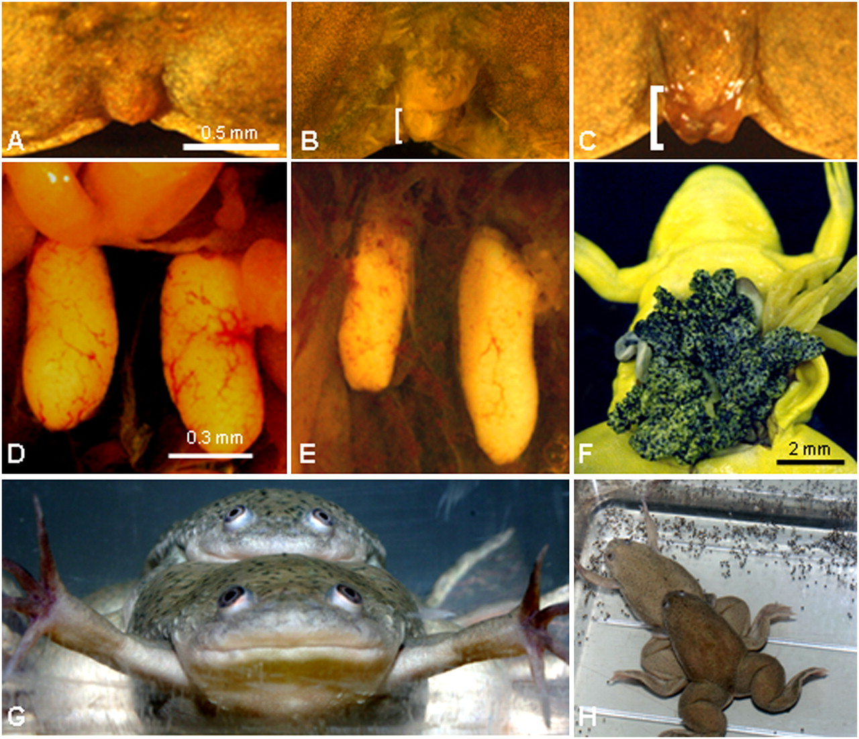Figure 1. (Tyrone B. Hayes et al. PNAS 2010;107:4612-4617)
Picture description by Hayes et al;
Atrazine feminized exposed males. Cloaca (A–C) and gonads (D–F) for control male (A and D), atrazine-exposed male (B and E), and atrazine-exposed female (C and F) ZZ animals (genetic males). (G) Atrazine-induced female (genetic male, ZZ) copulating with an unexposed male sibling. (H) Same pair as in G, producing eggs. Eggs (H) were viable and produced larvae that survived to metamorphosis and adulthood. Yellow coloration (F) is the result of fixation in Bouin’s solution. Brackets (B and C) indicate protruding cloacal labia. (Scale bar in A applies to A–C; in D applies to D and E.)

Works Cited
Anwer, F., Chaurasia, S., & Khan, A. A. (2016). Hormonally active agents in the
environment: a state-of-the-art review. Reviews on Environmental Health; Tel Aviv, 31(4), 415–433. https://doi.org/http://dx.doi.org.mutex.gmu.edu/10.1515/reveh-2016-0014
Banaszkiewicz, T. (2010). Influence of the Pesticide Dump on the Environment.
Contemporary Problems of Management and Environmental Protection, 5, 7-18. Retrieved December 6, 2017 from http://www.uwm.edu.pl/environ/vol05/vol_05_chapter01.pdf
Carson, R. (1962). Silent spring. Fawcett World Library. USA
Hayes, T. B., Khoury, V., Narayan, A., Nazir, M., Park, A., Brown, T., … Gallipeau, S.
(2010). Atrazine induces complete feminization and chemical castration in male African clawed frogs (Xenopus laevis). Proceedings of the National Academy of Sciences, 107(10), 4612–4617. https://doi.org/10.1073/pnas.0909519107
Mnif, W., Hassine, A. I. H., Bouaziz, A., Bartegi, A., Thomas, O., & Roig, B. (2011). Effect
of Endocrine Disruptor Pesticides: A Review. International Journal of Environmental Research and Public Health, 8(6), 2265–2303. https://doi.org/10.3390/ijerph8062265
Sass, J. B., Colangelo, A. (2006). European Union Bans Atrazine, While the United States
Negotiates Continued Use. Int J Occupational Environmental Health, 12(3), 260-267. Retrieved December 9, 2017, from http://centerforhealthyhousing.org/Portals/0/Contents/Article0565.pdf
Swan, S. H. (2006). Semen quality in fertile US men in relation to geographical area and
pesticide exposure. International Journal of Andrology, 29(1), 62–68. https://doi.org/10.1111/j.1365-2605.2005.00620.x
Taylor, E.L., Holley, G.A., Kirk, M. (2007). Pesticide Development, a Brief Look at the
History. Southern Regional Extension Forestry. Retrieved December 6, 2017 from https://sref.info/resources/publications/pesticide-development---a...history/at.../file
US EPA, O. (2015). Endocrine Disruptor Screening Program (EDSP) Overview
[Overviews and Factsheets]. Retrieved December 7, 2017, from https://www.epa.gov/endocrine-disruption/endocrine-disruptor-screening-program-edsp-overview
World Health Organization. (2004). Pesticides and Health Overview. [Overviews and
Factsheets]. Retrieved December 7, 2017, from http://www.who.int/mental_health/prevention/suicide/en/PesticidesHealth2.pdf

