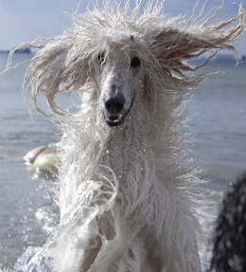
We’ve all had bad hair days! So why do these happen:
- We over style our hair with tortuous heat products
- The elements are unkind; rain, wind etc
- Hormones or age changes our hair texture
- We don’t eat well and our hair loses lustre
The factors above fall into the five categories known in Amatsu as the Godai:
Chemical Electrical Physical External Nutritional

These same categories have a regular impact on our bodies. Often unseen and
on a day to day basis their impact is quite small - repetitive actions cause muscle
fibres to change. In a positive way sports people and musicians use this ‘muscle
memory’ to help them become better at instinctively remembering certain
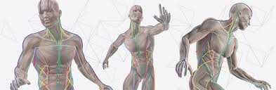
parts of their actions but whilst it can be a positive memory aid it also creates a
pattern. Tom Myers shows these
patterns so well in his book
‘Anatomy Trains’,

It is these patterns which, over time create a tightness in muscles, either
leading to pain, as in the case of 1994 where the typists claimed RSI (Repetitive
Strain Injury) or a tightening, which goes unnoticed, but which acts like a knot
or a corset in a particular area, until you stretch to reach for an everyday
object and something ‘goes’, (most commonly the lumber or lower back!)

The value of Amatsu is that it relieves the impact of the five factors our lives, ironing out the knots and restrictions on our muscles and fascia, giving the body more mobility and lessoning the risk of these knots or restrictions leading to stiffness, niggling pain or sudden, sharp pain.

