PO Box 1124 406 SE Oak Ave Roseburg, Oregon 97470 541-672-4392
POST 16 DUTIES OF MEMBERS
March 2017
www.roseburglegionpost16.org/
Post website

As most of you know I have headed up membership efforts for our Post, District 9 and the Department of Ore- gon. As Department Membership Chair and Department 1st Vice Com- mander we achieved 100% of mem- bership goal for 2 consecutive years. During membership drives and rein- vigorations held state-wide I regretfully told non renewed old members and potential new members that they did not have to come to meetings, participate in functions or volunteer at
Saturday March 11

POST MEETING WITH READING OF NOMINA- TIONS FOR THE 2017- 18 ELECTIONS . STATE OF THE BUDGET HEALTH OF POST 16

Discussion about mem- bership and the need for responses to dues requests.
fund raising events, parades, recogni- tion dinners, etc. In retrospect, that remark was a grave error. In Post 16—attendance at meetings is down. Only 8 –10 members staff the booth at the Sports show, Food Drives, Set up and tear down at picnics. Sit at a table during job fairs or recruiting drives.
Because it takes an active membership to make a Post continue to flourish and grow. HELP HELP HELP We must work hard to remain a 4 Pillars post.

39 MORE RENEWALS NEEED

Inside this Edition

Page 1: Duties of Mem- bers, Renewals

Page 2: Big Boy Raffle

Page 3: Sportsman Show Fundraiser Booth and Pictures of Volunteers

Page 4: Legion Insur- ance Trust

Page 5: Financial State of Post 16. Building upgrades.
TO BE 100% FOR 2018

Douglas County Veterans Forum Meeting is open to all Veterans Tuesday February 21st
5pm @ the Post

The Commander wishes to remind the following members that as of March 1, 2017 they will delinquent and will not re- ceive the magazine after the June 1917 issue. He is urging you to pay your dues this month because if they are not sub- mitted and paid later you will not receive a printed card for 2018.

THOMAS ADAIR, JACQUELINE ALEN,
J. BONEBRIGHT, KAYE CEPEDA, DENNIS CHURCH, RICHARD CONN, VERNON CONSTANTIN, H.A. COOL JR, ANTHONY DELCOLLO SR, DON- ALD DOLS, ROBERT ELLIOT, JAMES FITZPATRICK, JAMES FOSBACK, ANDY GAYLOR, CARL HUBENNETTE, JAMES HUCKINS, PHIL HUNKER, PAUL HUNTER, CHRISTOPHER IVERS, LYNN JACOBSON, MAXIE- LANE KNOTTS, DALE LANG, LYLE LIGHT, DONALD MAXWELL, WILLIAM

MCCART, STEPHEN MCFAR- LAND, JAMES MERRITT, KYLE O’CONNELL, LOWELL PARKER, BRIAN REED, DOANLD ROB- ERTS, JAMES ROCHELEAU, WIL- LIAM ROYCE, RORY SACKINGER, DAVID STOUT, JAMES THOM- ASON, EUGENE UNRUH, KEITH VANATTA, DALE WAMBOLT, ROBERT WELKER, RICHARD WHARTON, WESLEY WILHITE, JOSEPH YRAGUEN

Should you need us pick up your payment feel free to call the Post Commander Steve Bergadine (541- 733-7786), or the Adjutant Larry Hill (541.673.5668).

If you wish to be reimbursed for your envelope and stamp it will be

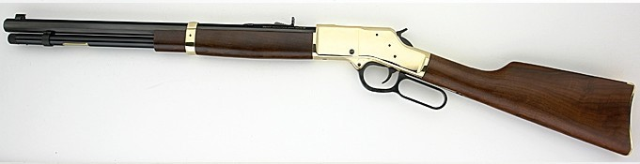

Sales kicked off at the Sports Show. Tickets sales have been very good to date. We have slightly over 400 more to sell. Buy early and often. Your support is needed. Sell price is $5.00 each or 5 for
$20.00. Tickets will be available at the Post during normal office hours. The winning number will be drawn on Veterans Day after our free breakfast.
The second prize is a tactical 1200 lumen Flashlight—Third prize is a gun cleaning kit.

There are a number of projects that need to be undertaken .Some of which will be partially funded by this raffle. Seal coat- ing and striping the parking lot.
Purchase of a new computer and soft- ware for the Finance Officer. Procure- ment of 50—60 new chairs for the meet- ing room.

1
WEBSITE
Across the street from the Post

9

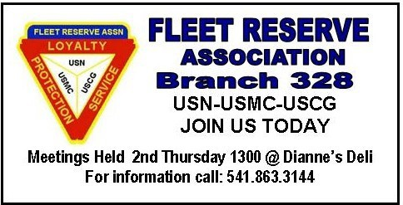

4
11
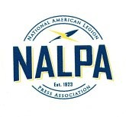
Business Card size Ads in the Newsletter—12 Months for $100.00 Contact the Post today & help support the Monthly Newsletter
The Newsletter is published monthly by Earle B Stewart American Legion Post 16 Roseburg, Department of Oregon
Publisher Larry Hill is a member of the National America Legion Press Association—NALPA

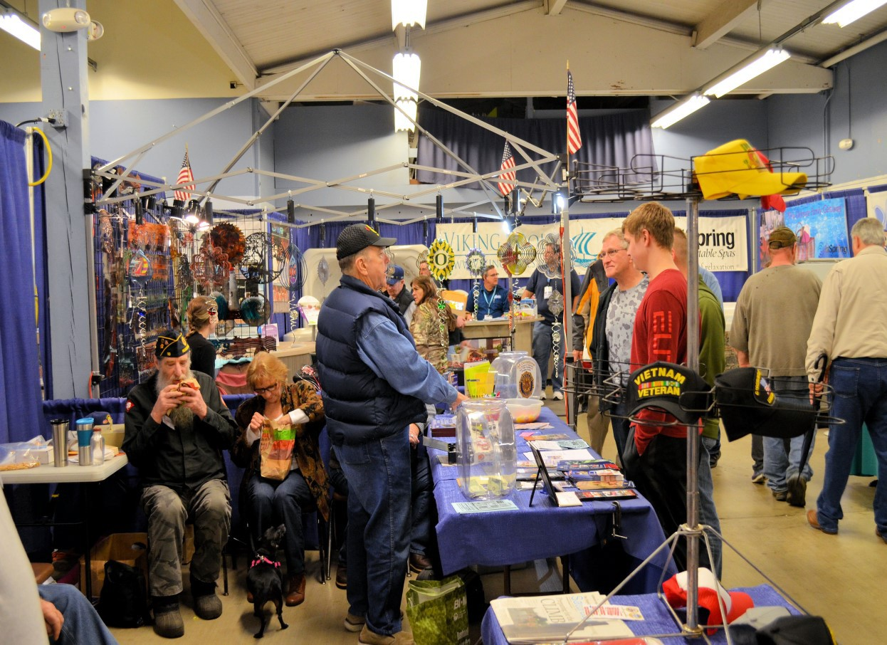POST 16 STAFFED A BOOTH AT THE ANNUAL UMPQUA SPORTS AND RV SHOW

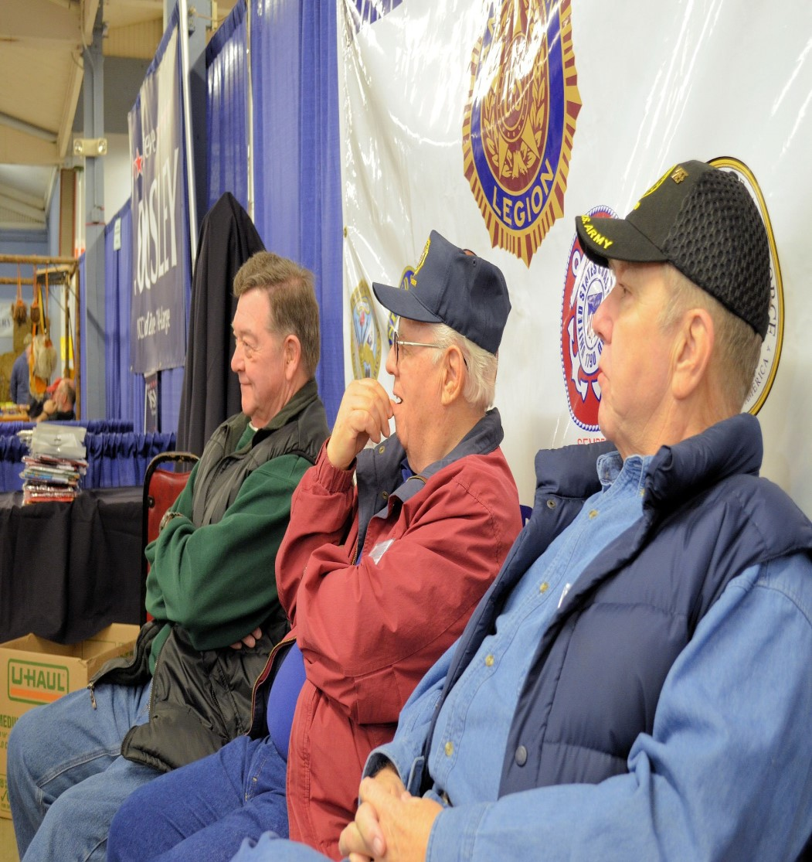
On February 17, 18 and 19 A nominal number of vol- unteers staffed a booth in farthest building where we have held forth for a number of years. The Post had a 20 foot double booth.

Volunteers spoke with interested veterans and signifi- cant others about the benefits of membership. Ad- vised, assisted and referred many to other veteran services in the Douglas County Area.

We sold 60% of the 1,000 tickets for the Henry .357 Rifle and there are about 400 remaining tickets.
$5.00 for 1 and $20.00 for five. Thus far raffle tickets have produced about $2,200.00 to support Post pro- grams. Come by the Post Monday or Friday 1200- 1500 hours and pick up your tickets.

Our thanks goes out to Dale Nelson, Mike Hamp- ton, Mike Harper, Larry Hill, Steve Bergadine, Bob Smith, Ted Blann, Bud Bessey, and Bob Rapp.
For standing four square and taking care of busi- ness.

We still have more tickets available and they will be
sold as the occasions arise

VOLUNTEERS STAFFING THE POST 16 BOOTH AT THE SPORTS SHOW

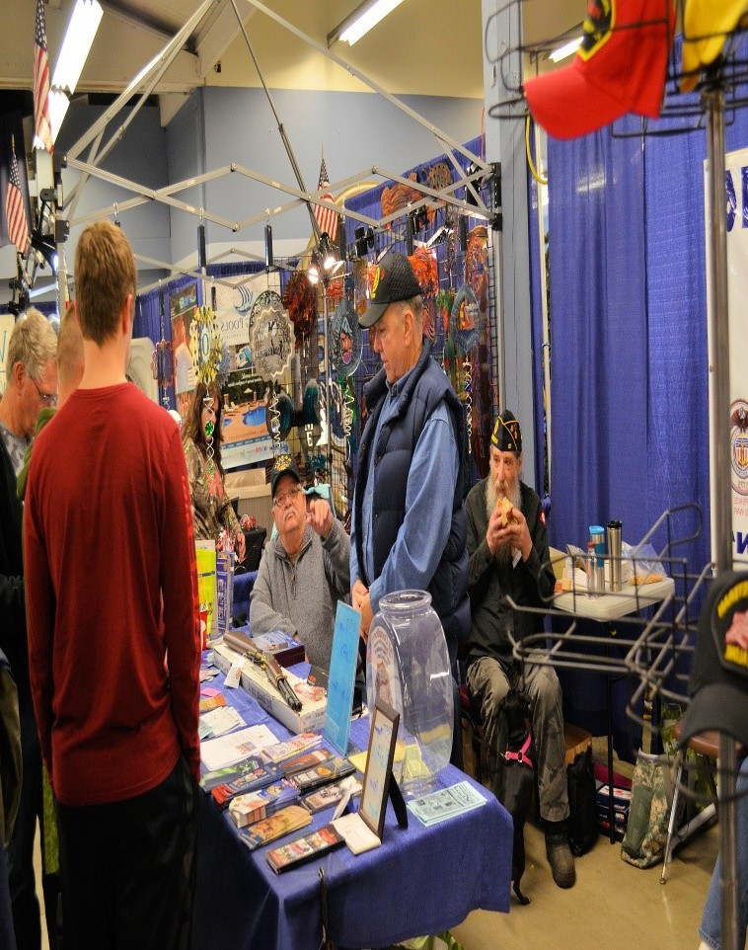

LEGION INSURANCE TRUST

Post officer Nominations for 2017-2018
COMMANDER—LARRY HILL 1ST VICE—DALE NELSON
2ND VICE—DOUG PAGE

Remember how a few years ago when you received your membership card there was an application form for the insur- ance shown above. Now all you have to do is go online one time and complete the form and you are covered for the dura- tion of your active membership.

This is a FREE benefit provided by the American Legion. Not only is good for you but Department receives a participation rebate depending on the number of Legionnaires in the de- partment of Oregon participate. The monies received are used to support the administration of the Department of Ore- gon.

Please visit The LIT.com/LegionCare1 website and complete the form.

Thanks for supporting another American Legion benefit. Both
for you and yours and the Department of Oregon.
Connect to e Benefits below
EBENEFITS
ADJUTANT— STEVE BERGADINE FINANCE OFCR—MIKE HARPER SVC OFFICER—BUD BESSEY HISTORIAN –KIRK CONNOR CHAPLAIN—TED BLANN
SGT. AT ARMS-=BOB SMITH JAG—MIKE HAMPTON
Like those in Chicago say—”Vote Early and Vote Often”

I say—Just Vote

The Officers of the Post thought it would be fitting to incorporate a monthly section honor- ing those members who have been called from our midst and have gone to report to Post Everlasting.
This month we are grateful that we do not have to report any of our members who have gone on.
For all veterans -Our sincere condolences to all the families and friends of those who were called from our midst.

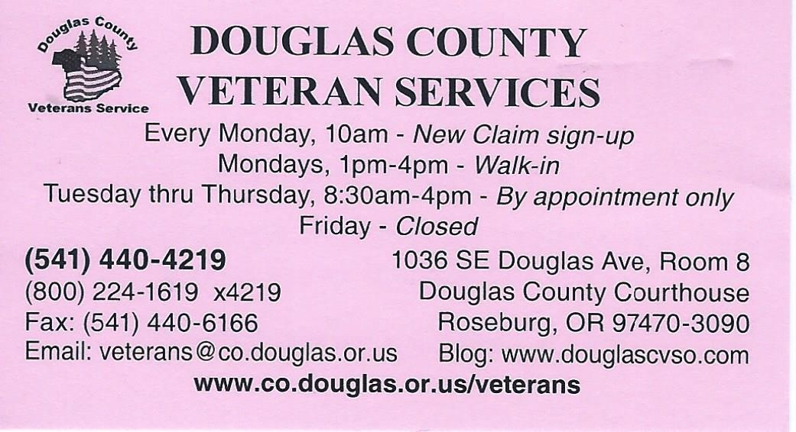
Sign-up Today to access and manage your personal VA Healthcare
MY healthevet

FINANCIAL STATE OUR POST

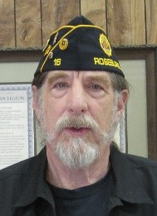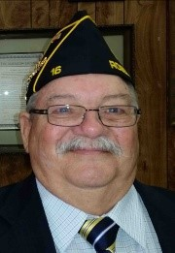As of February 28, 2017 the check- ing account balance is $ 2,087.00.

The latest from Transamerica the company servicing our investment account we stand at $97,313.00.

To any of you who have owned or managed a business or were an Adjutant, Quartermaster, Finance Officer would realize that might look good on paper until a closer look is taken at expenses and income.

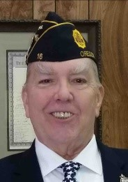As Dirk Kruysman always stated it is the duty and responsibility of the leadership and membership of Post 16 to maintain the building that was so generously given to us by the leadership in the 1960’s. There- fore, that is our primary objective.

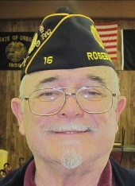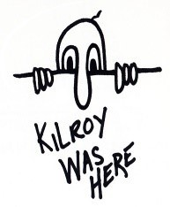In the next column I have compiled our expenditures thus far in FY 2017. They will be broken down in per month and a yearly total. In the next FY.

This snapshot of expenditures pre- sents a portion of FY 2017. (July 2016-June 30,2017)
Utilities
Electricity 881.83
Water | 190.05

Garbage 511.65
Sewer 240.00
Gas 959.30
Telephone/
Internet 361.21
Total 3,144.14

Programs
Doc Stewarts 6,500.00 Pass thru
Boys State 900.00 Girls State 700.00
Oratorical 0.00
Other 0.00
Total 8,100.00

Insurance 1,200.00
Veteran Support  Food Bank | 819.20
Gas | 200.00
Total 1,019.20
Building
Cleaning | 1,000.00
Fence/
Flashing | 3,650.00
Pest Control | 160.00
Lighting | 1,414.00
Total | 6.224.00
GRAND TOTAL | 19,687.34
LESS DOCS | 11,187.34

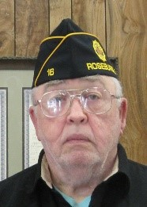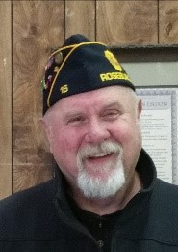BUILDING UPGRADES
Commander | 1st Vice
2nd Vice | Adjutant
Finance Officer tChaplain
Sgt. At Arms Service Officer

Smith Bud Bessey
Historian  Kirk Conner | JAG  Doug Page

In the Spring and Summer it will be necessary for the Post to undertake the following priority projects. Seal Coat and restripe the parking
spaces in our lot. Because if not
done this year it will be necessary
to completely replace the lot at con- siderable expense.
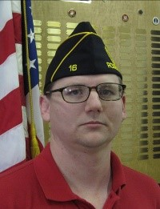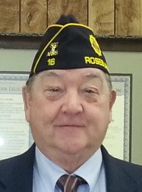Investigate and remediate any plumbing problems
Purchase 50 to 60 new chairs for the North Room.
Replace Computer/Monitor. Up- grade all software in the Finance Office. All bootleg or outdated soft- ware to be replaced.

I AM SORRY FOR THE LATENESS OF THIS MONTH’S NEWSLETTER . BUT WITH THE RESIGNATION OF OUR PUBLISHER IT WAS NECES- SARY THAT I STEP UP TO PLATE. I FLEW BLIND AND BY THE SEAT OF MY PANTS TO GET THIS OUT. PROMISE– I WILL BECOME MORE ADEPT AND FASCILE IN THE MONTHS TO COME AND WILL BE ON TIME. THANKS FOR YOUR PA- TIENCE AND UNDERSTANDING.

LARRY HILL

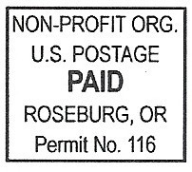
A ME RI C A N L E G I O N P O S T 1 6 P O B O X 11 2 4
R O S E B U RG , O R 9 7 4 7 0

Post Meeting Saturday March 11, 2017

March 2017

Sun | Mon | Tue | Wed | Thu | Fri | Sat
 |  |  | 1 | 2 | 3  Post Open 1-3 | 4 Battle Cross Dedication VA VA Bldg. 1030
5 | 6  Post Open 1-3 | 7 | 8 | 9 | 10  Post Open 1-3 DCVF Ex. Bd. 1200 | 11  Post Meeting 1200
12  Daylight Sav- ings Time Ends | 13  Post Open 1-3  VA VSO 1300  Auditorium | 14 | 15 | 16 | 17 Post Open 1-3 St. Patrick’s Day | 18
19 | 20  Spring Begins | 21  DCVF 5pm @ the Post | 22“Buddy Check 22” | 23 | 24  Post Open 1-3 | 25
26 | 27  Post Open 1-3 | 28 | 29 | 30 | 31  Post open 1-3

