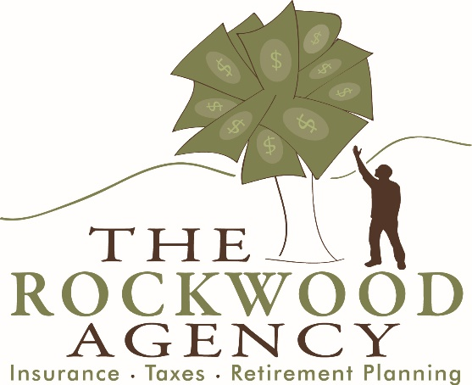
ROCK, PAPER, SCISSORS? NO PAPER, ROCK, WOOD!

Owner: Kabray Rockwood
(800) 691-7341
(800) 691-7341
(800) 691-7341
(800) 691-7341
(800) 691-7341
(800) 691-7341
(800) 691-7341
(800) 691-7341
(800) 691-731
(
(800) 691-7341

Address:
P.O. Box 270
2484 US Route 5 North
Windsor, VT 05089
Contact Info:
Local: 802-230-4100
Toll Free: 800-691-7341
www.therockwoodagency.com
therockwoodagency@hotmail.com

CONTACT THE ROCKWOOD AGENCY TO HANDLE YOUR PAPERWORK!

*Base Rates For Income Tax Year 2018

25 & Under (5 forms or less): $85
Seniors (over 65) (10 forms or less): $90
*Self-Employed/Single Member LLC’s:
W/ Individual or Joint Return
(Rates based on complexity & organization)
$285-$475+
Individual Return: $160
(10 forms or less)
Joint Return (over 65): $135
(10 forms or less)
*Joint Return: $215
(10 forms or less)

Rates Include Federal & 1 State E-file (Additional Fee per State)
Multi Member LLC., Trusts, Partnerships and Corporations please call for pricing
*Additional Forms/Data Entry/Rentals/Multiple Business/Multiple States
Will Result In A Higher Cost
**We will MATCH or BEAT any competing firms’ price!

The Rockwood Agency Tax Return Discount Program
*** Discount Program Applies When Tax Return is Paid Upon Pickup ***
Discount Program Cannot Be Paired with Any Other Discount Program (i.e. Gift Certificates)

Town of Windsor/Windsor County Resident: 5%
Insurance Client: 5%
Referral Discount: 5%
Repeat Customer: 5%
(Max 20% discount)

***** A 5% processing fee will be charged on any credit card transactions *****
(800) 691-7341
(800) 691-7341
(800) 691-7341
(800) 691-7341
(800) 691-7341
(800) 691-7341
(800) 691-7341
(800) 691-7341
(800) 691-731
(
(800) 691-7341

