July 2013 Newsletter

 | Northlake Crisis Pregnancy Center  814 W 21st Avenue  PO Box 3208  Covington, La 70433  985.893.4281

A Note from the Executive Director

Several months ago, I wrote a story in our newsletter about a woman named Beth. Beth had been extremely afraid when she found out she was pregnant. She was certain that abortion was the only option and had even gone as far as to make an appointment at an abortion clinic. She called our center the night before the appointment and came in for an after-hours ultrasound where she met her baby girl for the first time! Against all odds, she chose life for her child and is now a proud mother to a precious baby girl. Beth has continued to come to our center regularly for counseling, baby items and prayer. Yesterday she brought a friend who was considering abortion to meet with our nurse Renee and have an ultrasound. We were so thrilled that God was using Beth’s choice for life to influence those around her! As she waited for her friend’s appointment to finish, a pregnant teenage couple and their parents walked in. Carmen greeted the group and let them know that there would be a brief wait while Renee finished the other appointment. They took a seat next to Beth and her baby in the waiting room and began discussing the situation. The boyfriend was very vocal about his desire for this young girl to abort and the parents were ambiguous about where they stood on the issue. The young girl seemed very torn and afraid. Carmen listened in amazement as Beth struck up a conversation with the group. Beth shared her experience and the many obstacles that she faced as she made her decision to choose life. Beth’s baby girl was laughing and playing in her arms as she shared her story. Only the Lord could orchestrate timing like this! Not only had He used Beth in the life of her friend, but He simultaneously used her to minister to these young teens in the waiting room! Both the teen and Beth’s friend received ultrasounds and were able to see their babies for the first time. Both plan to come back to the center for follow-up appointments and Renee feels confident that both will choose life for their babies. We pray every day that the Lord will speak LIFE to the women that come to our center. He usually answers that prayer through us, but this time He chose to do it through one of our clients. I praise God that we had the awesome privilege of listening in.

Our Stats

We have seen 336 new individuals in 2013 and had 1062 appointments. We have performed 143 free pregnancy tests (130 positive and 13 negative). We have counseled 70 women considering abortion. We have provided 182 parents with food, diapers, clothing, formula etc. We have helped 124 women find pre-natal care. We have provided 57 women with professional counseling. We have shared the gospel with 169 individuals, prayed with 310, and provided 278 with spiritual encouragement. We have cried with these women, laughed with them, and shared in their joys and sorrows. All of it has been a privilege.

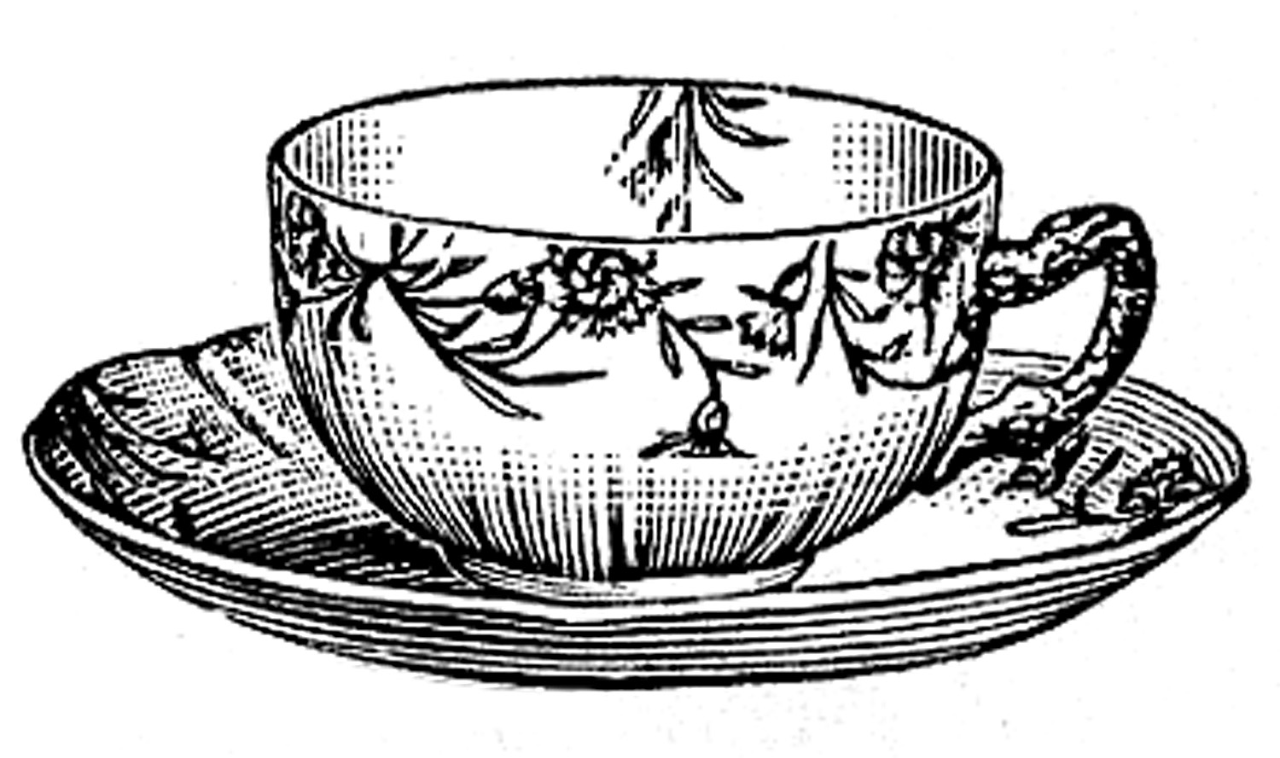 | Please mark your calendars for our Fall Tea Event.  Saturday, September 14th  We hope you can join us!  Visit www.northlakecpc.com to reserve your seat!

Special Needs

We are collecting used china, teapots, teaspoons, tea hats, and large capacity coffee brewers for our fall tea event. If you have items that you would like to donate, you can drop them off any time during business hours. All donations are tax deductible. Thanks!

Important Updates

Statistics say that one in three women are walking around with the secret shame of past abortion. If you are one of these women, let me encourage you to begin "Forgiven and Set Free". You will find healing and wholeness as you enter into this post-abortion Bible study which effectively ministers God’s healing grace in a safe and supportive environment. This confidential 12-week study begins Wednesday August 21st. Please visit www.northlakecpc.com to register or call 985.893.4281.

Our Staff & Volunteers

Rachel Q. Adair, Executive Director Natalie Barber McKenna Trahan
St. Timothy United Methodist Church First Baptist Church Mandeville Church of the King

Carmen Brawders, Center Director Christina Parker Molly Taylor
Bogue Falaya Baptist Church First Baptist Church Covington Church of the King

Ashley Hurley, Professional Counselor Loyda Groff Kathy Bass
Fellowship Bible Church Iglesia Baptista Cristo Redentor Bogue Falaya Baptist Church

Renee LaGamba, Nurse Manager
Church of the King

Our Board of Directors

Mark Siverd, President  Faith Presbyterian Church | Debbie Wondergem  Northlake Assembly of God | Drew Maliskas  Covenant Christian Church
Allison Jung  St. Peters Catholic Church | Kathy Bass  Bogue Falaya Baptist Church | Nancy Frantz  Our Lady Of The Lake Catholic Church
Joe Taylor  Church of the King | Mike Mire  Most Holy Trinity Catholic Church

Our Medical Advisor

Dr. Ted Guillory, Medical Director

