THE HEALING HEARTS CLUB
A Therapeutic Support Group
For Children of Divorce
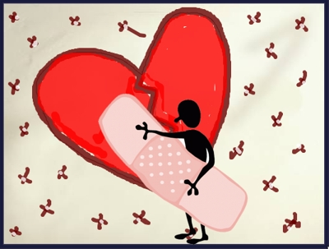
It’s not just my parent’s divorce – it’s mine, too!
Children are always affected by divorce. This can be a sad, confusing and scary time for them. Our children’s support group provides a safe place for children 7 to 11 to explore feelings and learn coping skills to help them navigate the adult world of divorce. In addition, they will be provided with the opportunity to develop relationships with other children who are in a situation similar to their own.
Topics include:
What Happened to My Family?
Divorce is Hard: Facing My Feelings
Growing and Changing
Two Houses, One Me
Parents Forever: Loving My Parents
My Family: Unique, but Mine
Cost for each session is $25 and is billable to insurance. Scholarships are available for those who qualify.
Space is limited and preregistration is required. Please call Melissa at 630 730 1828.

