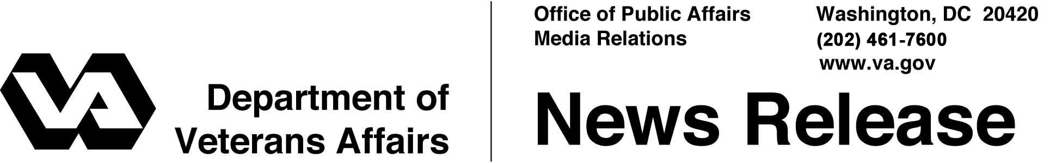
FOR IMMEDIATE RELEASE
December 20, 2012

VA, SSA and IRS Cut Red Tape for Veterans and Survivors
New Policy Eliminates Paperwork, Allows More VA Staff to Focus on Eliminating Claims Backlog
WASHINGTON – The Department of Veterans Affairs announced today it is cutting red tape for Veterans by eliminating the need for them to complete an annual Eligibility Verification Report (EVR). VA will implement a new process for confirming eligibility for benefits, and staff that had been responsible for processing the old form will instead focus on eliminating the compensation claims backlog.
Historically, beneficiaries have been required to complete an EVR each year to ensure their pension benefits continued. Under the new initiative, VA will work with the Internal Revenue Service (IRS) and the Social Security Administration (SSA) to verify continued eligibility for pension benefits.
“By working together, we have cut red tape for Veterans and will help ensure these brave men and women get the benefits they have earned and deserve,” said Secretary of Veterans Affairs Eric K. Shinseki.
VA estimates it would have sent nearly 150,000 EVRs to beneficiaries in January 2013. Eliminating these annual reports reduces the burden on Veterans, their families, and survivors because they will not have to return these routine reports to VA each year in order to avoid suspension of benefits. It also allows VA to redirect more than 100 employees that usually process EVRs to work on eliminating the claims backlog.
"Having already instituted an expedited process that enables wounded warriors to quickly access Social Security disability benefits, we are proud to work with our federal partners on an automated process that will make it much easier for qualified Veterans to maintain their VA benefits from year to year," said Michael J. Astrue, Commissioner of Social Security.
"The IRS is taking new steps to provide critical data to help speed the benefits process for the nation's veterans and Veterans Affairs," said Beth Tucker, IRS Deputy Commissioner for Operations Support. "The IRS is pleased to be part of a partnership with VA and SSA that will provide needed data quickly and effectively to move this effort forward."
All beneficiaries currently receiving VA pension benefits will receive a letter from VA explaining these changes and providing instructions on how to continue to submit their unreimbursed medical expenses.
More information about VA pension benefits is available at http://www.benefits.va.gov/pension and other VA benefit programs on the joint Department of Defense—VA web portal eBenefits at www.ebenefits.va.gov.

# # #

