COMMUNICATION
The class have been using Lámh for communication each day. The following link will give you free access to the online material.
www.lamhsigns.org
Simply follow below instructions:
- Click ‘apply for membership’
- Enter the code ‘lovelamh’
- Follow the simple registration instructions.

The children have been using the following signs in class:
- Greetings
- Hello
- Goodbye

- Food
- Eat
- Drink
- Dinner
- Hot
- Cold
- Apple
- Banana
- Sweet
- Biscuit
- Burger
- Cheese

- Feelings
- Help
- Happy
- Good

- Hygiene
- Brush hair
- Brush teeth
- Toilet
- Clothes
- Daily use
- Mummy
- Bus
- Finished
- Boy
- Girl
- House
- Music
- bed
Sentences
Hello Mummy
Goodbye mummy
Thank you mummy
Good boy
Good girl
Eat dinner

Note: when doing the sign face your child and both do and say the sign. Praise any attempt, it doesn’t have to be perfect just a reasonable effort.
We also sing a daily Lámh song to the tune of ‘this is the way we…’
The child looks at a picture (please see below) and uses the associated sign whilst singing, for example, ‘this is the way we brush our teeth, brush our teeth, brush our teeth, this is the way we brush our teeth on a cold and frosty morning’.
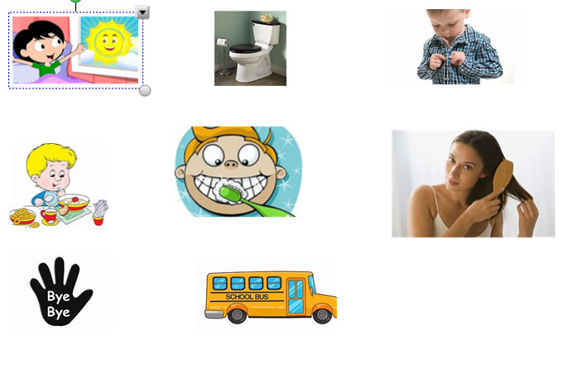
Do above with your child using the signs and signing the song.
- This is the way we get out of bed, out of bed, ect…
- This is the way we use the toilet.
- This is the way we put on our clothes…
- This is the eat the food…
- This is the way we brush our teeth…
- This is the way we brush our hair…
- This is the way we say bye bye…
- This is the way we drive the bus…

Other useful websites for enhancing communication skills:
https://www.starfall.com/h/
http://www.speechtx.com/language/language_fun.htm
https://www.do2learn.com/

Writing
Depending on the individual child there are a number of techniques
1, Mark making: the child can experience making marks with paint, shaving foam or using their finger in sand.
2. The child can trace letter and numbers with hand over hand support
3. The child can draw lines horizontally and vertically between objects
4. The child can attempt to write their name and copy numbers and letters independently.

Writing resources can be obtained at www.twinkl.com
There is currently a free sign up.

Mathematics
We use www.topmarks.co.uk
This is a free service. Simply select the tab ‘Learning Games’.
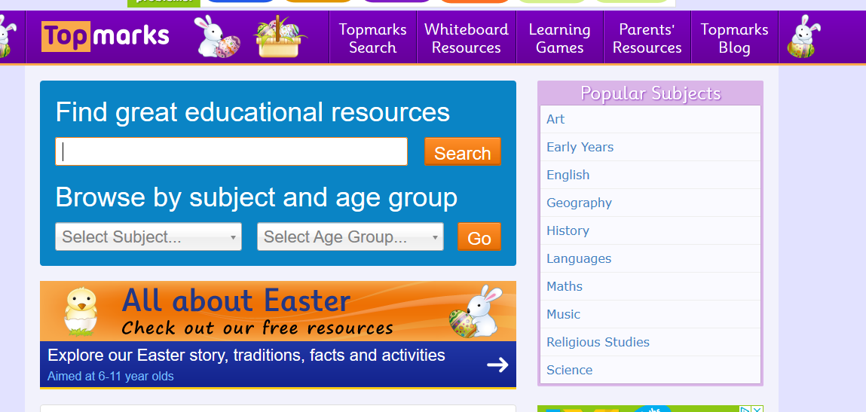

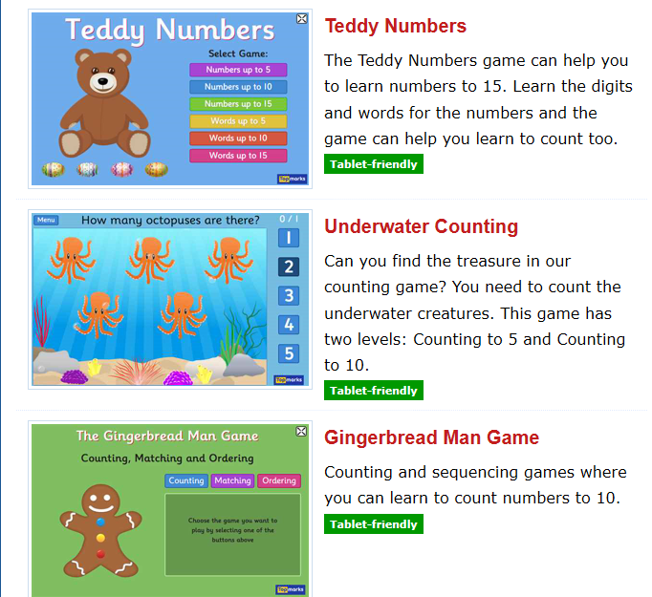
- Then select any of the following three games.

- Depending on abilities you can select numbers to 5 or numbers to 10.

Other activities include your child counting out loud to ten, counting objects to 10 and ordering objects big or small.
Number song web links:
http://www.youtube.com/watch?v=F2OpkQuOjig

ART
Check out the free resources for Early Years on www.scholastic.co.uk and free resources on www.twinkl.com

TACPAC
The children in our class love tacpac and currently you can receive free sessions online.
To obtain 5 free TACPAC sessions:
Click on the following link
http://tacpac.co.uk/product/set_5
At the checkout enter code 8Q7A3TXS
Once this is done go to http://www.facebook.com/TacpacLtd to watch the short videos on how to do TACPAC.
Further resources for all subjects will follow.
Thanks. Declan.

