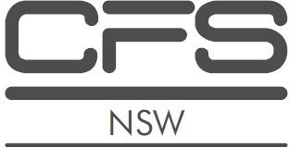
NSW Complete Financial Services Group Pty Ltd
NSW Complete Financial Services Group Pty Ltd

ADVISER PROFILE
JOY MAN JOUNG LEE
Authorised Representative
No. 233337
NSW Complete Financial Services Group Pty Ltd
Education: Joy has completed a Diploma of Financial Services and an Advanced Diploma of Financial Services.

JOY MAN JOUNG LEE

NSW Complete Financial Services Group Pty Ltd
ABN 791 284 037 98

1/11 Manning Street
TUNCURRY NSW 2428
Mobile: 0413998246
Email: joymjlee@tpg.com.au

Joy Man Joung Lee is an Authorised Representative of NSW Complete Financial Services Pty Ltd. Joy is authorised to provide you with advice in the following areas:

- Life Products (including Life Products under Superannuation).

Joy specialises in advising clients regarding personal protection insurance which includes:

- Death.
- Total and Permanent Disablement (TPD).

NSW Complete Financial Services Group Pty Ltd
ABN: 791 284 037 98
AFSL: 457600
ACL: 424396
Head office: 1/11 Manning Street
Tuncurry, NSW, 2428.
Phone: 1300 700777
Email: nswcfs@bigpond.com
Web: www.completefinancialservices.com.au
- Income Protection.
- Trauma/Critical illness.
- Business Expenses.

Joy’s commitment is to provide educated, experienced advice for her clients to help protect them and their dependents should any of the insured events occur.

Experience
Joy has 17 years (2001 – 2018 current) of experience in financial planning risk insurances.

Page 1 of 1

