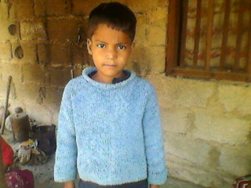
Name: Raj

Date of Birth : 18 Feb 2004
Age: 9 Year
Child’s standard in school Grade-1
Religion : Christain

Raj is a 9 year old boy who is living in Churiyamai V.D.C. Ward no. 5 located in Hetauda, Makawanpur is in Nepal. His mother has worked in the circus. She has since left the circus. She had gotten married with an Indian boy when they worked together at the circus. They both are faced with lots of problems in their lives. They don't have a way to own their own property. They are staying in a rented home. It's expensive for them so they have a difficult time paying for the home's rent.
Raj's father works at a construction area. He doesn't have any fixed income source. So, they aren’t able to provide him with a good education. He needs to continue his education but his parents are not able to pay to sustain his education. Therefore we should provide an educational sponsorship for him so he can meet his goal.
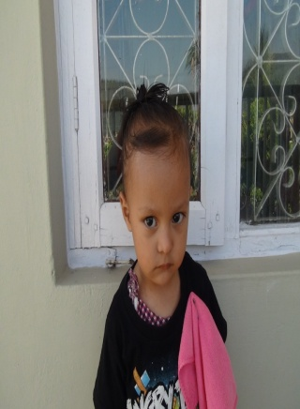
Name Syron
Date of Birth 1 May 2009
Age 4 years
Religion Christain
Syron is a 4 year old boy who lives with his mother at his grandparent's home which is located in Hetauda in Makawanpur Nepal. His grandparents are jobless and they don't have any source of income so they live in poverty. Due to their poverty they are faced with many problems, and Syron has been directly influenced by all of this. They have lots of problems in meeting their daily needs. So they cannot provide him with nutritious food and a good education, which is very important for children at their age.
Geeta Thapa is Syron's mother and has been facing lots of problems in her life. She had gotten married at a young age and then she gave birth to a beautiful baby boy. There was a misunderstanding between her and her husband's family later on in their marriage concerning who the father really was. Her husband didn't believe that Syron was his child and didn't want to take responsibility for him so she is now staying separately from her husband. That's why she is staying with own her parents. Her family is in poverty. Her father is the only one working and makes $50 each month to support the whole family. This isn't enough to support themselves and they also don't have enough property that can provide them with good shelter. It is clear that it's difficult for Syron's future to succeed in this home so he is in need of help from our staff at the Safe House.

