Nutrition Plus, Inc.
Emily Roark Patti Brenn Susan Morrell
(620) 221-2777 (620) 218-4994 (785) 224-4104
roark2@cox.net pattibrenn@cox.net smorrell12@gmail.com
www.nutritionplusinc.com
May is:
National Asparagus Month
National Barbecue Month
National Salad Month
National Salsa Month
National Strawberry Month

Important dates to remember:

“Infant Feeding in the CACFP”

TBD - Topeka Workshop at library 6:30 pm
TBD - Winfield Workshop at Presbyterian church
6:30 pm
May 29th - Checks and direct deposits go out

Let’s limit screen media!
Screen media is visual content delivered via digital screens that include TV’s, movie screen, computer screen, and smaller screens such as smartphones and tablets.
The American Academy of Pediatrics recommends the following screen media guidelines for young children:
- Educate parents about brain development in the early years and the importance of hands-on, unstructured, and social play to build language, cognitive and social/emotional skills.
- For children younger than 18 months, avoid use of screen media. Parents of children 18 to 24 months of age, who want to introduce digital media, should choose high-quality programming and watch it with their children to help them understand what they’re seeing.
May 2020

- For children ages 2 to 5 years, limit screen use to 1 hour per day of high-quality programs such as Sesame Street. Parents should co-view media with children to help them understand what they are seeing and apply it to the world around them.
- For children younger than 2 years, there is limited evidence of benefits. Adult interaction with children is crucial.
- Child care providers should have planned activities indoors and outdoors (weather permitting) that would allow the children to walk, play games, or plant a garden.
- Children that have too much screen time are at risk for gaining weight and for obesity. Research has shown that children who spend a lot of time watching TV are easily swayed to choose foods they see advertised. When children see food commercials they may want to eat. The food that is advertised may be high in sugar, salt, or fat.
- Keep in mind that the early years are a time of critical brain development, building secure relationships, and establishing positive health behaviors.
- Keep mealtimes and parent-child playtimes screen free for children and parents.
- No screen time 1 hour before naptime or bedtime, and remove devices from bedrooms before bed.
There are many alternatives to screen time. Get them outside. Give them some fun “chores” to help out with. Do some crafts. Build forts. Build anything! Play with board games or puzzles. Start collections. Learn to cook. The possibilities are endless if you put in the time!

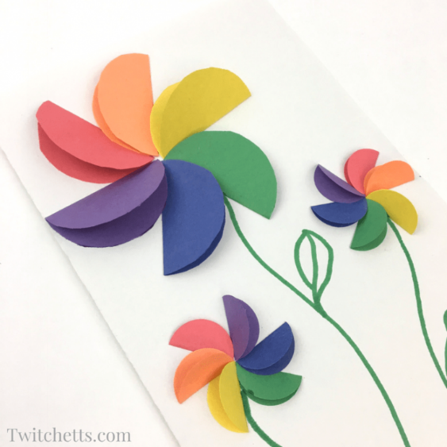
Rainbow Paper Flowers
(These will make wonderful Mother’s Day Gifts!)

You will need:

- Construction paper in rainbow colors
- Glue Stick
- Something round to trace around (coffee can lid, cup, bowl…)
- Scissors
- Marker or Crayon for stems

Instructions:

- Trace and cut out 6 circles from your construction paper. One circle for each color of the rainbow. (red, orange, yellow, green, blue, and purple).
- Take and fold each circle in half and crease well. They will look like little tacos.
- Place some glue on one side of your folded circle (aka taco). Then place the half circle onto a piece of paper. Next, take the opposite color, from the color wheel, and place it across from your first pedal. Be sure that the open sides of your half circles are pointing away from each other.
- So red across from green, blue across from orange, and yellow across from purple. This will help you space out your pedals.
- Fill in with the rest of the colors in ‘rainbow order’. Red, orange, yellow, green, blue, purple, and you’re done!
Pizza Casserole
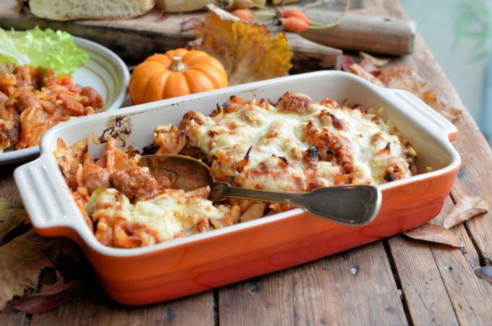

Ingredients:

2 cups macaroni or similar pasta
1 lb. ground beef or turkey
1 (14 oz.) jar pizza sauce
1 (4 oz.) can tomato sauce
1 (4.5 oz.) can mushroom slices-drained
1 lb. mozzarella cheese-shredded

- Preheat oven to 350 degrees
- Bring a large pot of lightly salted water to a boil. Cook elbow macaroni in the boiling water, stirring occasionally, until cooked through but firm to the bite, about 8 minutes. Drain.
- Cook and stir ground beef in a skillet over medium heat until meat is crumbly and browned, about 10 minutes; drain excess grease.
- Mix cooked ground beef, macaroni, pizza sauce, tomato sauce, and mushrooms in a bowl. Layer half the macaroni mixture into a 9x12-inch baking dish; top with 1/2 the mozzarella cheese. Layer remaining macaroni mixture over the top; sprinkle remaining mozzarella cheese over macaroni mixture. Cover dish with aluminum foil.
- Bake in the preheated oven until cheese has melted and casserole is bubbling, about 35 minutes. Let cool for 3 to 5 minutes before serving. As always, thanks for being the best of Nutrition Plus, Inc., Emily, Patti & Susan

