Lindenia tetraphylla, Lestes macrostigma and Selysiothemis nigra in Chios, Greece, 2015. Mike Taylor 21st February 2016
Lindenia tetraphylla ( Eversmann, 1836)
In June 2015 I observed and photographed males, females and an in-cop pair at the Armolia reservoir. I also observed ovipositing on the surface of shallow marginal water in an area with submerged waterweeds. Two individual females were seen ovipositing when both were in view at the same time.
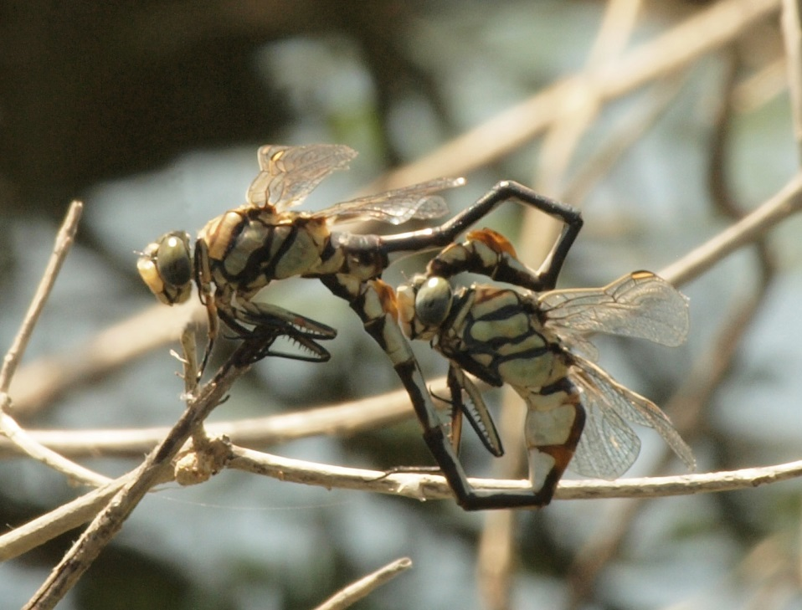
In-cop pair, Armolia reservoir 17th June 2015
A visit to Zifias reservoir on the 20th June was rewarded with good close views of males patrolling the sand and gravel area containing small stunted bushes on the western side of the reservoir. One individual allowing a close approach for photography.
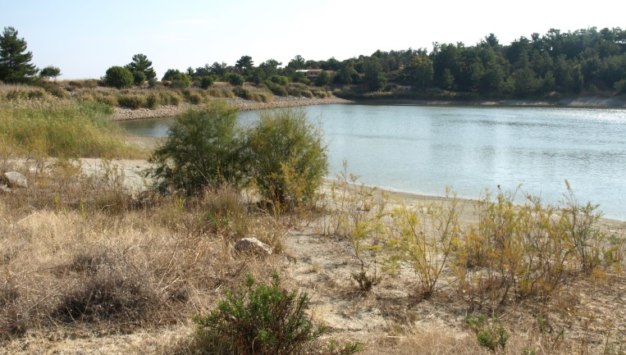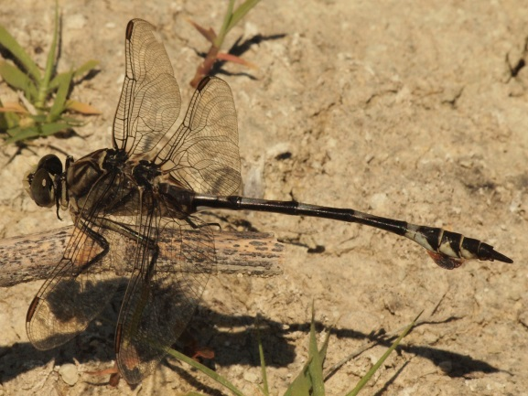
Lestes macrostigma ( Eversmann, 1836).
The mass emergence of this species at Lithi salt marsh occurred on the morning of the 3rd May in 2015, some eighteen days later than the mass emergence in 2014 which occurred on the 15th April 2014.
As was the case in 2014 large numbers were found. Visitors wishing to see these damselflies at Lithi should park in the car park at the western edge of the marsh, see photograph. Large numbers are to be found in the ditches around the car park as well as widely throughout the marsh.
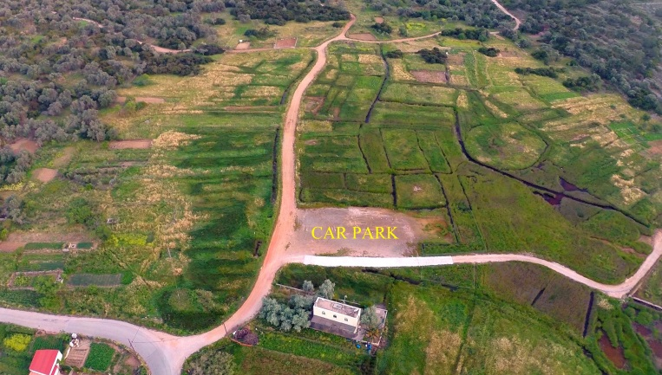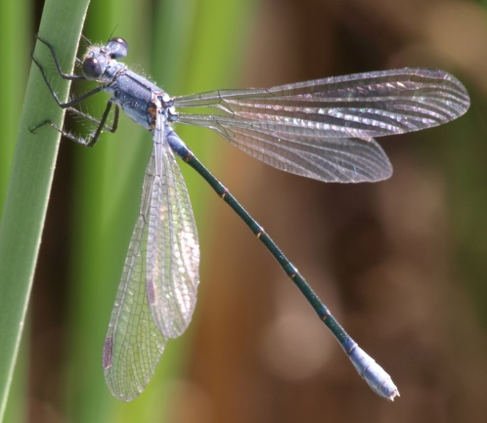
Lithi Marsh car park Teneral female
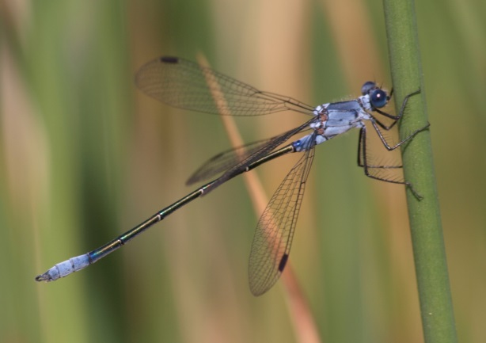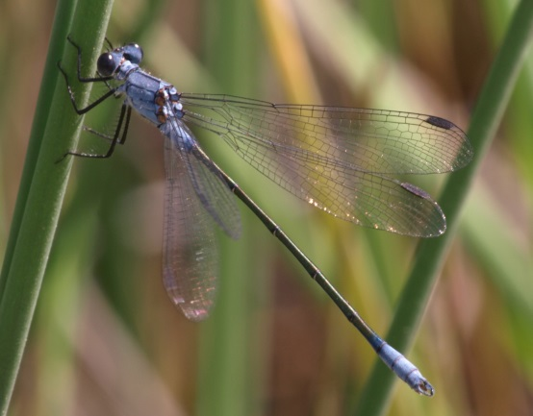
Female Male
Selysiothemis nigra ( Vander Linden, 1825 ).
Many tandem pairs of ovipositing insects were observed in mid June at the Armolia reservoir, often with up to a dozen pairs in view at the same time.
The Mayor of Chios’ Council has approved work at the Armolia reservoir to improve visitor access to the dragonfly sanctuary site by spring 2016.

