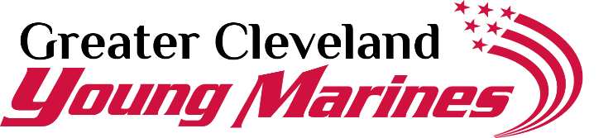
Second Annual Drug Demand Reduction 5K- Running Drugs Out Of Our Communities
The Greater Cleveland Young marines is hosting our second annual 5k to bring communities together to take a stand against drug use in our communities. We are reaching out to area businesses, organizations, and individuals to assist in making this event a tremendous success. You can be a part of this great cause! Proceeds from this event will go towards drug education and prevention for the youth of Greater Cleveland Young Marines. The deadline for sponsorships is September 7 ^{th}, 2019. Please consider one of the following packages:

- PRESENTING SPONSOR - $1,500
Company logo on race bib
Company representative as official starter of the Drug Demand Reduction 5K
Company featured in all press releases & publicity
Company featured on all event forms, flyers, and notifications created after sponsorship received
Company logo displayed above all other sponsors on event shirts
Recognition on Hermes race website, and Greater Cleveland Young Marines website and social media
10 free event registrations
- PLATINUM SPONSOR - $1,000
Company featured, and logo displayed at water stop
Company featured on all event forms, flyers, and notifications created after sponsorship received
Company logo displayed on event shirts
Recognition on Hermes race website, and Greater Cleveland Young Marines website and social media
7 free event registrations
- GOLD SPONSOR - $500
Company logo displayed at Post Race Award Ceremony
Company featured on all event forms, flyers, and notifications created after sponsorship received
Company logo displayed on event shirts
Recognition on Hermes race website, and Greater Cleveland Young Marines website and social media
5 free event registrations
- SILVER SPONSOR -$250
Company logo on all event forms, flyers, and notifications created after sponsorship received
Company logo displayed on event shirts
Recognition on Hermes race website, and Greater Cleveland Young Marines website and social media
2 free event registrations
- BRONZE SPONSOR-$100
Company logo displayed on event shirts
Recognition on Hermes race website, and Greater Cleveland Young Marines website and social media
NAME:________________________________COMPANY________________________________________________
ADDRESS______________________________CITY/STATE/ZIP____________________________________________ EMAIL:______________________________Make checks payable to Greater Cleveland Young Marines & return to: 5575 W 220th St Fairview Park, OH 44126
1 free event registration
CONTACT DAN DOTSON FOR MORE INFORMATION CO@GREATERCLEVELANDYM.COM OR 216-280-7827

