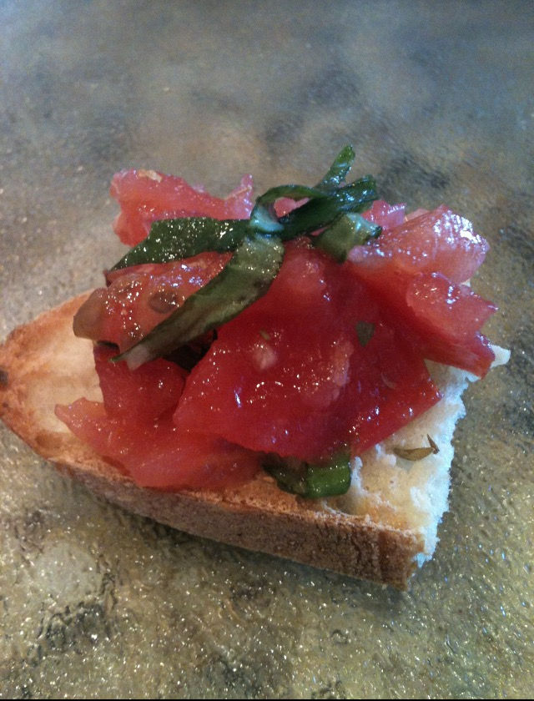
Bruschetta
*For this recipe I don't use specific measurements, because you can't mess this up and you cannot have too much garlic or basil!!
Roma tomatoes, crushed by hand or chopped
Garlic, minced
Fresh Basil, roughly chopped
Dried oregano
Salt & Pepper
Olive oil
Italian bread, sliced
Combine all the ingredients into a mixing bowl and toss till everything is coated. Let the Bruschetta marinate at room temperature for 1 hour. Place the sliced bread onto a cookie sheet, drizzle with olive oil and salt and pepper. Bake till lightly toasted. and spoon on the Bruschetta!
Saluti (Cheers in Italian)

