2014 – 12 MONTH DOMESTIC VIOLENCE POETRY CALENDAR
ADVOCATING AGAINST DOMESTIC VIOLENCE THROUGH POETRY
CAROLYN, DAUGHTER OF MARIE
www.carolyndaughterofmarie.com
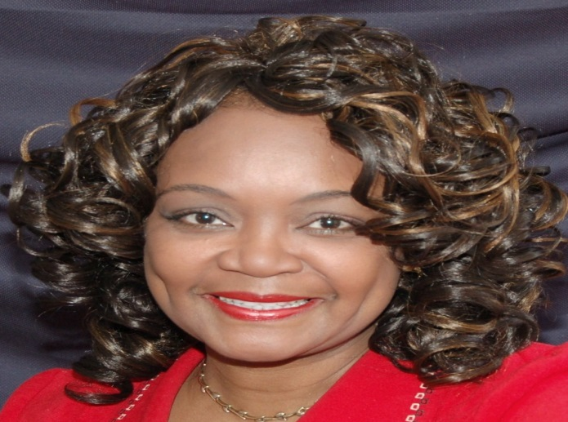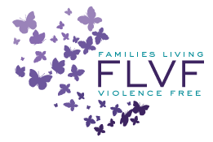
CAROLYN E. ESTES CRISIS LINE HELP (919) 528-3579
10% OF PROCEEDS FROM THIS CALENDAR WILL BE DONATED TO FLVF
(See back of calendar for more information about FLVF)

