PIANO, VOCAL, MUSICAL THEATRE

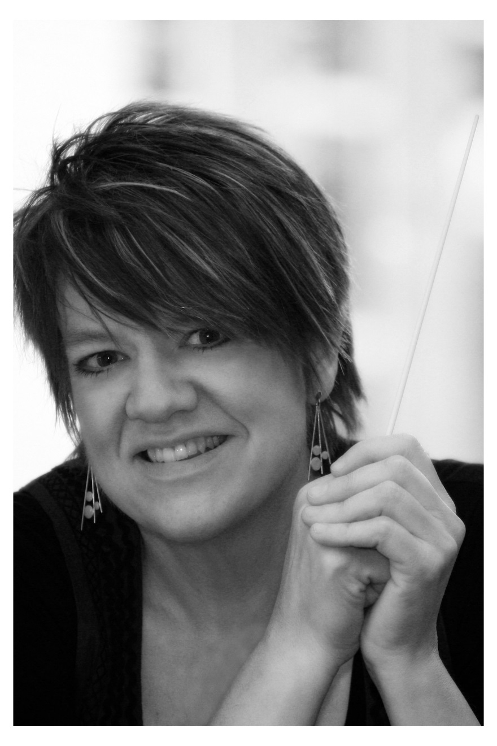
Dr. Joy Berg - Professor of Music, Director of Choral Activities and Director of Alumni Relations at Concordia University of Edmonton. Joy received a piano performance degree first, and fell in love with accompanying, especially accompanying singers. But throughout her journey, gradually spent time focused on conducting choirs. So now, as well as teaching courses in the music department, she directs the three Concordia choirs – the Concordia Concert Choir (auditioned student choir, with 45 singers), Bella Voce Women’s Choir (with 30 singers), and the Concordia Community Chorus (with 110 singers). She is a life-long learner, and is currently completing her Doctorate of Worship Studies. Dr. Berg often adjudicates and workshops in the area of choirs, voice, junior piano, handbells, and church music.

CHORAL

Kimberley Denis is known for her energy and enthusiasm both on stage and off, and is sought after as a soloist, choral clinician, and adjudicator for voice and choir. Upon completion of both a Bachelor of Commerce and a Bachelor of Music degree at Mount Allison University, she returned to Alberta to complete Masters degrees in both choral conducting and vocal performance. Vocal credits include starring in a year-long tour with Up With People, as well as productions of Jason Robert Brown's song cycle Songs for a New World, as Cathy in The Last Five Years, and as Kate in Kiss Me, Kate! She is also a singer with Pro Coro Canada and has toured extensively as a singer with the world percussion duo, Jamani. In addition to her stage work, she has a flourishing voice studio at MacEwan University Conservatory of Music. She has conducted a wide variety of ensembles across the country and presently directs Shumayela, Kikimasu and Vacilando with the Kokopelli Choir Association and the Edmonton Metropolitan Chorus. In addition to her work as a singer and conductor, she arranges pieces for choirs and is also the managing director for the Alberta Band Association.
BAND

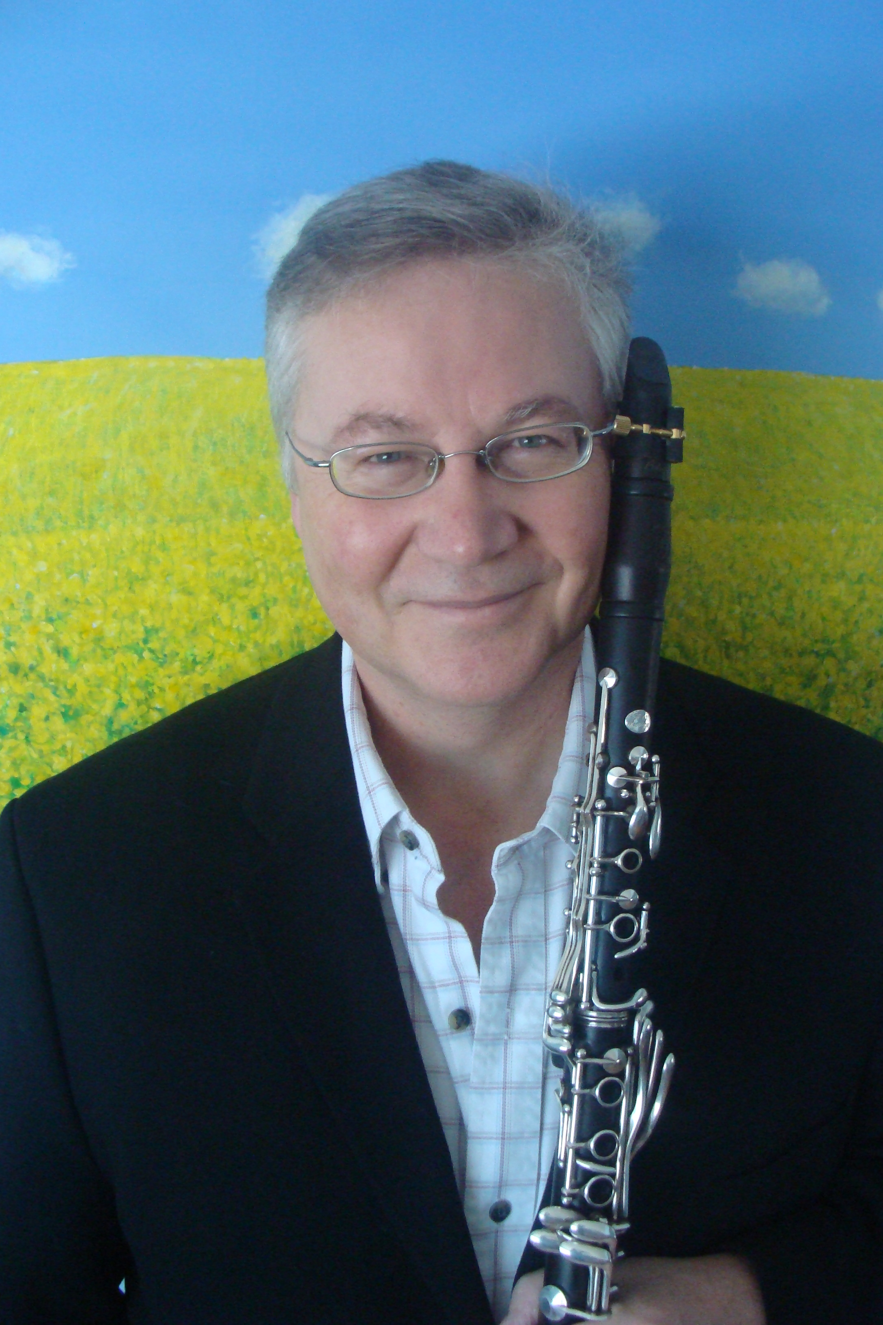
Clarinetist Don Ross plays some 150 shows a year, split between classical, jazz, world and experimental music. He plays regularly with such groups as Saint Crispin’s Chamber Ensemble, the Gadjo Collective gypsy band, the Edmonton Symphony, Opera Nuova, Mile Zero Dance and many others. He teaches clarinet at the U of A, Alberta College, King’s and MusiCamp Alberta. A good example of his composing is the score to the animated film Patternicity at vimeo.com/79143425. He studied at the Universities of Alberta and Toronto and at Northwestern in Chicago. Recent engagements include concertos with Edmonton Winds and the U of A Symphonic Wind Ensemble, session playing The McDade celtic orchestra, the Alberta Symphony Orchestra, MaisonMuziek and AC/Dixie and a performance of the Mozart Quintet for Clarinet and Strings with Saint Crispin's at King's.

STRINGS

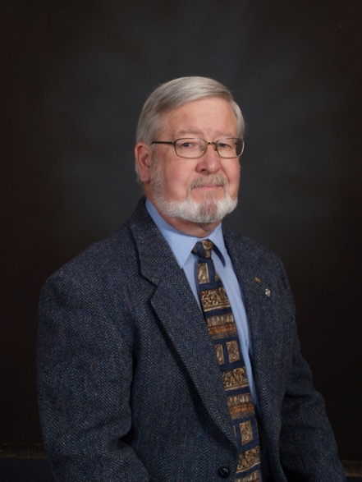
Larry Schrum spent 30 years teaching music in a wide variety of settings in the U. S. and Canada. During that time his groups were active and successful in Regional, National and International festivals. Since retiring in ‘98, he divides his time between serving as a clinician/adjudicator/guest conductor/Speaker in Western Canada and the U. S., while also running his own company, First Stroke Music Publishing. He also has directed many groups in the Edmonton area, including the highly regarded River City Big Band and the Grant MacEwan Arts Outreach Big Band. He may be heard playing percussion in the performances and recordings of the Trocadero Orchestra. The River City Big Band recordings “Just Friends” and “River”, containing his compositions and arrangements, are available on i-tunes.

