Whitewater River Watershed Steering Committee Meeting
Minutes of April 17th, 2014
Whitewater River Watershed

Attendees: Chelsea Tooley, Heather Wirth, Mike T. Schwab, Michael C. Miller, Evan Divine, Chris Fox, Anna Morrow, Ben Braeutigam, Helen Kremer, Bruce Koehler, John Williams,Tim Hesselbrock, Mike Kohlsdorf

The meeting began at 6:00pm at the Harrison Library in Harrison, OH. After Chelsea Tooley called the meeting to order, attendees were asked to review the previous meeting minutes. With no immediate revisions, members of the committee were asked to see Chelsea or Heather if they had any additions or corrections.
Under New Business, committee members were given a packet of 28 potential logos. Under the suggestion of Ben Braeutigam, each committee members was asked to share their three favorite designs. The designs with the most votes were further discusses. The committee voted on design number 6 (provided that the word Project was removed via suggestions from Chris Fox) featured at the top of the page. Plans for the coordinators to move ahead with promotional item ordering and website updates were approved.
Next, the committee discusses self-organization. The committee felt that having a co-chair system would be more effective by allowing the chairs to split responsibility. Chris Fox mentioned that it would be nice to have a chair from each state. After some discussion, the committee elected Tim Hesselbrock and Mike Kohlsdorf co-chairs of the Whitewater River Watershed Project steering committee.
Afterwards, Ms. Tooley passed around a sheet of sample goal and mission statements from other projects and opened the floor for discussion. Bruce Koehler recommended his suggestion from a previous goal and mission statement worksheet. Most of the committee liked the example form Coffee Creek’s Watershed Project and also the Tanners Creek Watershed Project. Combining aspects of the two, the group narrowed it down to choices. They committee agreed to vote on a final version that the coordinator would send around next week.

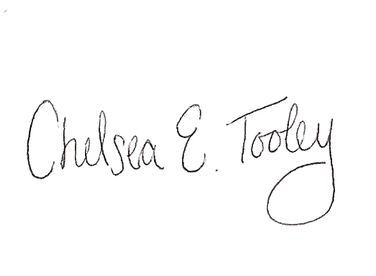
With no further business, discussion points, or concerns the meeting was adjourned. The next Steering Committee for the Whitewater River Watershed Project was set for mid-June provided meeting space availability.

Chelsea E. Tooley, Outreach Coordinator

