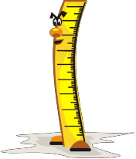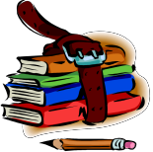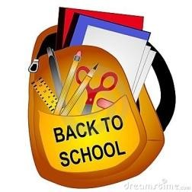Great Foundations Christian School Supply List
2018-201

Preschool Kindergarten 1st & 2nd Grade

1 Scholastic News ($5.50 automatically billed) 1 Scholastic News (automatically billed)

1 box of jumbo size crayons (8 count) 5 #2 pencils (no paper covered pencils) 10 #2 pencils (no paper covered pencils)

1 pkg. large markers - (4&5 years only) 1 box of large markers (8 count- not thin tipped) 1 box of crayons (24 count)
1 set of Prang or Crayola watercolor paints 1 box of crayons (8 count - regular size) 1 pair scissors

4 glue sticks 1 box of colored pencils (12 count) 2 large soft erasers
1 pack of playdoh 4 containers of Play-Doh brand playdoh 1 paint shirt (needs to fit over clothing)
1 pair of scissors 1 pair of scissors 2 two pocket folders (pockets on the bottom)

1 pencil box 1 pencil box 1 wide ruled paper

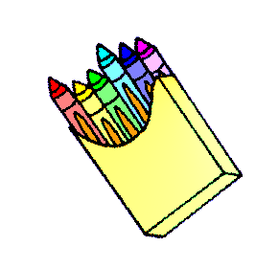1 box of Slider Ziplock gallon size bags 2 large soft erasers 1 4 oz. bottle of washable glue (no colored glue)

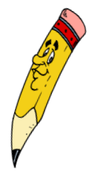2 large pencils (4&5 years only) 6 glue sticks 3 rolls of paper towels

1 paint shirt 1 paint shirt (needs to fit over clothing) 2 boxes of 200-count or larger facial tissues

4 rolls of paper towels 1 pocket folder 4 4 roll pkg. of toilet paper
1 box of 200-count or larger facial tissues 1 set of Prang or Crayola watercolor paints 1 book bag (standard size)
2 4 roll pkg. of toilet paper 1 4 oz. bottle of washable glue (no colored glue) 1 box of colored pencils
1 pkg. construction paper 3 rolls of paper towels 1 pkg. of plastic spoons
1 book bag (standard size) 2 boxes of 200-count or larger facial tissues 1 pkg. of paper plates
4 4 roll pkg. of toilet paper 1 ruler with centimeters & inches
** (Note: read bottom page) 1 pkg. napkins 1 pkg. thin tipped markers
Please write in marker child's name on every 1 book bag (standard size) 3 2” Binder
item they bring that stays at school. One full 3 2” Binder 1 Bible
change of clothes including; underware, socks, pants & shirt 1 Bible

(Continued on back)
3rd & 4th Grade 5th & 6th Grade 7th & 8th Grade

10 #2 pencils (no paper covered pencils) 1 6th Grade - Protractor & compass 1 2-3" 3-ring binder
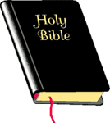1 box of colored pencils 30 #2 pencils (no paper covered pencils) 10 pencils (your choice)
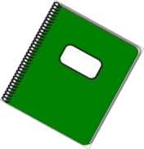1 box of crayons 1 large soft eraser or tiny erasers 1 set of pocket dividers
1 glue stick 1 pair of scissors 1 pair of scissors
3 red pens 1 12" ruler with metric 2 large soft erasers
3 black pens 1 box of colored pencils (12 count) 1 pkg. graph paper
1 pair of scissors 4 Paper Pocket folders 1 pkg. notebook paper (college ruled)
2 large erasers 1 4 oz. bottle of washable glue or glue stick 1 clear protractor and compass
2 pkg. wide ruled notebook paper 6 spiral notebooks 2 2 pocket folders
4 2 pocket folders 1 pkg. magic markers 1 12" English/metric ruler
3 2-3 in. Binder 1 pkg. notebook paper 1 4 oz. bottle of washable glue or glue stick
1 set of dividers for 3-ring binder 1 pencil box 1 pkg. ruled index cards
2 wide ruled spiral notebooks 1 box of crayons 3 pens: red, blue/black
1 Bible 1 Bible 1 6th Grade - Protractor & compass
3 rolls of paper towels 3 rolls of paper towels 4 1 subject notebooks (college)
2 boxes of 200 count or larger facial tissues 2 boxes of 200-count or larger facial tissues 1 plastic milk crate
1 large container of disinfectant wipes 1 Bible 1 highlighter
1 book bag (standard size) 1 book bag (standard size) 1 book bag (standard size)
1 Bible

