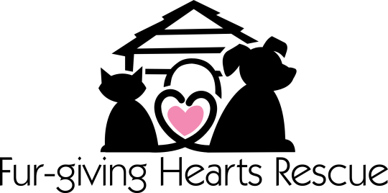
WAIVER OF LIABILITY AND HOLD HARMLESS AGREEMENT

In consideration for adopting a dog/cat from Fur-giving Hearts Rescue, I hereby release, waive, discharge and covenant not to sue Fur-giving Hearts Rescue, its officers, servants, agents, volunteers and employees.
By signing this agreement, I acknowledge there are potential risks and hazards connecting with adopting a dog/cat. I hereby elect to voluntarily assume and accept all responsibility for adopting and caring for this dog/cat.
I voluntarily assume full responsibility for any risks of loss, property damage or personal injury that may be sustained by me, or any loss or damage to property owned by me, as a result of adopting a dog/cat from Fur-giving Hearts Rescue.
I further hereby agree to indemnify and hold harmless Fur-giving Hearts Rescue from any loss, liability, damage or costs they may incur due to this adoption. It is my express intent that this Release shall bind the members of my household.
- I have read the foregoing release, understand it, and sign it voluntarily as my own free act and deed;
- No oral representation, statements or inducements, apart from the foregoing written agreement, have been made;
- I am at least eighteen (18) years of age and fully competent; and
- I execute this Release for full, adequate and complete consideration fully intending to be bound by the same.

Regarding The Adoption of:___________________________

Signed on the _____ day of ________________, 20_______.

Participant Signature:_______________________________

Printed Name:_____________________________________

FGHR Witness:____________________________________

