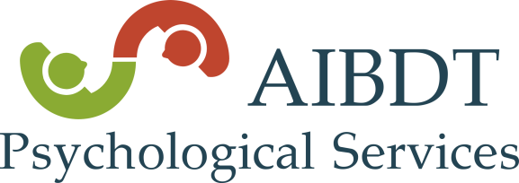
Psychological Testing and Child Development

Psychological and Neuropsychological testing is the process of administering tests and other tools to measure and observe behavior to arrive at a diagnosis and guide treatment. With children, psychological testing is utilized to better understand child development as well as to determine the potential presence of a particular behavioral, psychological, or developmental disorder.

Children & Adolescents:

Children may benefit from psychological testing when
- there are suspected or known developmental delays,
- there are parent or teacher concerns with possible ADHD,
- the process of learning academically is slow or effortful,
- there are potential medical (e.g., genetic disabilities, brain injury or other neurological conditions) that would involve memory, learning, information processing, attention, or language based issues, and
- the child has made minimal progress behaviorally, emotionally, or developmentally despite ample treatment and intervention supports.

During the testing process, the psychologist will administer norm-referenced psychological tests, such as IQ testing, language, memory, social perception, learning, or motor tests, for example, as well as conduct a thorough clinical interview, collect and analyze parent and teacher behavior rating measures, and review school, medical, and therapy records, as available. The psychologist will collaborate with the primary care physician and/or therapist to provide direction in treatment needs and goals for interventions.

The psychologists at AIBDT all have extensive experience in testing a variety of psychological & neuropsychological conditions of childhood to include Autism Spectrum, intellectual disabilities/global developmental delays in early childhood, language-based disabilities, psychiatric issues involving anxiety and depression, Tourette’s/Tic disorders, learning disabilities, and medical issues involving brain injury, seizures, and fetal alcohol and drug exposure, for example.

Adults:

AIBDT has also recently started to offer psychological testing for adults as well. This testing includes adult Autism Spectrum and ADHD testing, personality assessment to better understand emotional, interpersonal, and job related concerns, as well as testing needed for such things as disability insurance, police academy recruits, and gun permits.

**Please note, we do not provide psychological assessment for purposes of determining child custody.

