Mindful Psychotherapy

Individual Psychotherapy

Couples Counseling

Family Therapy

Group Psychotherapy

Mindful Living Workshops

Developing the Art of Living

Mindful Psychotherapy can help you
- Treat yourself with compassion
- Feel less stress and tension
- Develop a greater space for inner peace
- Learn how to live with cravings instead of giving into them
- Be more present in your life
- Deepen your self-understanding and self-awareness
- Improve your relationships
- Utilize your body's wisdom
- Be available to witness life's surprises and miracles
- Improve your quality of life, health & brain functioning

In the Here & Now
Mindful Psychotherapy

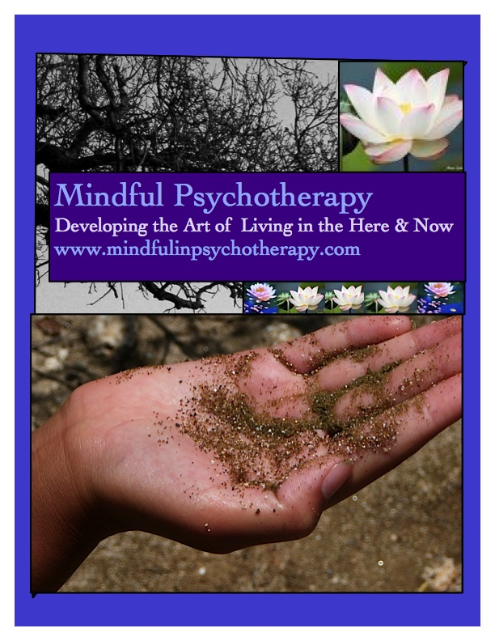



Mindful Psychotherapy
www.mindfulinpsychotherapy.com

Offices in Menlo Park & San Carlos
Phone: 650 269 8126
tanya@mindfulinpsychotherapy.com
Tanya T. Wiser, LCSW
Tanya T. Wiser, LCSW 17621
Tel: 650 269 8126
Private Practice Offices:

Menlo Park, CA
859 El Camino Real

San Carlos, CA
963 D Industrial Rd

(650) 269 8126


Mindfulness is…

Live in Acceptance Instead of Fear
For most of us, when life feels out of control our fear-based reaction is to fight, flee or freeze. When fear dominates, our sense of possibility disappears, we withdraw and we are restricted even within our closest relationships. At times, we pull back so much that we end up feeling separate from our own inner truth, wisdom and heart. Unfortunately, these fear-based efforts to protect ourselves actually prevent us from dealing with difficult situations effectively. Worse yet, they escalate conflict leaving us in even more distress. It takes intention and effort to overcome our impulses to withdraw from painful experiences. Mindful practices help us recognize and accept our inner experiences without shutting down, running away or freezing. It is when we stand in awareness and acceptance that we are able to turn toward our painful experiences and find a wise path through them.

Improve Your Life, Health & Brain Functioning
By using mindfulness practices to focus your attention, you literally change the structure of the brain, re-sculpting the neural pathways that underlie a sense of personal well-being. Cultivating a more mindful way of being is associated with less emotional stress, more positive states of mind, and better quality of life. In addition, mindfulness practice can influence the brain, the autonomic nervous system, stress hormones, the immune system, and health behaviors, including eating, sleeping and substance use.

Utilize Your Bodies Wisdom & Be More Present
When we turn our attention to our senses and intuition we tap into a limitless potential for expansion and engagement.

We experience our lives through our bodies whether we are aware of it or not. Yet we are usually so mesmerized by our ideas about the world that we miss out on much of our direct sensory experience. Even when we are aware of feeling a strong breeze, the sound of rain on the roof, a fragrance in the air, we rarely remain with the experience long enough to inhabit it fully. In most moments we have an overlay of inner dialogue that comments on what is happening and plans what we might do next.
-Sharon Salzberg

Deepen Self Understanding & Improve Relationships
We improve the quality of our relationships when we improve our ability to perceive the inner workings of our minds. As we become increasingly intimate with the inner workings of our mind, we also develop our ability to understand others. This vital skill is the foundation for building deeper, and more satisfying, relationships.

Paying attention
on purpose
in a particular way
without judgement
in the present moment.
-Jon Kabat-Zinn

saying YES to life by
being available to witness life's surprises and miracles

Mindful Psychotherapy
www.mindfulinpsychotherapy.com

Offices in Menlo Park & San Carlos
Phone: 650 269 8126
tanya@mindfulinpsychotherapy.com
(650) 269 8126

