Tis the Season www.maryjobrown.org December 2019

As we get ready to say farewell to 2019 and ring in 2020, we want to catch you up with the flurry of post-luau activity. The finishing touches have been applied to several planned projects so we can start the new year with a clean slate.
After our annual meeting on October 19th, board members Terri DiOrio and Marcy Young headed out to shop for our Veterans Day care package for deployed U.S. military—an Air Force contingent that does rescue missions. We hope that they enjoyed their boxes of goodies and supplies—and thank them for their service. We also decided to do a one-week online Pampered Chef party during the first week of December as a boost to our fundraising coffers (more on that in a minute)
Christina and Sharon went into full-on shopping mode and shopped for the five families that we adopted for Christmas this year. Using our well-honed strategy of bargains and coupons we were able to amass a lot of great gifts and, even though we had an additional family to support stayed UNDER budget (proof that there are miracles!)
Our online Pampered Chef party started on November 30th and December 1st we met at Christina’s Christmas Castle. As usual, she had some delicious food and drink to fuel our Christmas wrapping party. We ended with our annual Yankee Swap –passing our gifts around while Sharon read the Right-Left version of “The Night Before Christmas”
Once again we want to thank St. Joseph’s Parish in Wakefield for their assistance in connecting us with families to help during the holy holiday season. Our Christmas wish is that our deliveries will be a turning point for these families and that 2020 will be a better, healthier and happier year for them.

BY THE WAY That previously mentioned Pampered Chef party? What a great week—playing games and going back and forth with our INCREDIBLE consultant, Marchian Crane. He really put the FUN in FUNdraiser; online Family Feud--Guess the Top Ten Favorite Christmas Songs—You Write the Christmas Story—he had more games for us to play than Amazon, keeping our attention and truly adding a new and fun layer to online shopping. Not only did he take the stress out of the week for us, he donated a large percentage of the sale to our foundation—over $700. As announced at the outset, these monies will be added to our donation to Child Life Services at the Floating Hospital for Children at Tufts Medical Center. THANK YOU to all of you who joined in, shopped, wished us well and laughed with us. We highly recommend Marchian for all your Pampered Chef purchases!
AND we would like your feedback about this! Would you be interested in our doing this again? Same time next year? Or maybe in the spring, just in time for Mother’s Day-Father’s Day-and summertime grilling? Let us know! Just email Sharon! sharon@maryjobrown.org
Looking Ahead
Soon we will begin our ninth year of spreading smiles through acts of kindness—and are looking into adding some new ways to accomplishing that. Any and all changes will be announced via our next newsletter and our facebook page. We are open to any suggestions you might have---do not hesitate to share your ideas with us.
We already have an Army regiment stationed in Iraq lined up for our Valentine’s Day Care Packages. We keep them in our thoughts this holiday season and will do our best to bring some smiles to them.

We are happy to share with you that in March of 2020, there will be a Court of Honor at St. John’s Preparatory School in Danvers as Shiloh Ellis becomes an Eagle Scout. One of our 2016 Kindness Campaign finalists, we are not surprised that this amazing young man has attained this! From all of us at the Mary Jo Brown Foundation: Congratulations Shiloh! We look forward to more great news about you in the future!
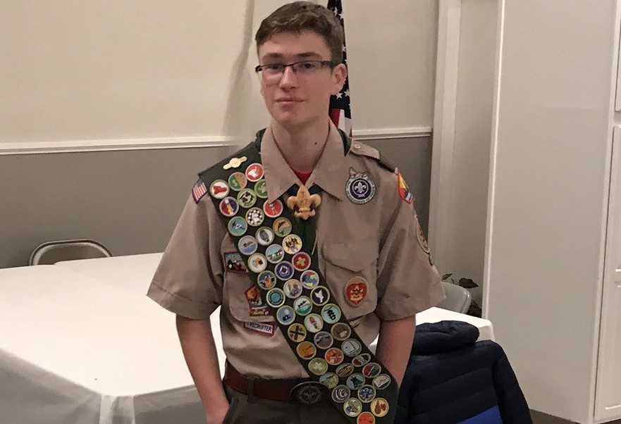!
AND
Save the Date! October 4, 2020 Our NINTH Annual Indoor Luau!
Saugus Elks Hall Saugus, MA 3PM to 7PM
More to follow in the New Year.

May all your dreams come true. Happy New Year!

